A Project Report on

**Inventory Management**

*Submitted*

In Partial Fulfilment of the Requirements

for the Degree Of

**M.Sc. (CA&IT)-VI**

**Submitted to**

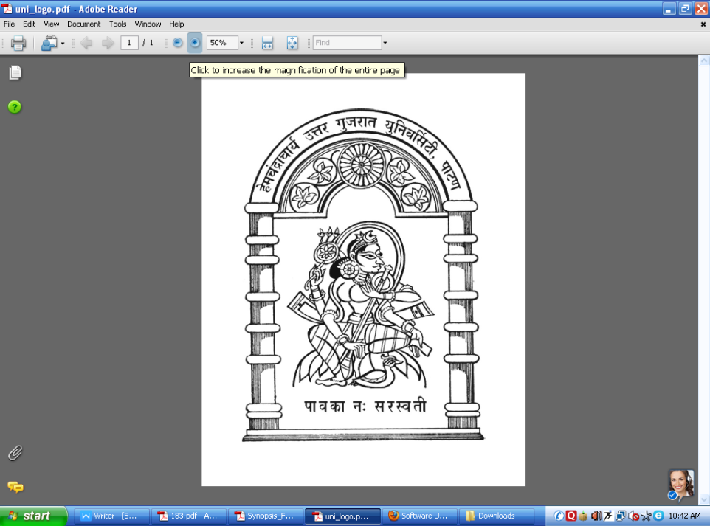

**Department of Computer Science,**

**HEMCHANDRACHARYA**

**NORTH GUJARAT UNIVERSITY**

|  |  |
| --- | --- |
| **Submitted By:**  Modi Tanish R.(125)  Modi Tejasv M.(127) | **Project Guide**  Dr Nimesh I Modi.  Dr Bhavesh M Patel. |

**June, 2023**

**Acknowledgement**

I would like to thank Mr Bhavesh sir Principal of Department of Computer Science for providing good infrastructure and Hi-Tech lab facilities to develop and improve student’s skills.

I am highly indebted to Dr Nimesh Modi and Mr Bhavesh sir for his guidance and supervision as well as for providing necessary information regarding the Project.

I would like to express my gratitude towards my lovely Parents for their kind cooperation and encouragement which help me in completion of this Project Report.

My thanks and appreciations also go to my friends who helped me out with their abilities.

With immense pleasure, we present this report on the project assignment “Inventory Management”

**Thank You.**

**Tanish & Tejasv**

**INDEX**

|  |  |  |  |  |
| --- | --- | --- | --- | --- |
| CHEPT NO | TITLE | | | PAGE NO |
| 1 | INTRODUCTION | | |  |
| 1.1 | Project Profile | | 2 |
| 1.2 | Project Definition | | 3 |
| 2 | SYSTEM ANALYSIS | | |  |
| 2.1 | Hardware & Software Configuration | | 5 |
| 2.2 | Requirement Analysis | | 6 |
| 2.3 | Existing System | | 7 |
| 2.4 | Need for new System | | 8 |
| 2.5 | System Modules | | 9 |
| 3 | SYSTEM DESIGN | | |  |
| 3.1 | DATA FLOW DIAGRAM | | 10 |
| 3.2 | ER-Diagram | | 15 |
| 3.3 | DataDictionary | | 17 |
| 4 | INTERFACE DESIGN | | |  |
| 4.1 | Screen Shots | | 23 |
| 4.1.1 | Admin Module | 24  49 |
| 4.1.2 | User Module |
| 5 | CONCLUSION & FUTURE WORK | | | 64 |
| 6 | REFERENCES & BIBLIOGRAPHY | | | 65 |

**Chapter 1-> Introduction**

* 1. **PROJECT PROFILE**

|  |  |
| --- | --- |
| Project Title: | Inventory Management |
| Project Definition | inventory management is to help businesses easily and efficiently manage the ordering, stocking, storing, and using of inventory. |
| Type Of Application | Web-base Application |
| Front End: | HTML5, CSS3, JAVASCRIPT |
| Back End: | My Sql |
| Project Duration | 6 Months |
| Team Size: | 2 |
| Developed By | Modi Tejasv,Modi Tanish |
| Submit To: | Dept. Of Computer Science, HNGU Patan |

**1.2 Project Definition**

**Project Title :** Inventory Management

Inventory management is the supervision of noncapitalized assets -- or inventory -- and stock items. Inventory management supervises the flow of goods from manufacturers to warehouses and from these facilities to point of sale. A key function of inventory management is to keep a detailed record of each new or returned product as it enters or leaves a warehouse or point of sale.

Organizations from small to large businesses can make use of inventory management to track their flow of goods. There are numerous inventory management techniques, and using the right one can lead to providing the correct goods at the correct amount, place and time.

Inventory control is a separate area of inventory management that is concerned with minimizing the total cost of inventory, while maximizing the ability to provide customers with products in a timely manner. In some countries, the two terms are used synonymously.

**Chapter 2-> System Analysis**

* 1. **Hardware & Software Configuration**

2.1.1 Software Requirements

|  |  |
| --- | --- |
| **OPERATING SYSTEM :** | Windows |
| **FRONT END :** | Html5, CSS3, Javascript |
| **BACK END :** | My Sql |
| **BROWSER :** | Crome, Opera And Any Mordern Browser |

2.1.2Hardware Requirements

|  |  |
| --- | --- |
| **PROCESSOR :** | Intel I3 1.0 GHz or Higher |
| **RAM :** | 256 MB or Updated |
| **Hard Disk :** | 20 Up to 160 GB or Higher |

* 1. **Requirement Analysis**

The project aims to develop an Inventory Management System that will facilitate efficient tracking, monitoring, and control of inventory for a business. The system will provide functionalities for inventory management, stock tracking, order fulfillment, and reporting to optimize inventory levels, streamline operations, and improve overall efficiency.

Implement features for managing supplier information, purchase orders, and automated order placement.

1. Product Categorization
2. Product Measurement
3. Stock Inquiries
4. Automatic Stock-out Reports
5. Vendor Managed Inventory
6. E-commerce

Design a user-friendly interface that is intuitive and easy to navigate, allowing users to interact with the system efficiently.

**2.3 Existing System**

Manual Tracking: Inventory levels were manually tracked using methods such as periodic physical counts, where employees would physically count the items in stock and update the records accordingly.

Paper-Based Records: Inventory information was recorded on paper documents, such as inventory cards or ledgers. These records included details such as item descriptions, quantities, and locations.

Lack of Real-Time Data: The old system often lacked real-time data, making it difficult to have an accurate view of inventory levels at any given moment. Inventory updates were typically done periodically, resulting in delays and potential inaccuracies.

Limited Reporting: Generating reports required manual compilation of data from various sources, which was time-consuming and prone to errors. Reports were typically basic and did not provide in-depth analysis or insights.

Higher Risk of Errors: With manual processes, there was a higher risk of errors in recording inventory levels, leading to inaccuracies in stock counts and potential issues such as stockouts or overstocking.

Inefficient Reordering: Determining when to reorder items relied heavily on manual calculations and estimates. This could result in understocking or overstocking, leading to increased costs or missed sales opportunities.

**2.4 Need For New System**

If the current inventory management processes heavily rely on manual data entry, spreadsheets, or paper-based documentation, it can lead to errors, inefficiencies, and delays.

If the current system does not provide real-time updates on inventory levels, stock movements, and product availability, it becomes challenging to make timely decisions, respond to demand fluctuations, or prevent stockouts.

If the existing system lacks essential features such as demand forecasting, supplier management, or integration with other business systems, it hampers the efficiency of inventory management and prevents seamless business operations.

If the current system does not support accurate demand forecasting, it can result in either excess inventory or frequent stockouts, leading to increased holding costs or lost sales opportunities.

**2.5 System Modules**

* + 1. Admin
    2. User

**Chapter 3-> System Design**

**3.1 Data Flow Diagram**

Context Level

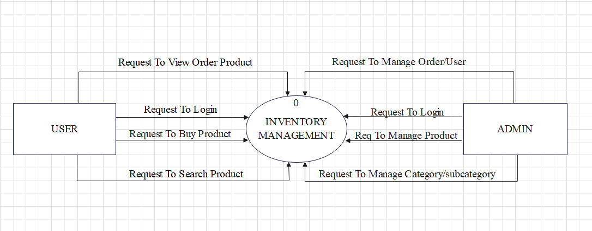

First Level

1. Manage Admin:-

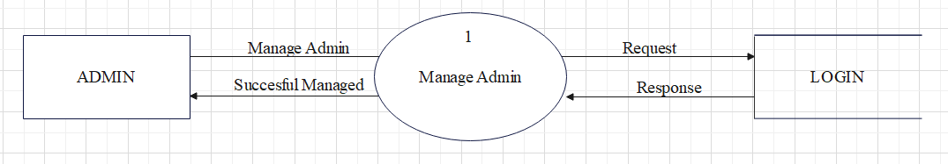

1. Manage User:-

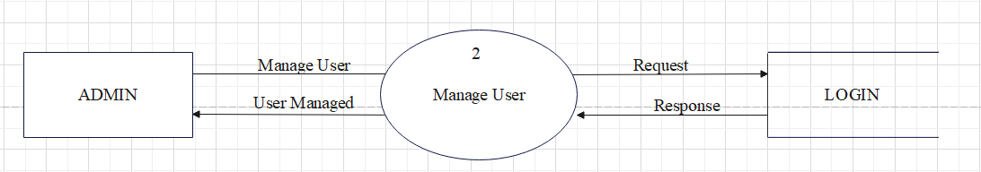

1. Manage Category :-

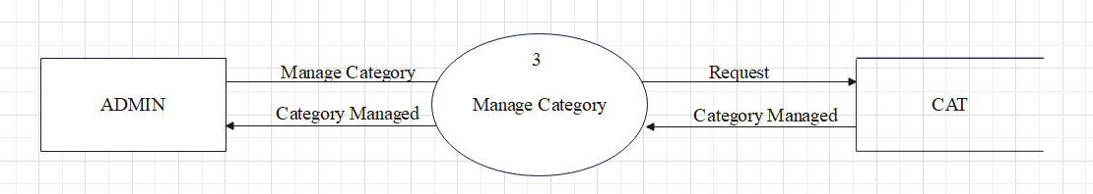

1. Select Category :-

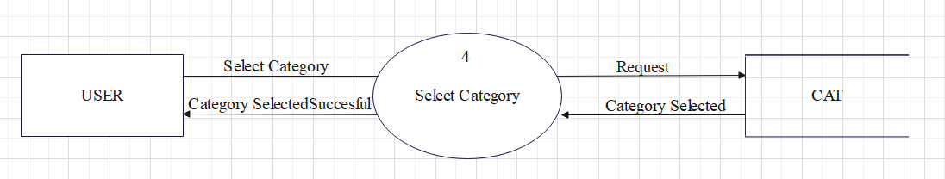

1. Manage Brand :-

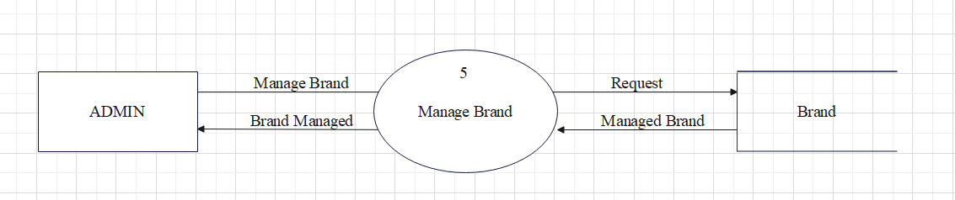

1. Manage Order:-

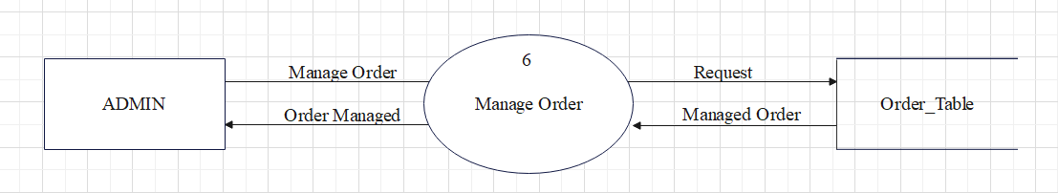

1. Place Order:-

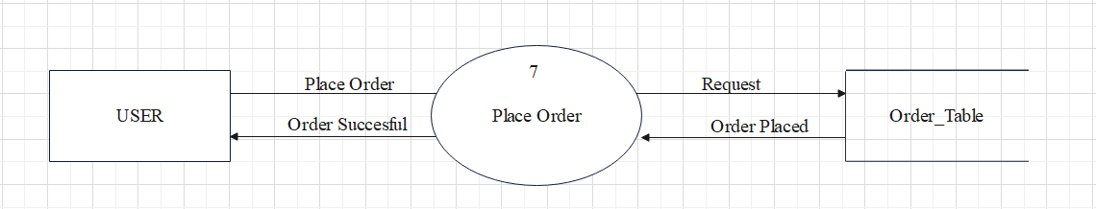

Second Level

1. Manage Sub_Category:-

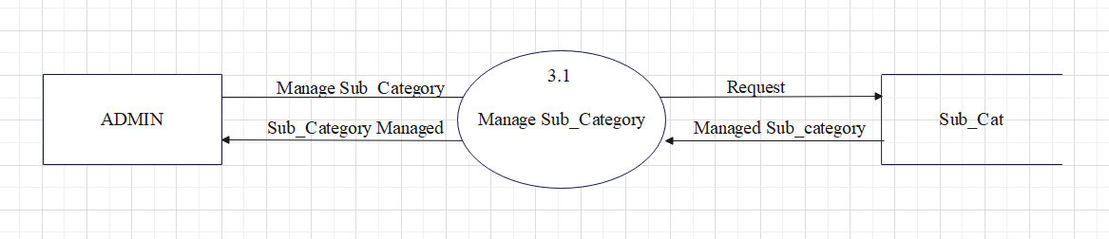

1. Select Sub_Category:-

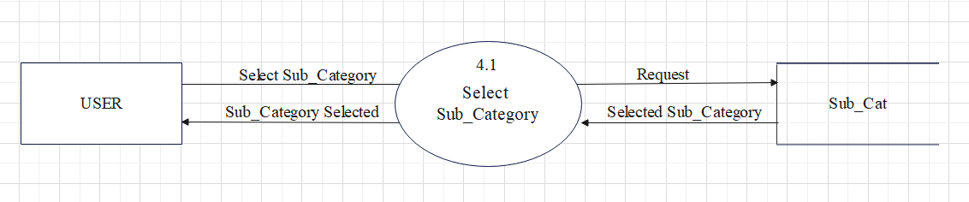

1. Manage Transaction:-

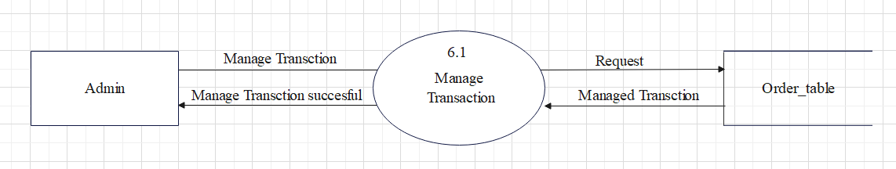

1. View Transaction:-

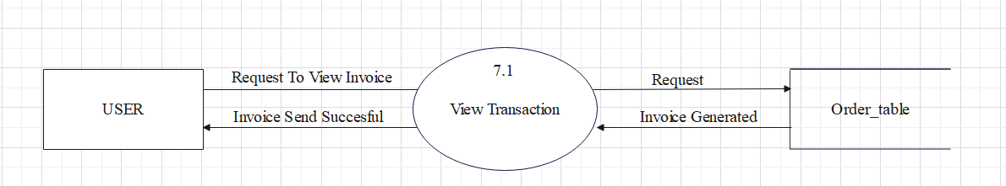

Third Level

1. Manage Product:-

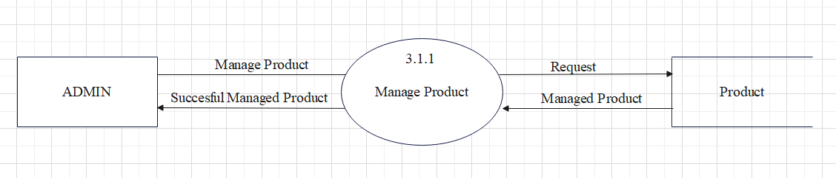

1. Select Product:-

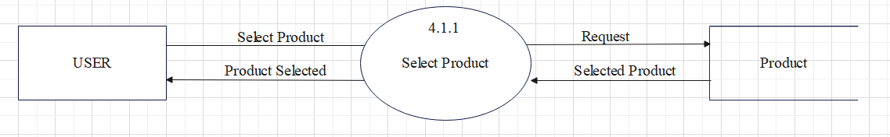

**3.2 ER Diagram**

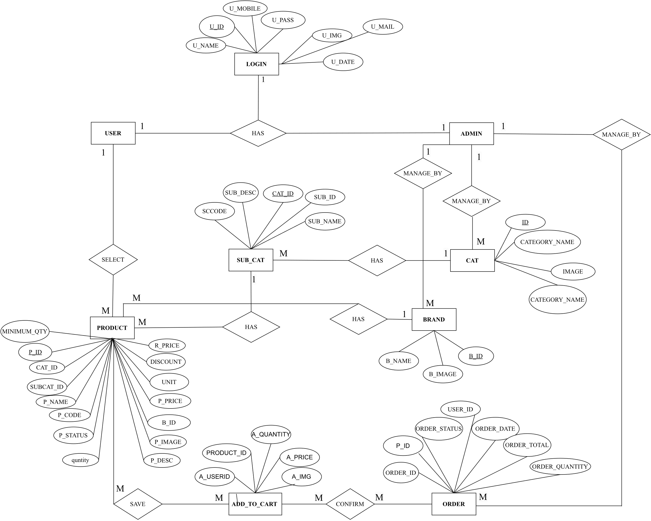

**3.3 Data Dictionary**

**1. Login :-**

Primary Key: u_id

Description: This table is used to store Data of user/admin

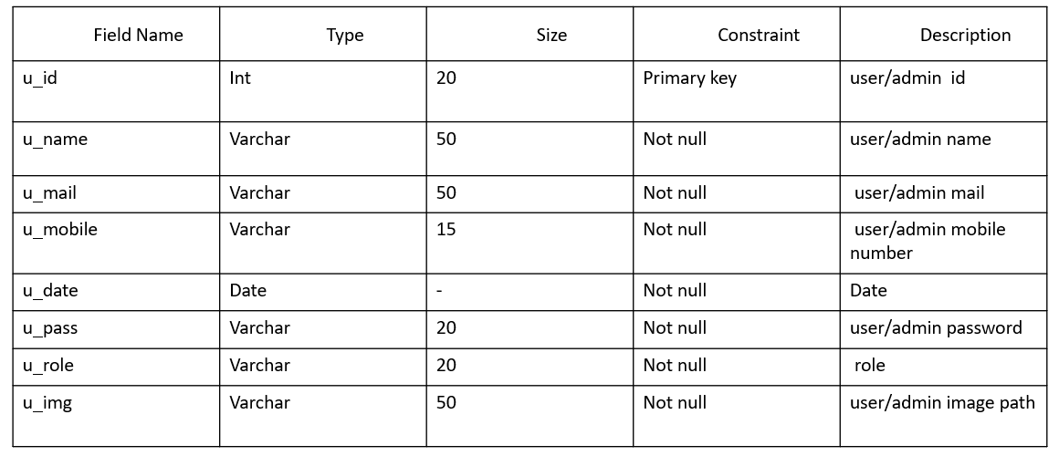

**2. Cat :-**

Primary Key: id

Description: This table is used to store product category.

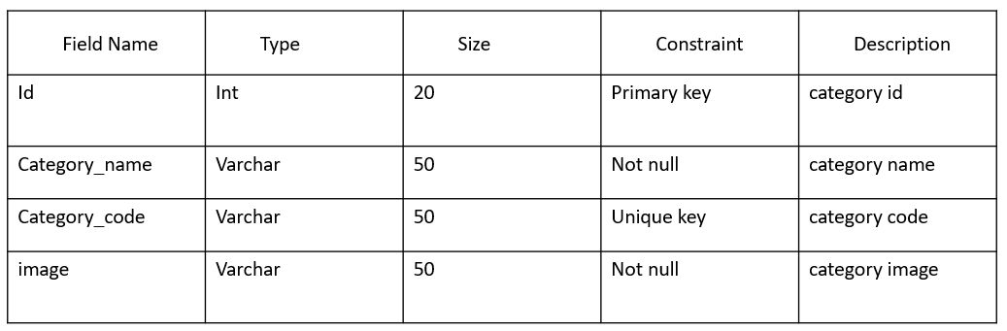

**3. sub_cat :-**

Primary Key: Sub_id.

Foreign Key: Cat_id

Description: This table is used to store product of Sub_category.

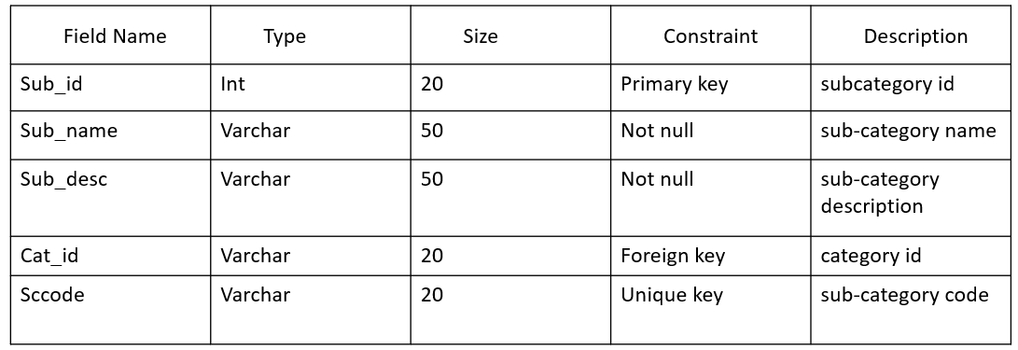

**4. Brand :-**

Primary Key: Sub_id.

Foreign Key: Cat_id

Description: This table is used to store product Brand

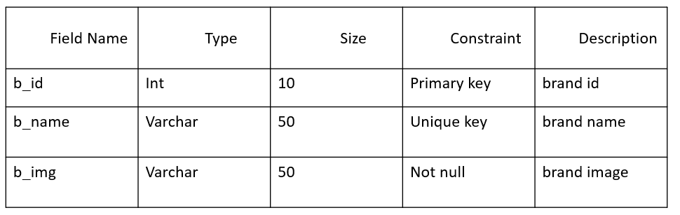

**5. Product:-**

Primary Key: P_id.

Foreign Key: Cat_id,Subcat_id,b_id

Description: This table is used to store Product .

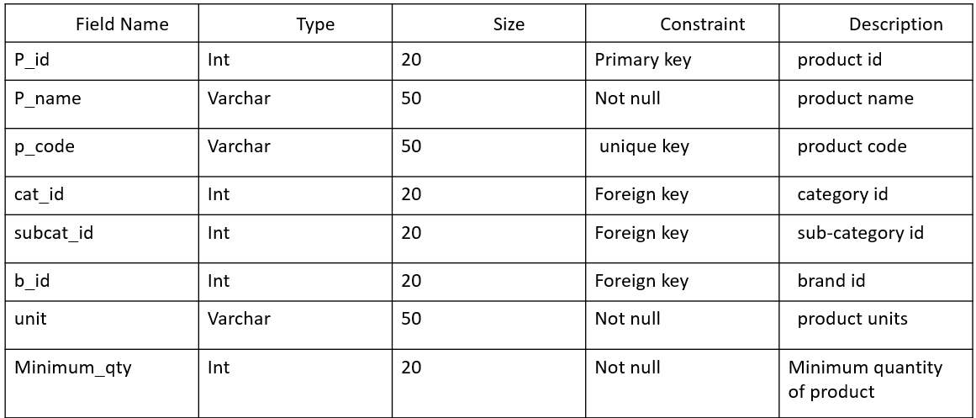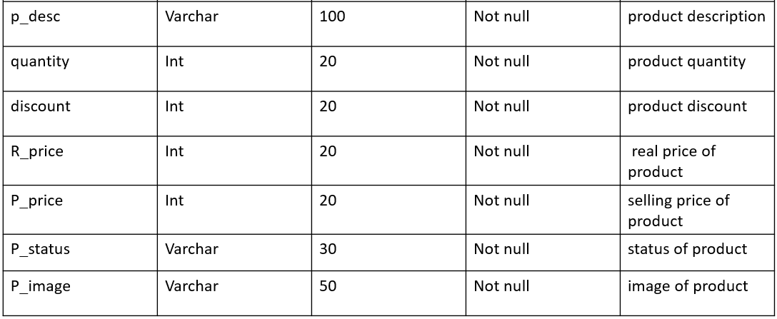

**6. Add_To_Cart:-**

Foreign Key: Product_id,User_id

Description: This table is used to store Cart

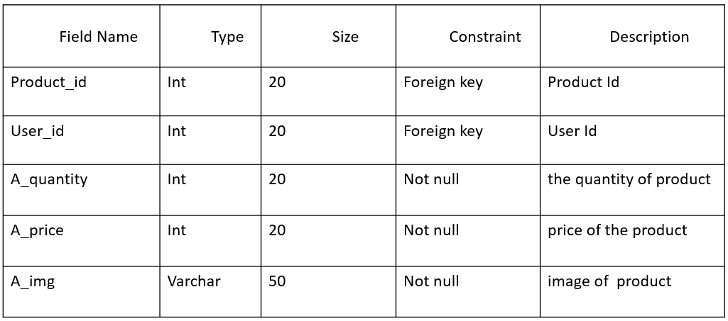

**7. Order table:-**

Foreign Key: user_id,p_id

Description: This table is used to store Order of user

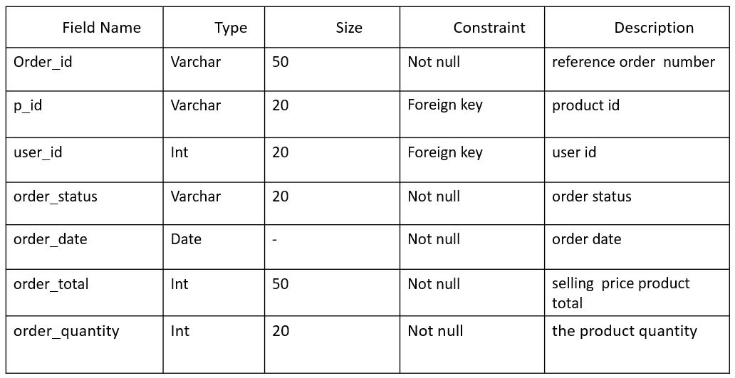

**Chapter 4-> Interface Design**

**4.1 :- Screenshots**

**4.1.1: Admin Module**

1) Sign In As Admin:-

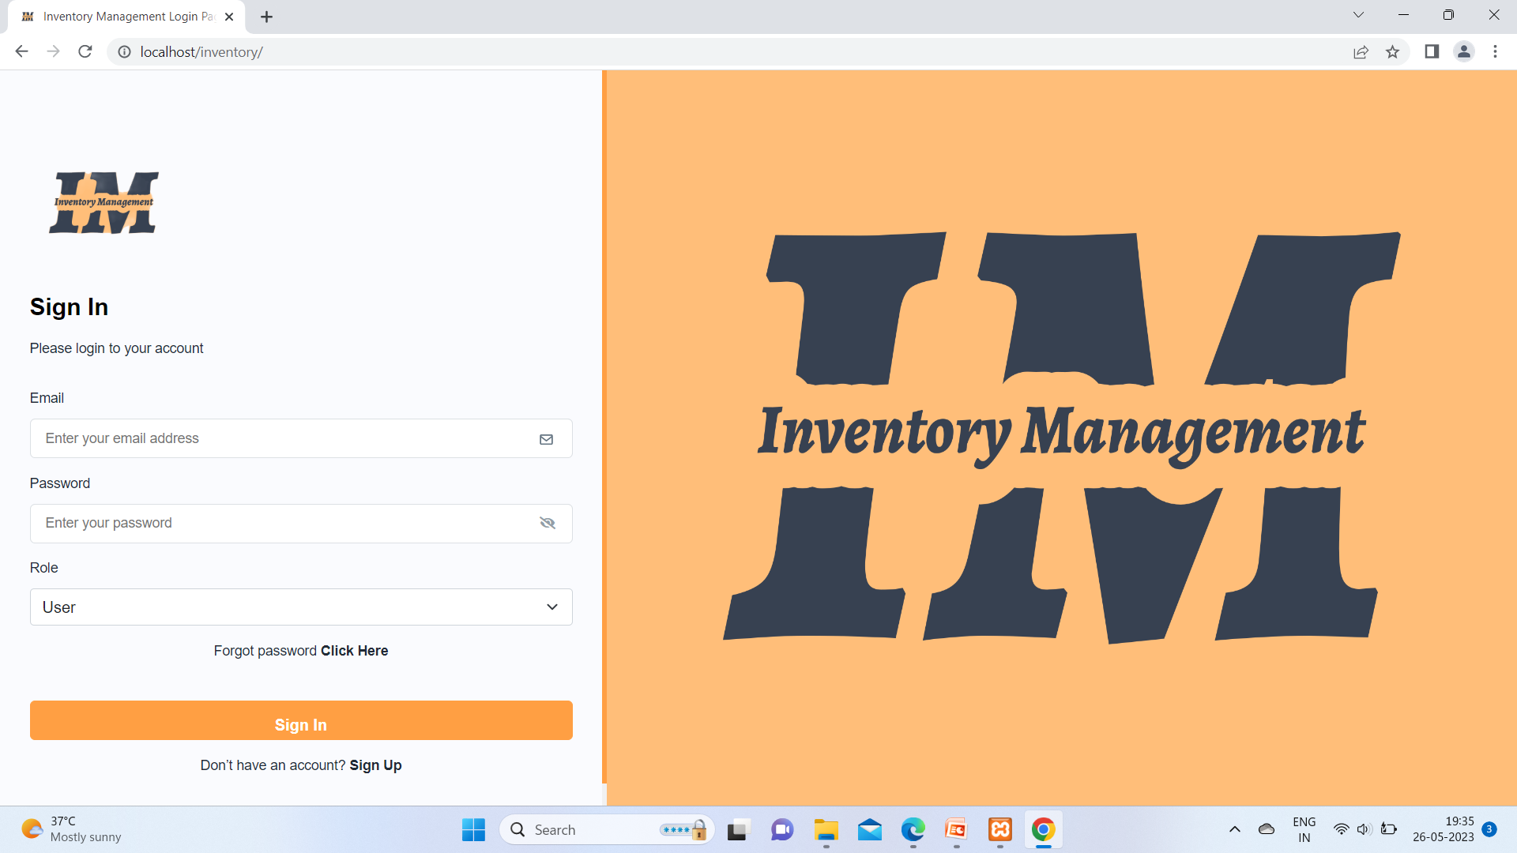

The Give image illustrate Admin log in from sign in page and .This page is index page of the out website.

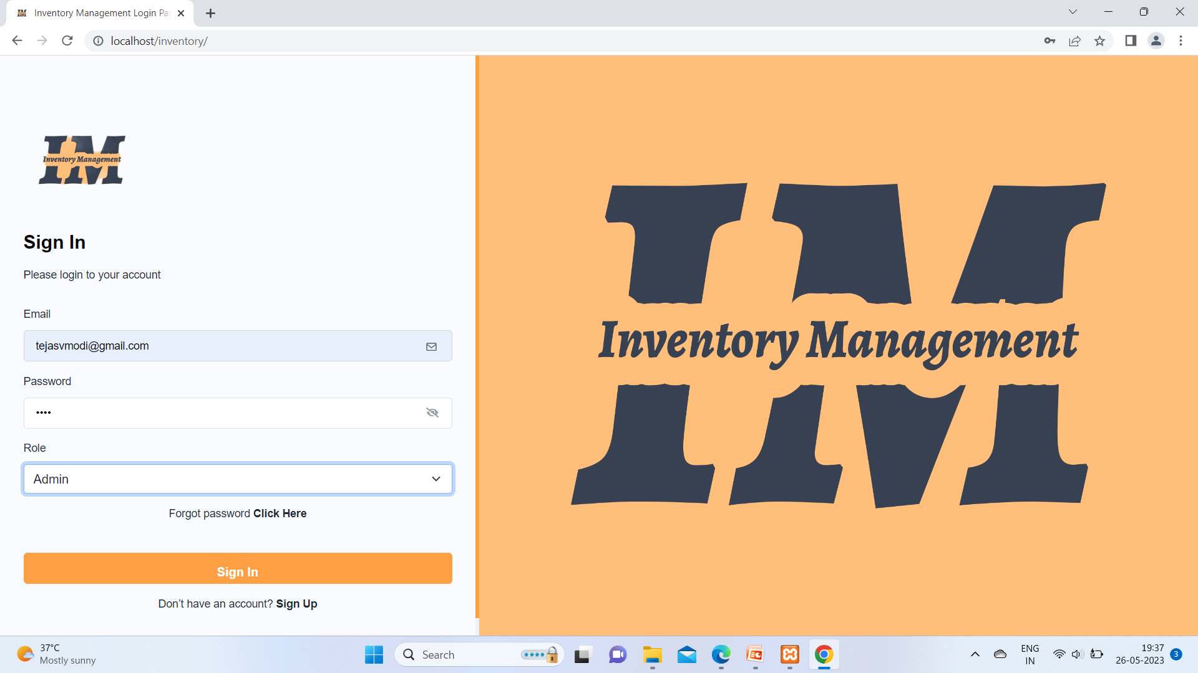

The Give image illustrate Admin log in from sign in page and .Filing In Textbox Value.

2) Dashboard Page:-

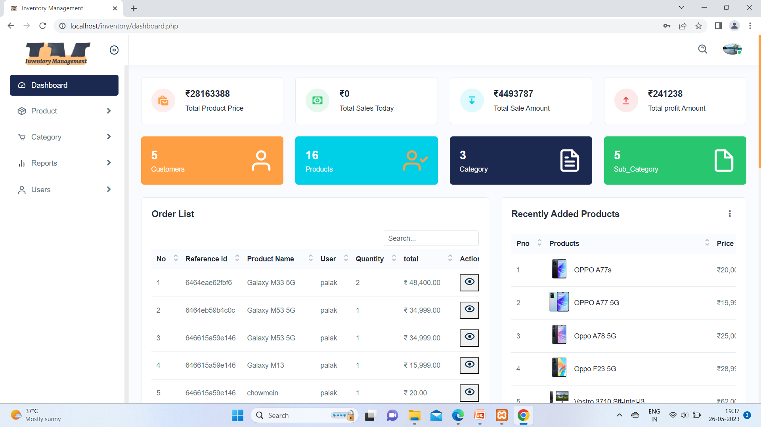

The Given Photo represtents On admin dahsbord here many Product,order and Etc List.

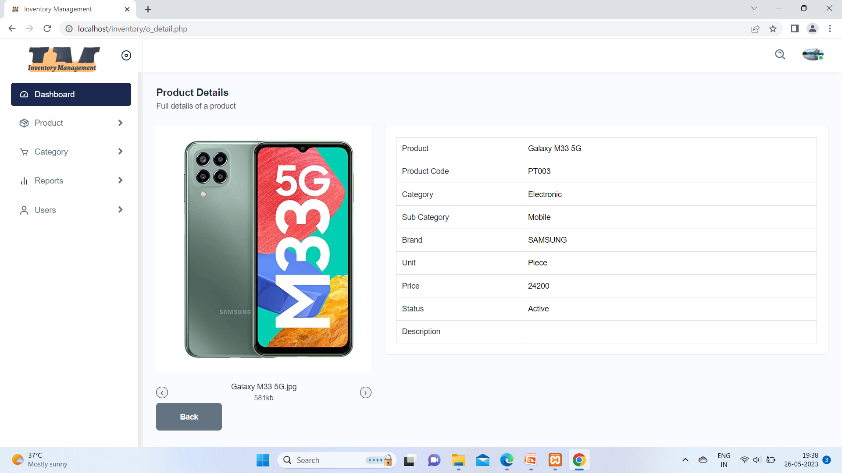

On above photo this is detail of product and here some information about Samsung galaxyM33 5G phone.

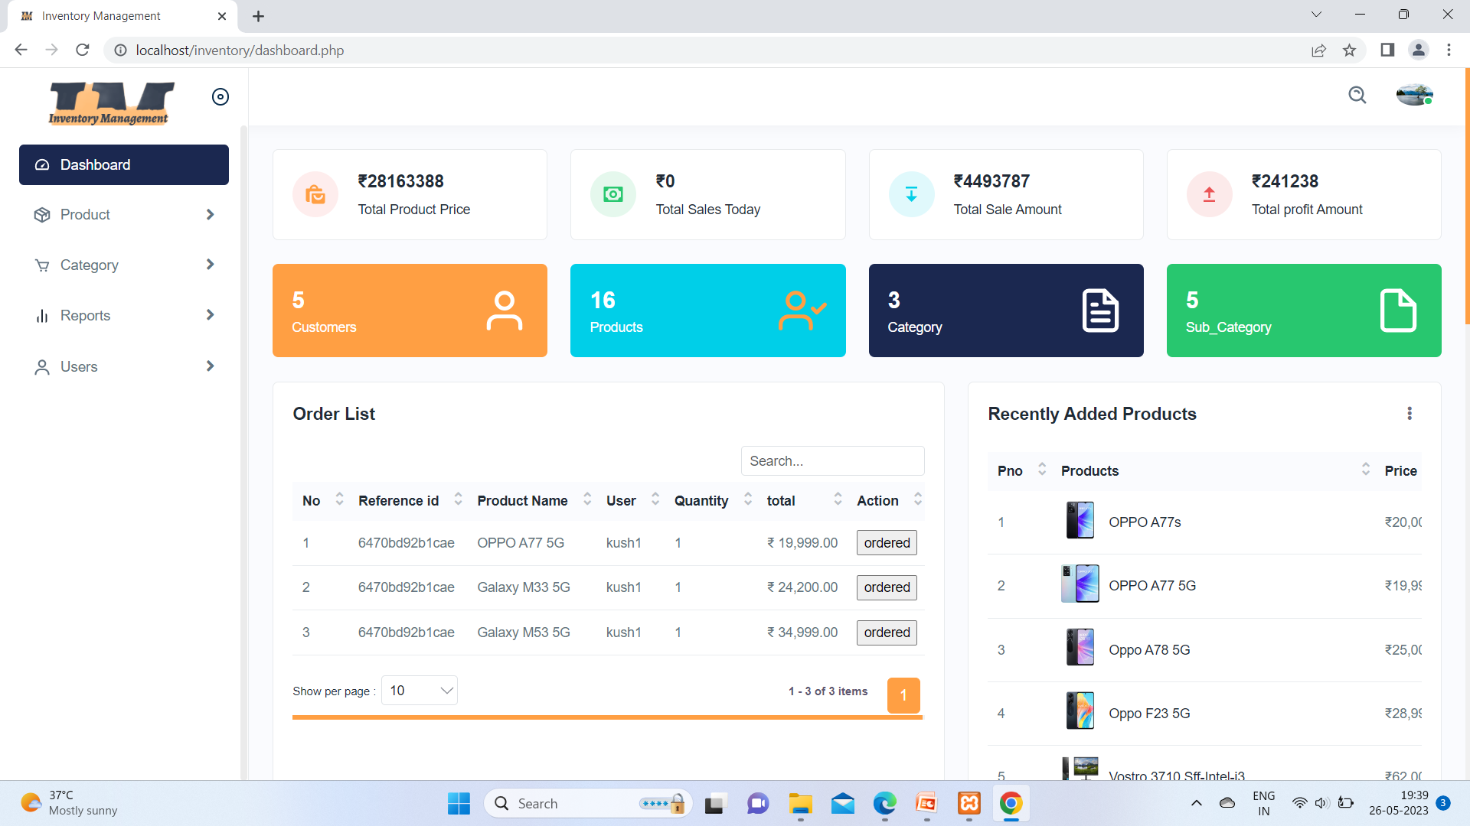

From upper image it is clear that,admin approve Order after user order will confirm .today sales is

Zero.

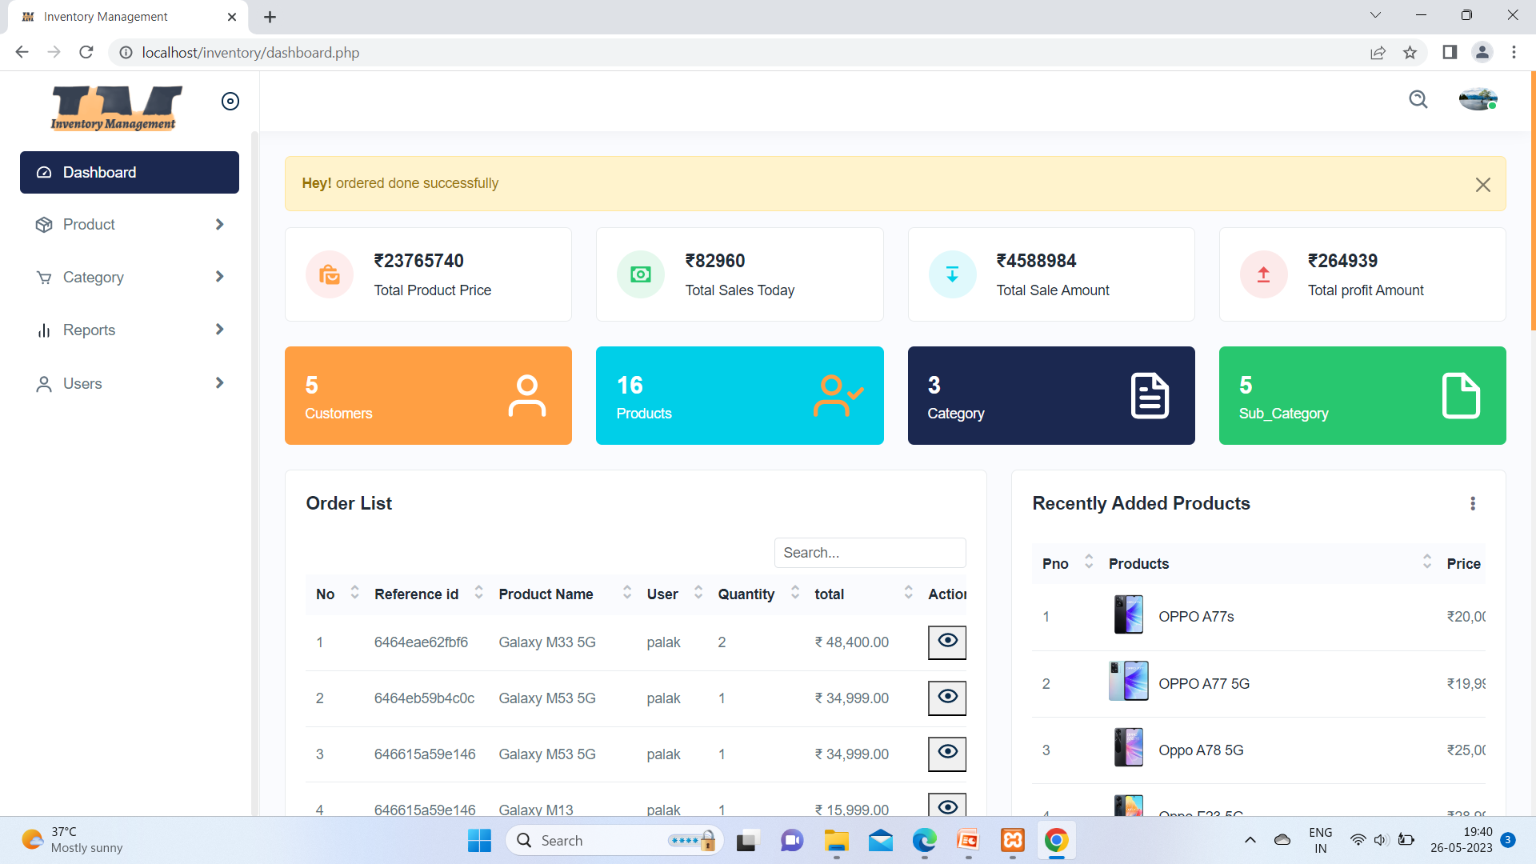In this picture we can see Order has Done Successful and it will add in order list which is into Report filed.

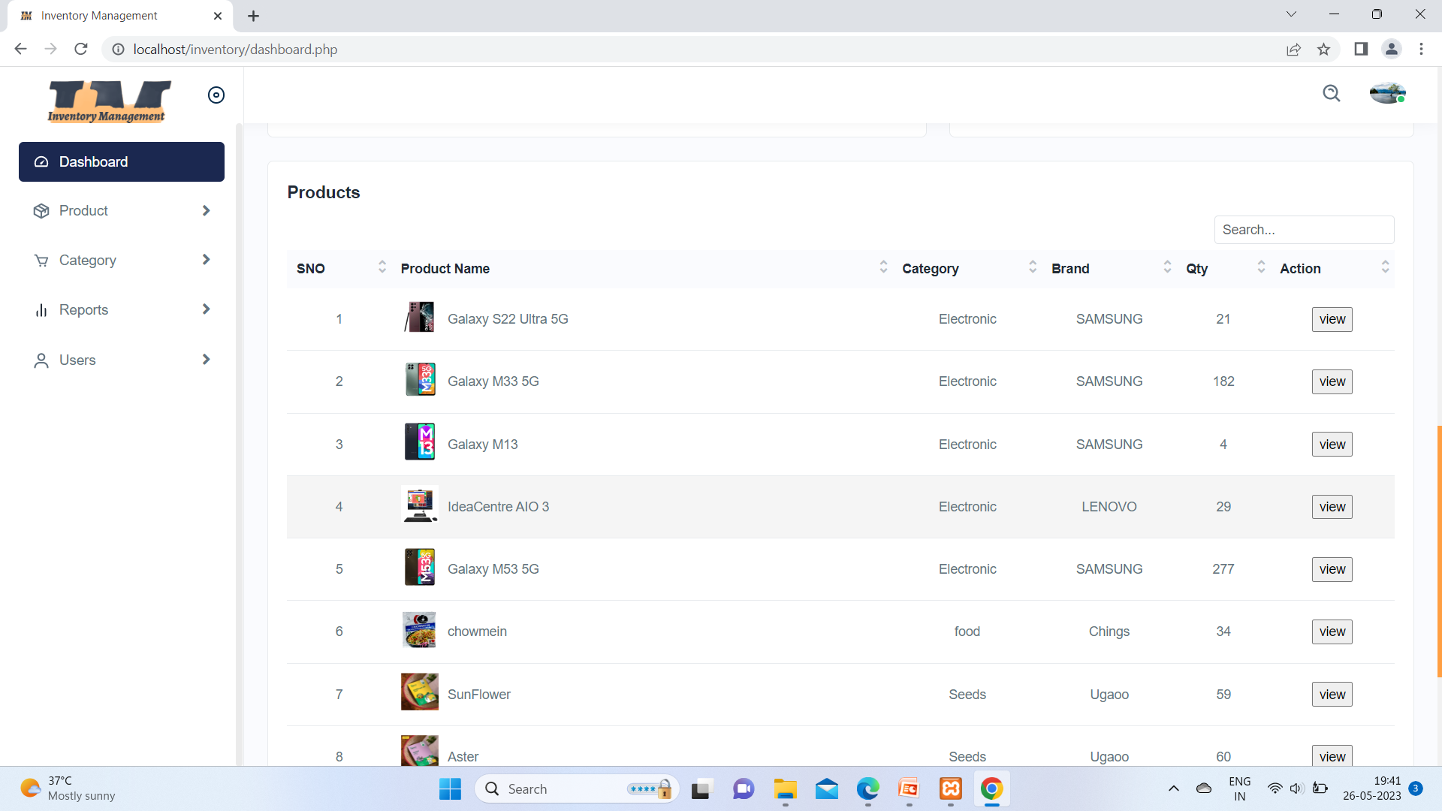

This image is about on product List which has category,Brand,How many Oty we have and Action .

It mean we can disable the product

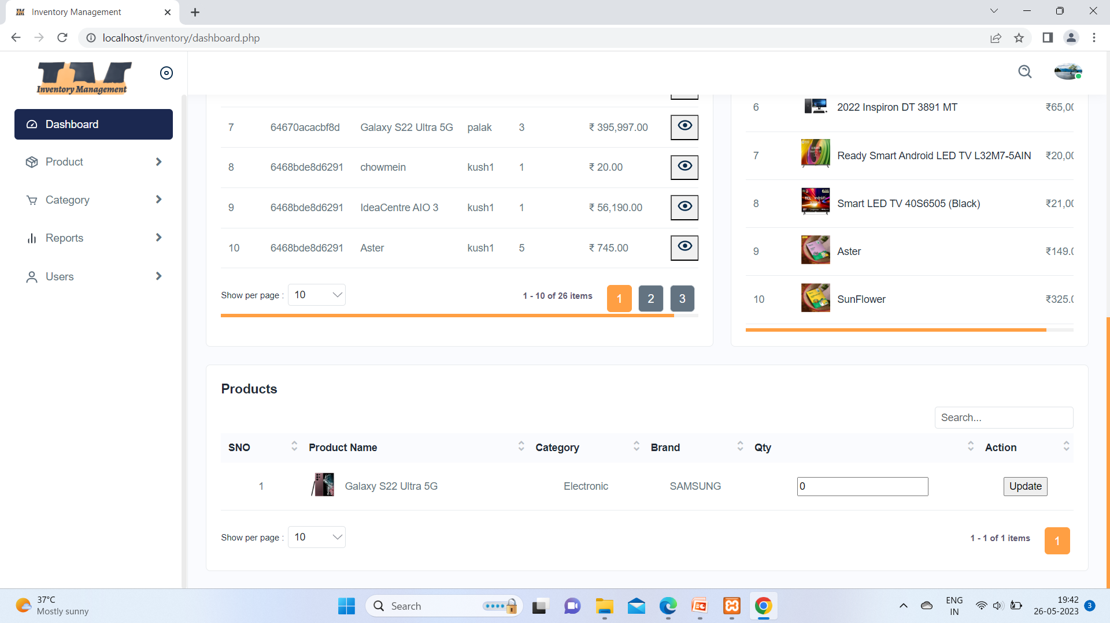

Above photo is about when any product Qty is zero then automatically.System make one new table at Dashbord of admin and You can see from above picture

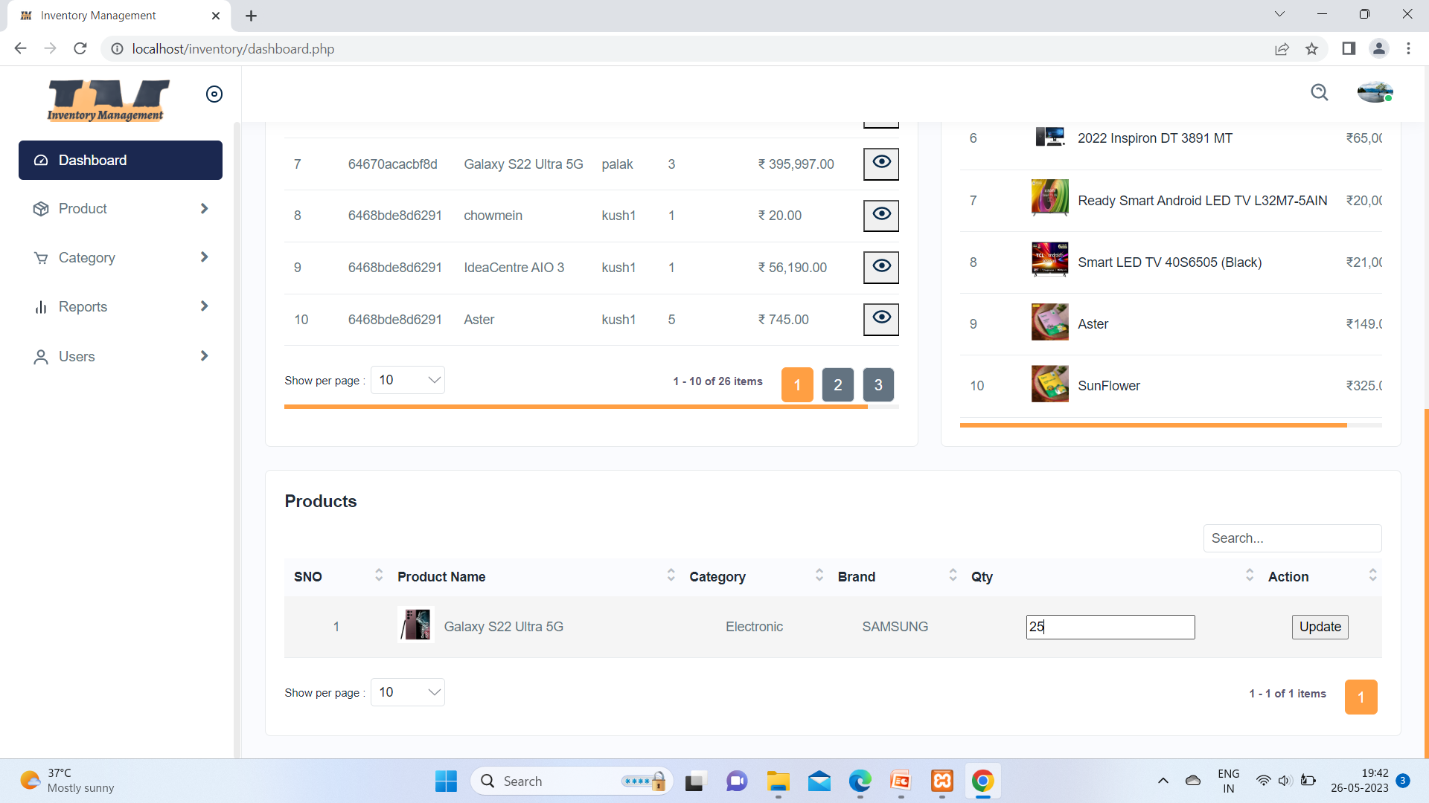

And again in this photo we can see Admin update qty of Galaxy s22 Ultra 5g.

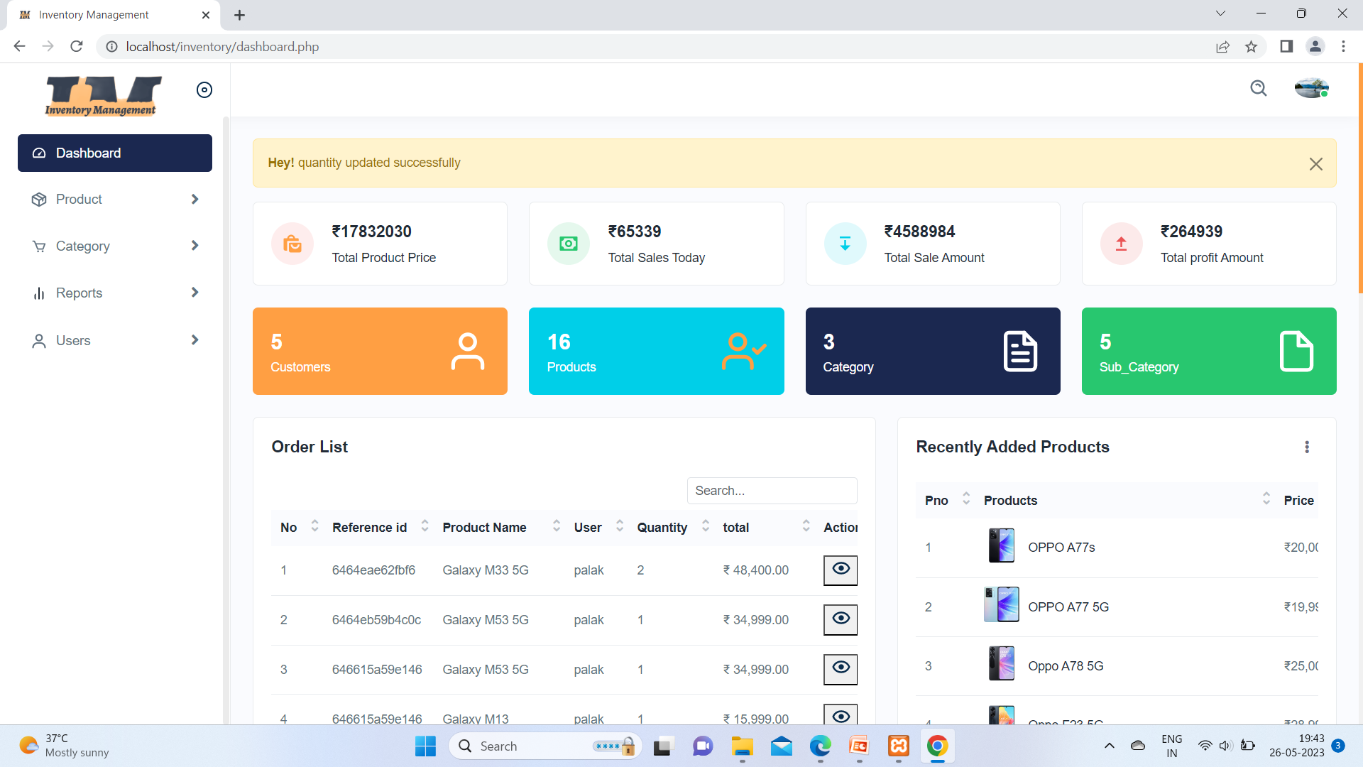

Here the Quantitye is updated message and after that .The product table added this product.

3) Admin Profile:-

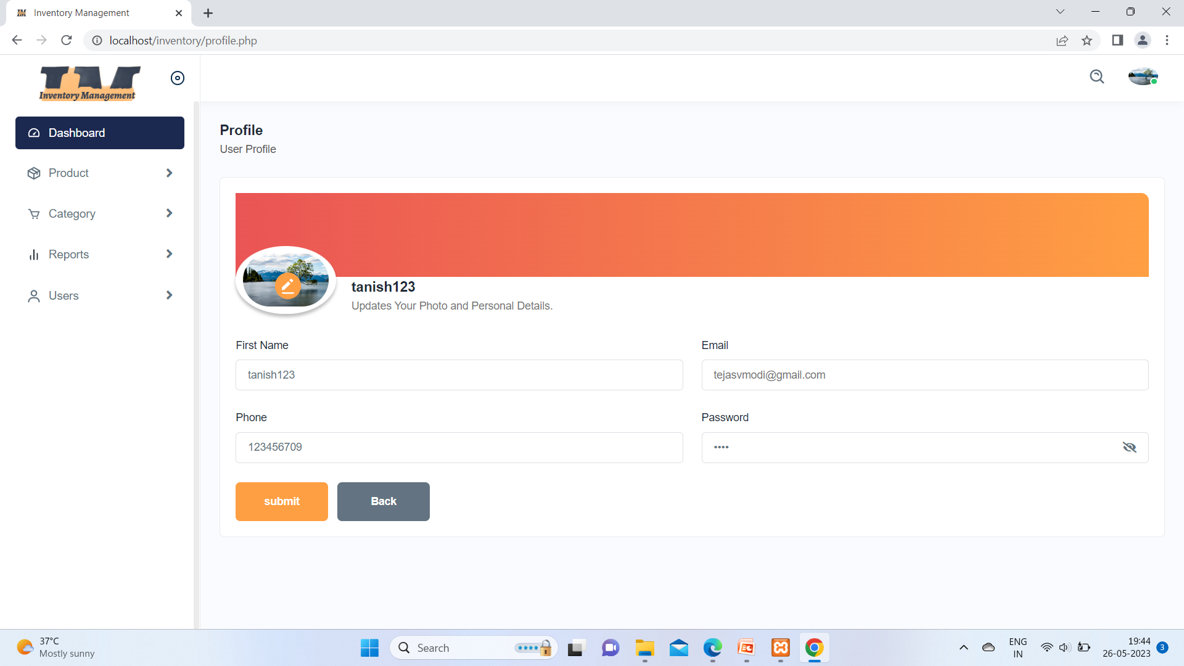

This picture illustrates admin profile and here so many fields like First name ,Email ,Phone ,Password and photo In this case admin can update his profile

4) Updating Profile:-

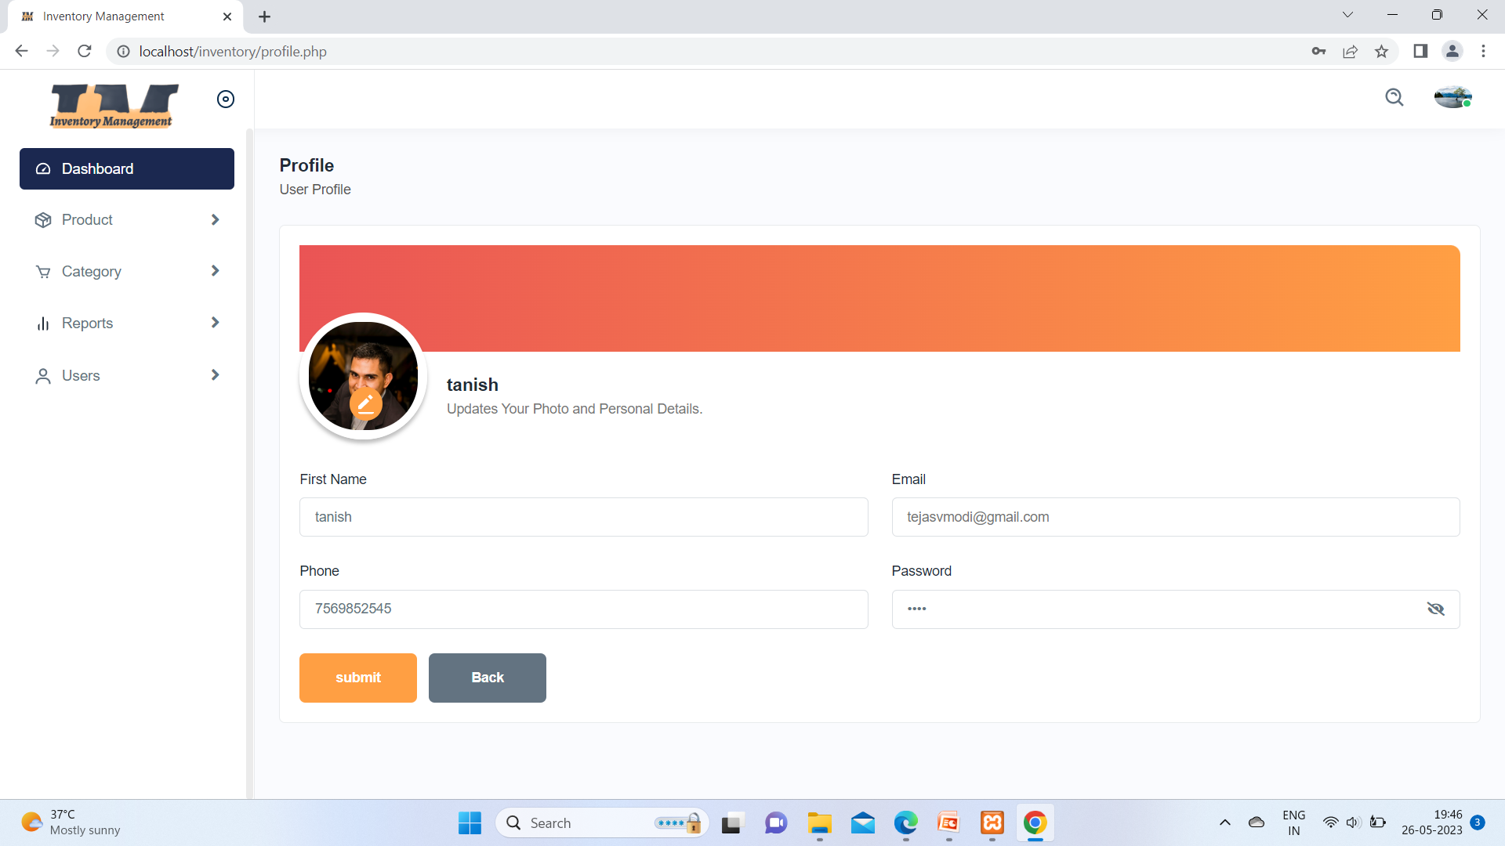

Here admin changed his photo .

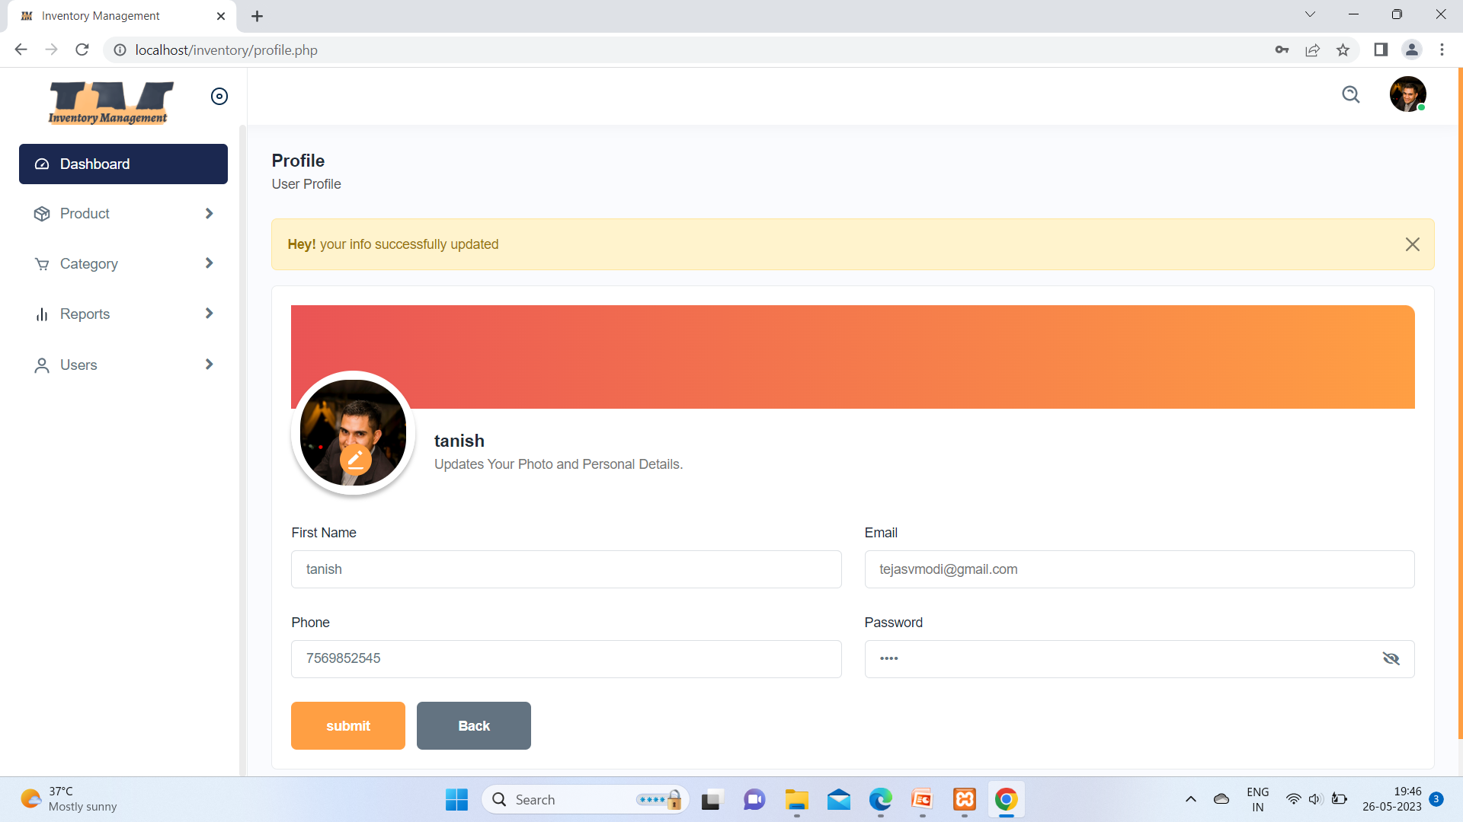

Here message pop up your successful updated.

5) Category Page:-

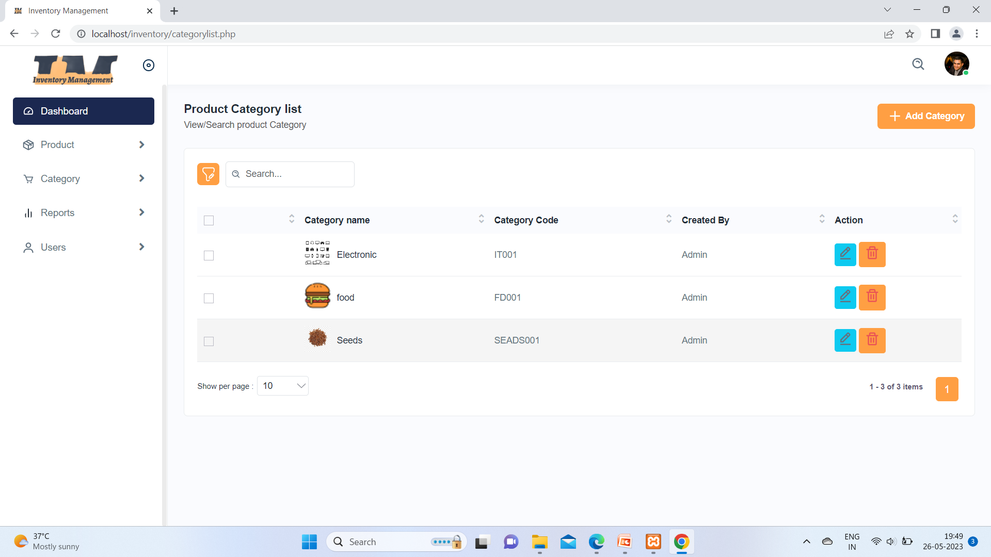

In this above image this is the Product category list table and admin can add and manage product from here from +Add Category button.

6) Add Category Page:-

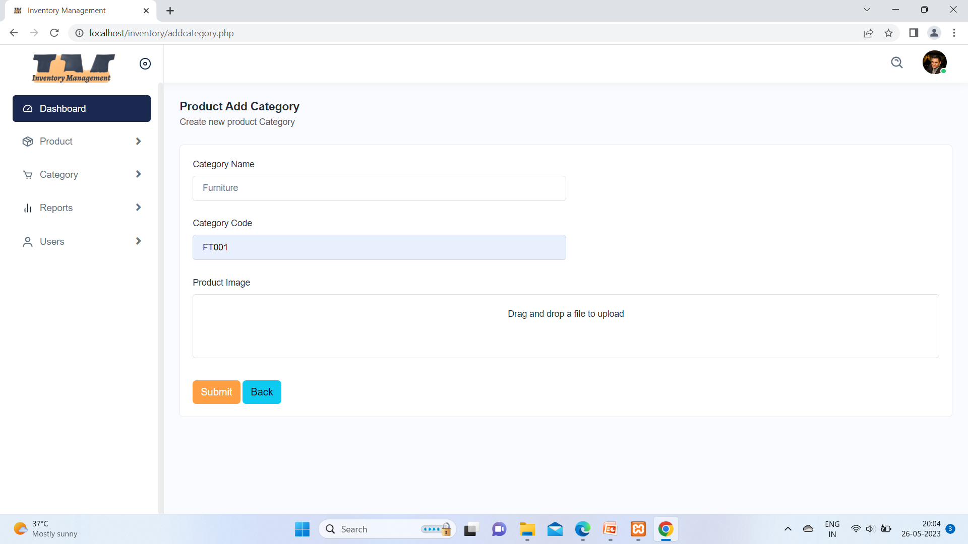

When admin click on add button it will open upper page and he has fill this text fields, such as Category name , Category Code and image of Category.

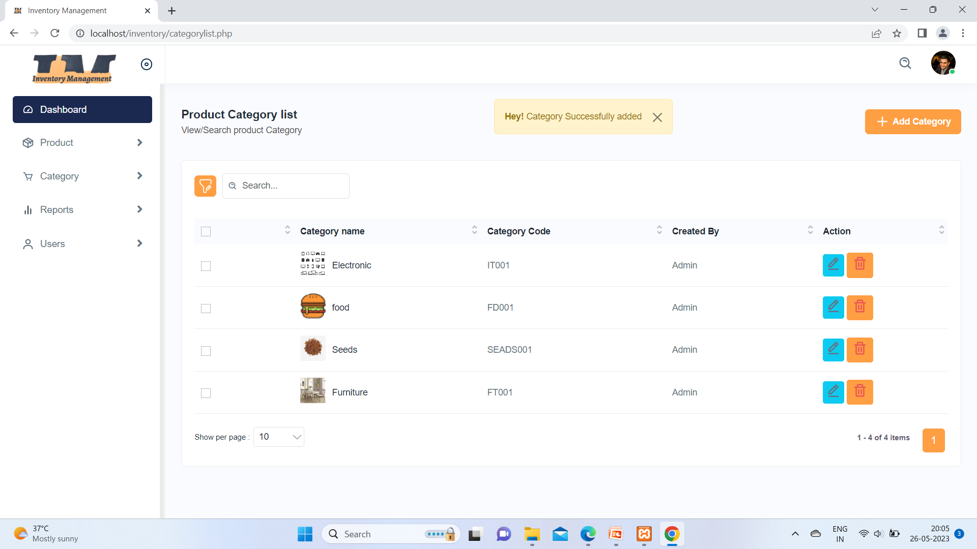

Here when click on Submit button it will send a message category added successful.

7) Edit Category Page:-

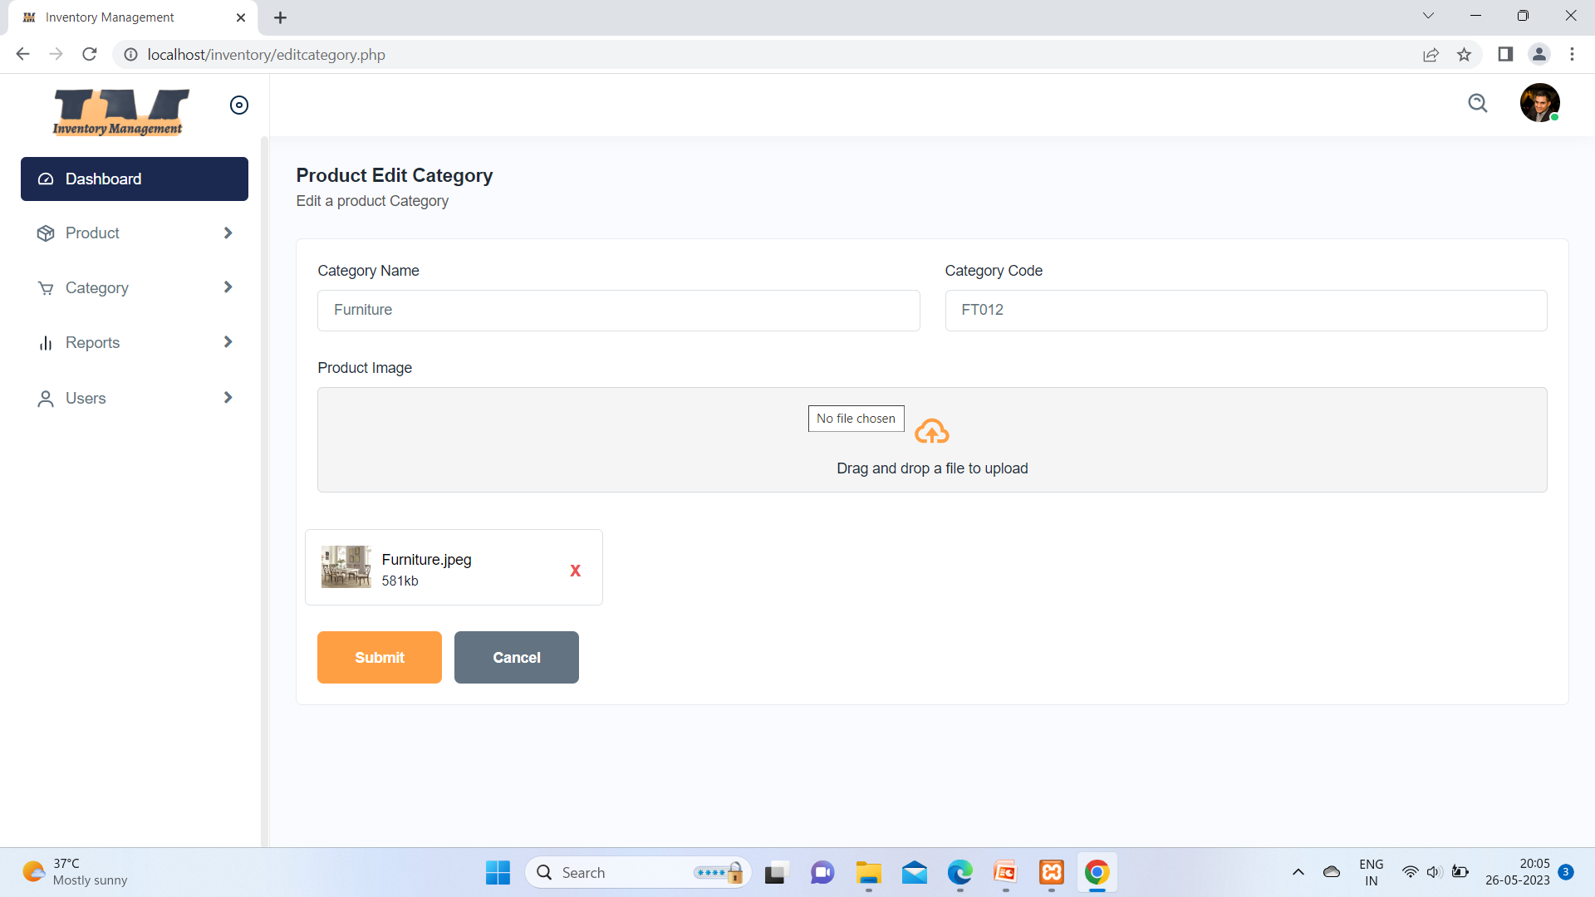

On the list page on Action field it has two buttons one for delete category and one for update when you click on update then pop up this above page will open and you can update catrgory,

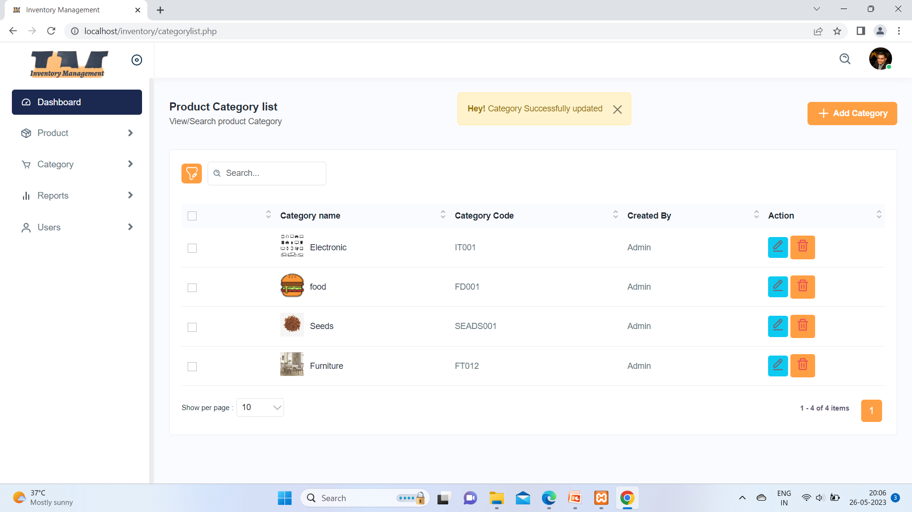

Here Category Updated message you can see.

8) Product Sub_Category Page:-

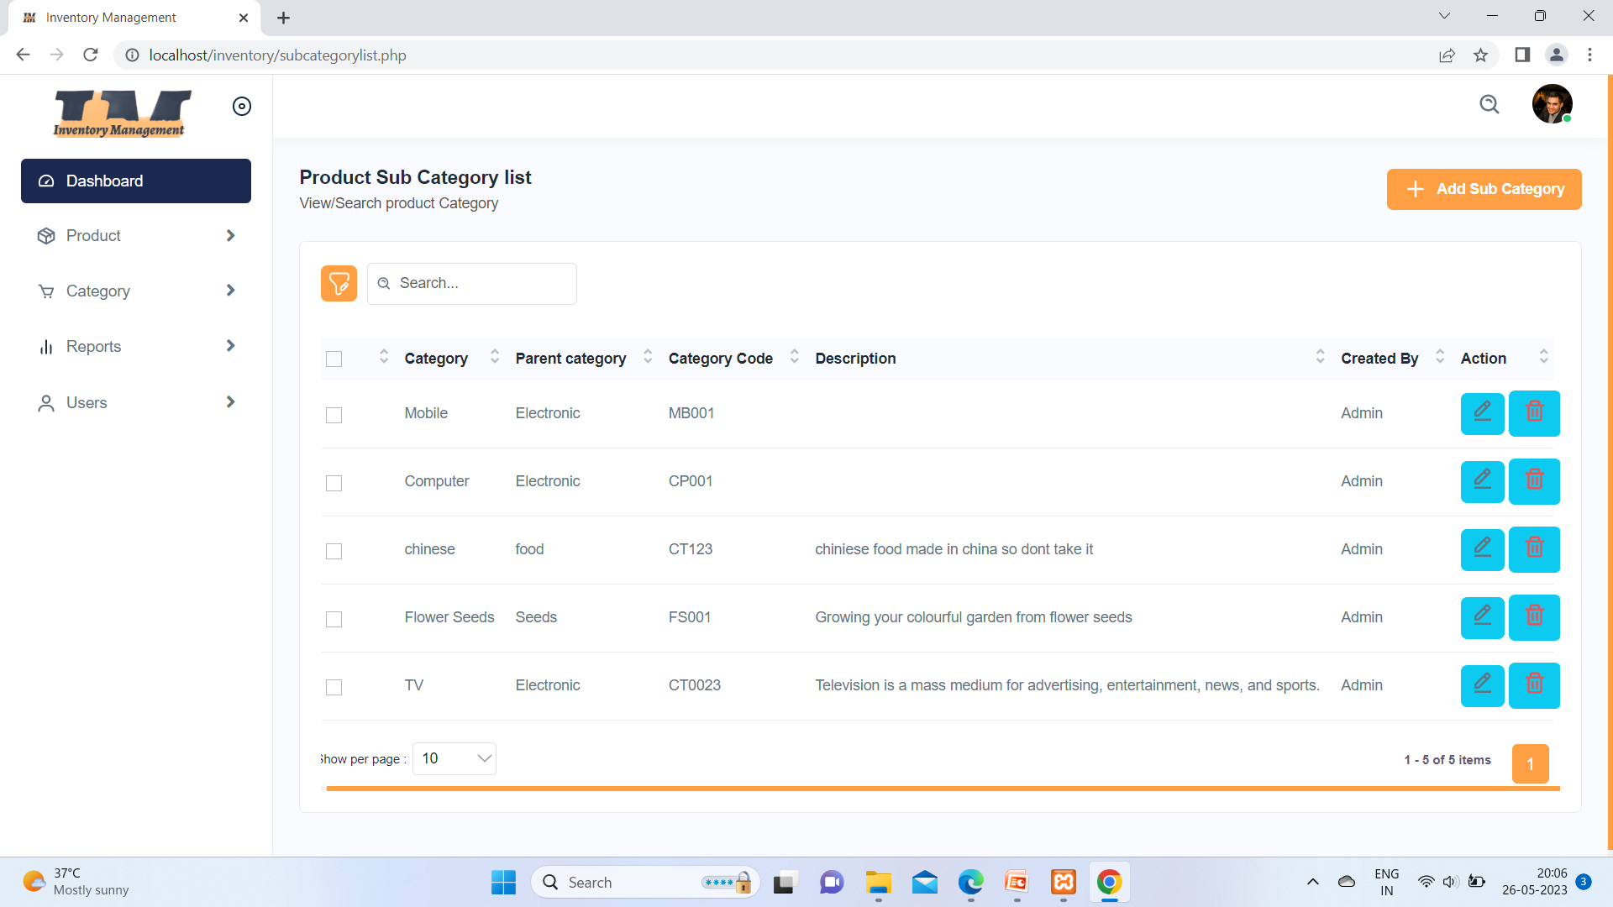

In this above image this is the Product subcategory list table and admin manage and also add sub category add from +Add subcategory button.

9 ) Insert Sub_Category Page:-

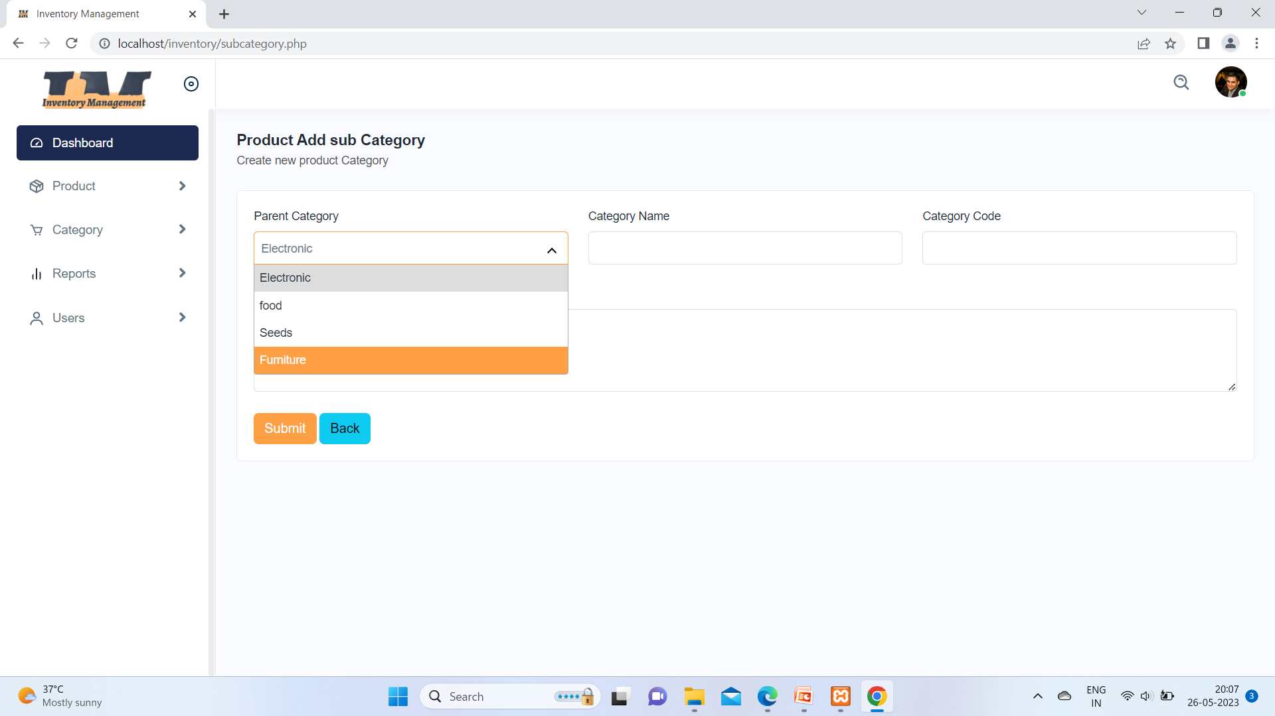

After clicking add button open above page.in this page fields such as, Parent Category name, subcategory name, subcategory code and Desc.

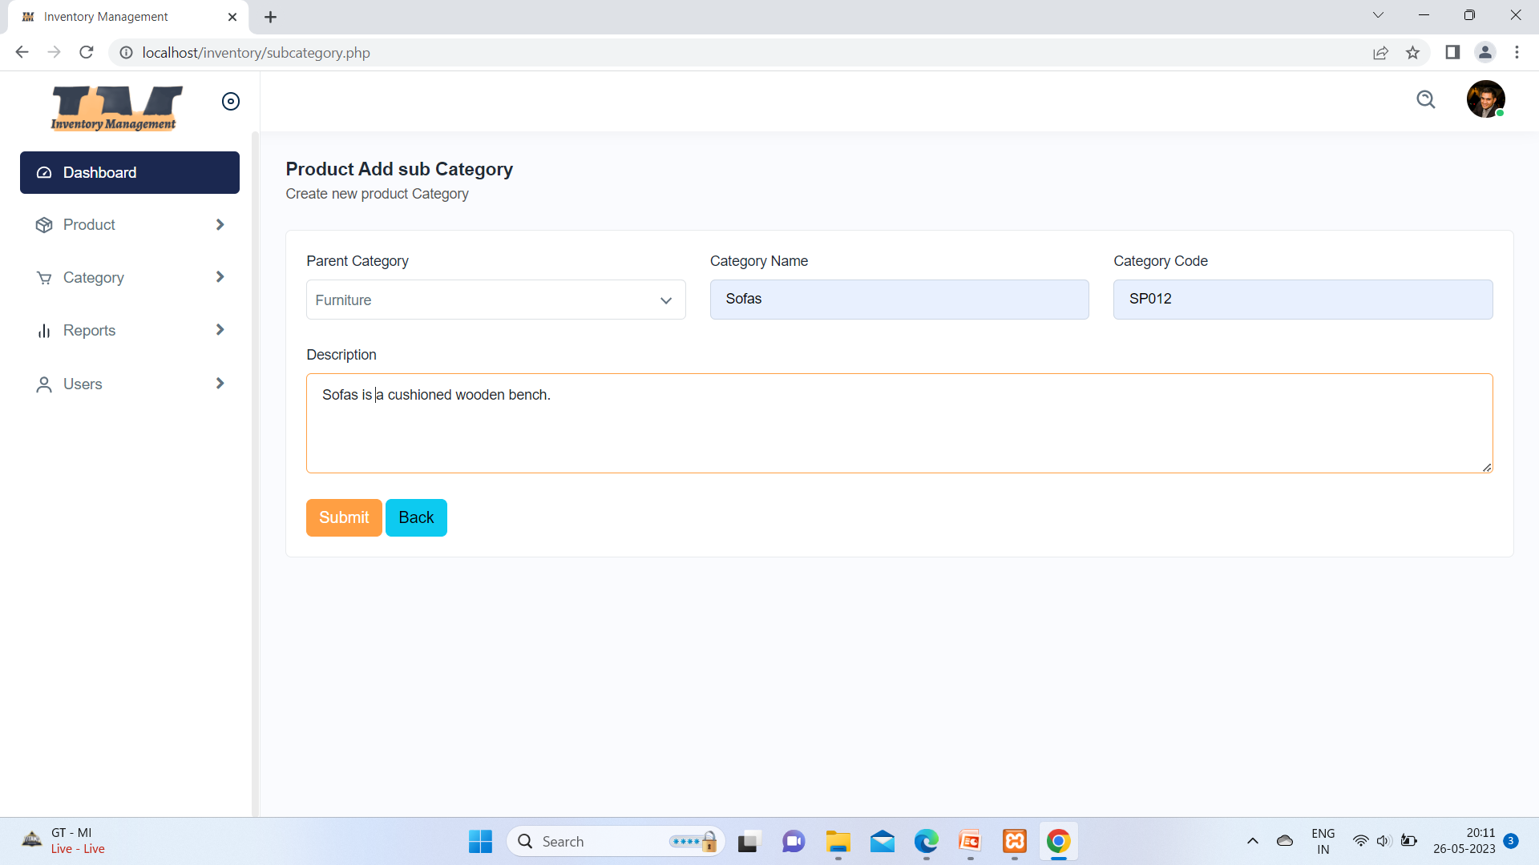

Parent category is dropdown button .it must required for insert sub category.

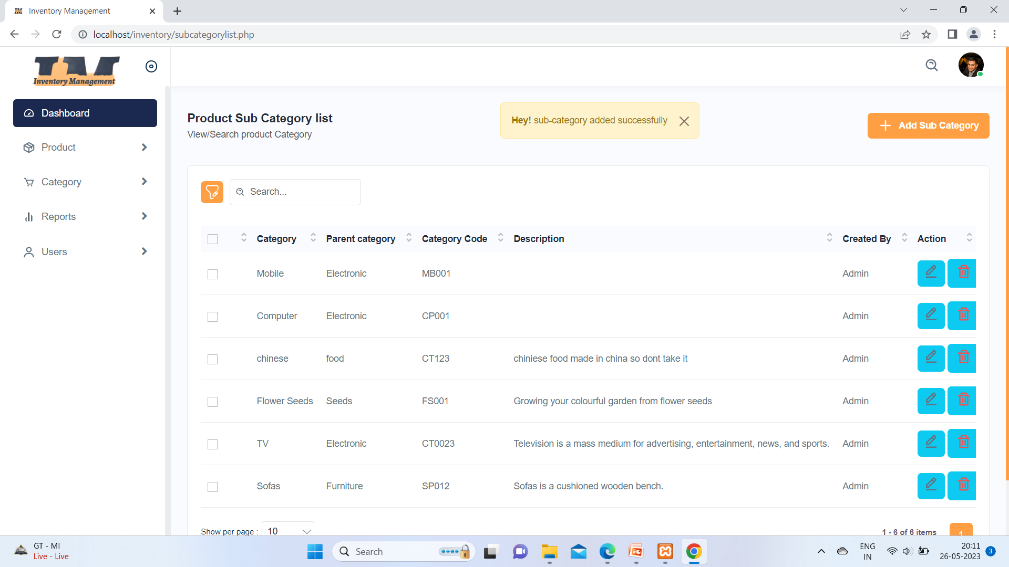

From above image its clear that sub category added successful.

10 ) Updating Sub_Category Page:-

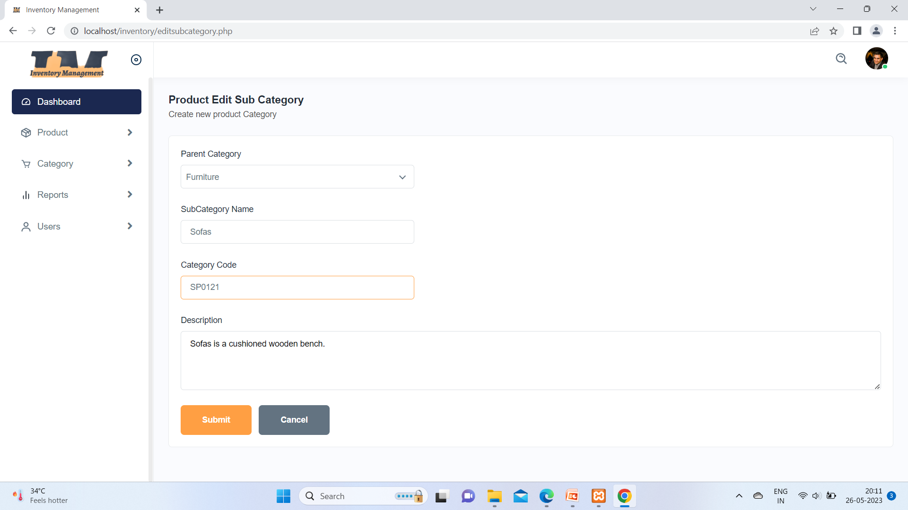

On the list page on Action field it has two buttons one for delete subcategory and one for update when you click on update then pop up this above page will open and you can update subcatrgory

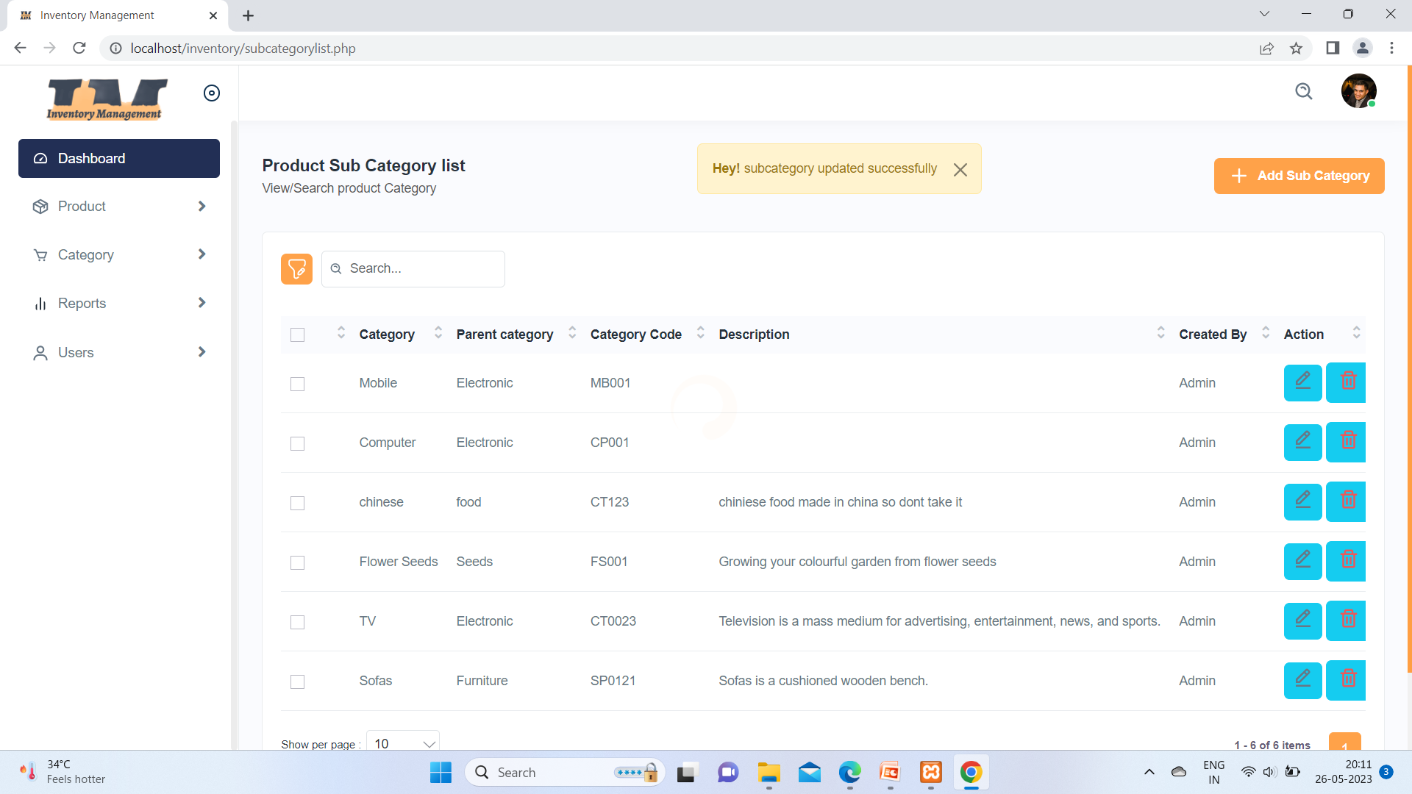

Here you can see sub category has updated and message is also displays.

11) Brand Page:-

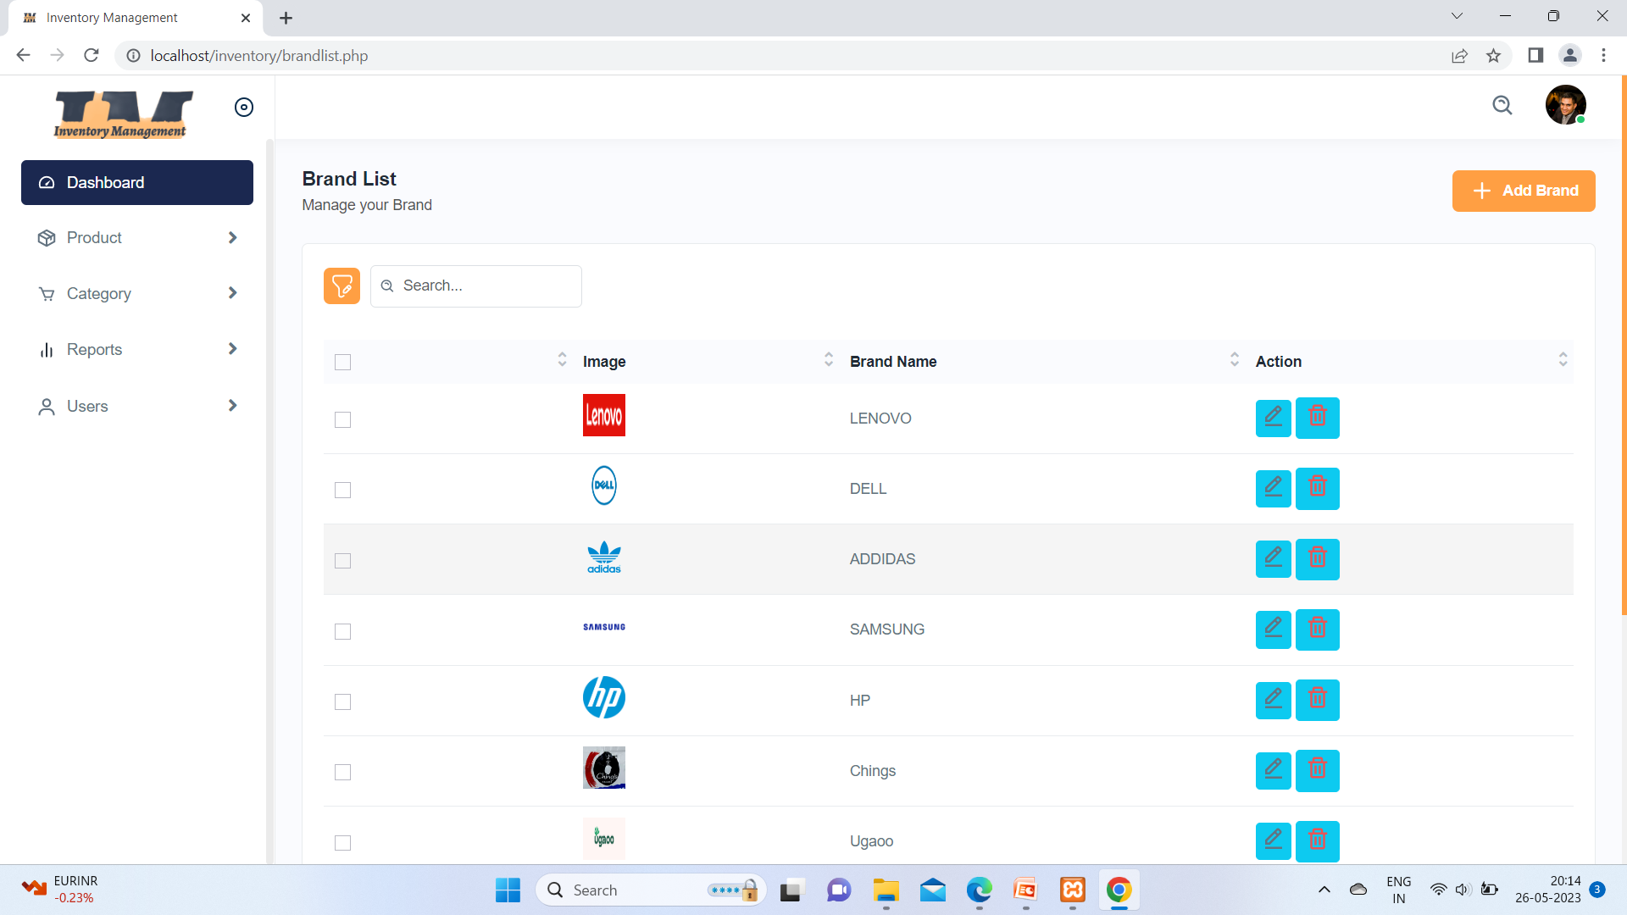

In this above image this is the Product Brand list table and admin manage and also add Brand from +Add Brand button.

12) Insert Brand Page:-

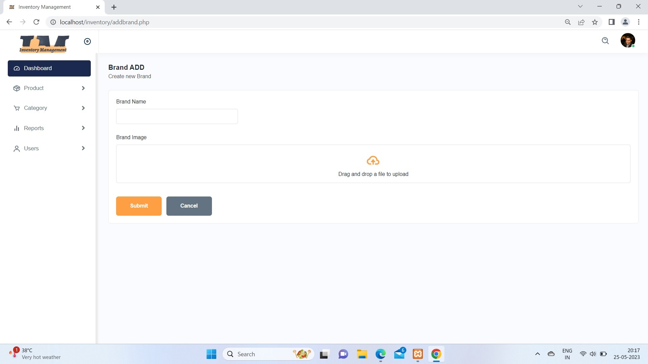

After clicking add button open above page.in this page fields such as Brand name and Image.

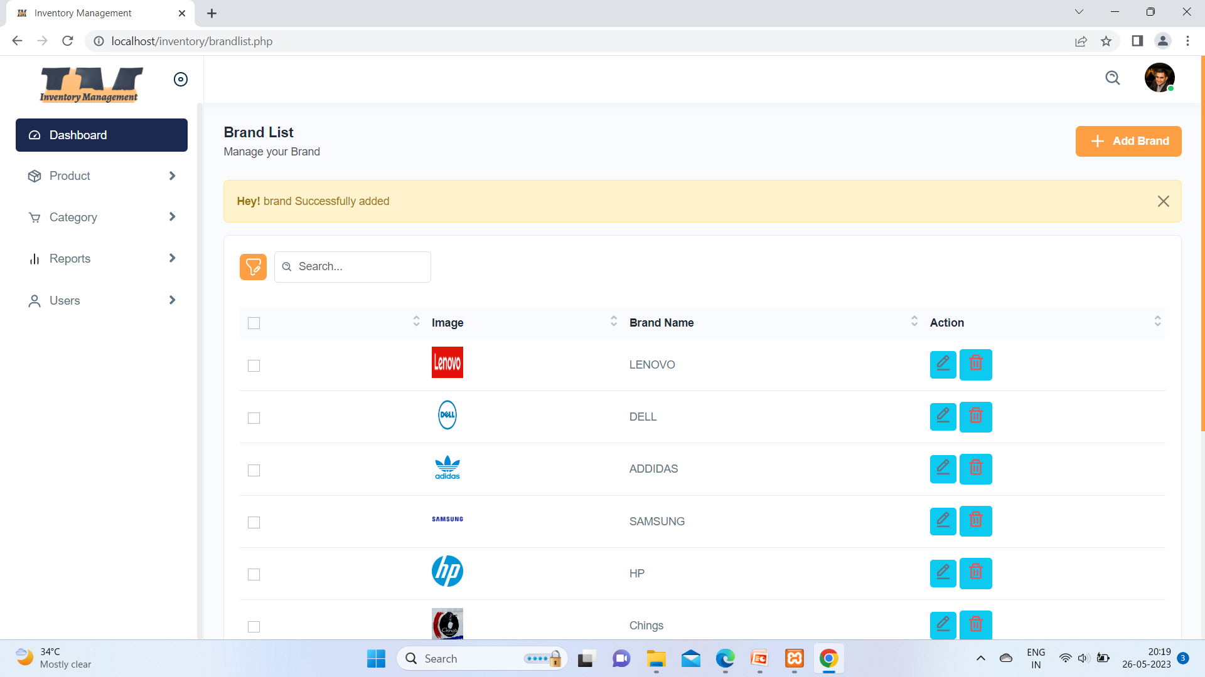

Here you can see brand has successful added.

13) Product Page:-

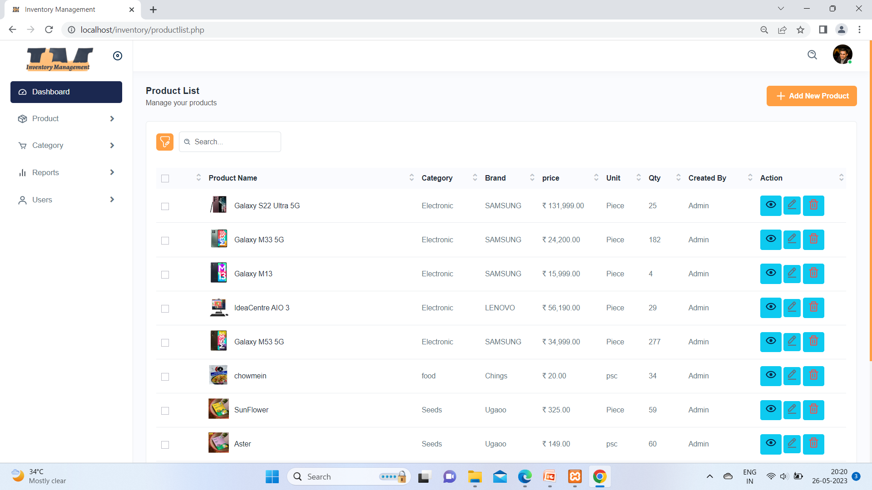

In this above image this is the Product list table and admin manage and also product add from +Add subcategory button.

14) Add Product Page:-

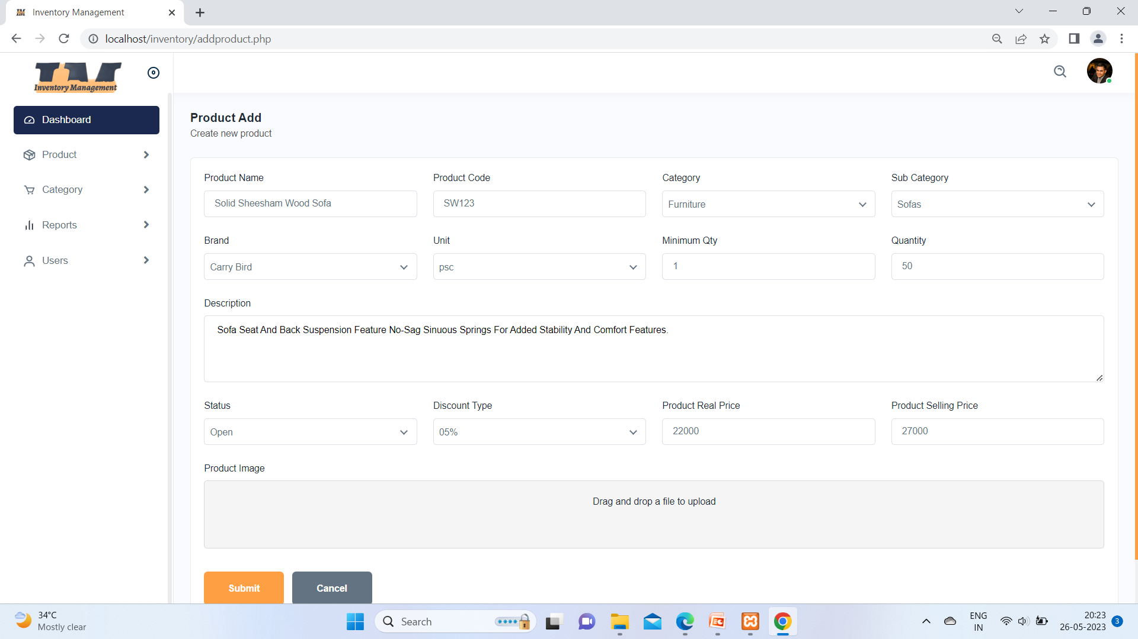

After clicking add button open above page.in this page so many fields such as, Parent Category , Parent subCategory,and Brand most important

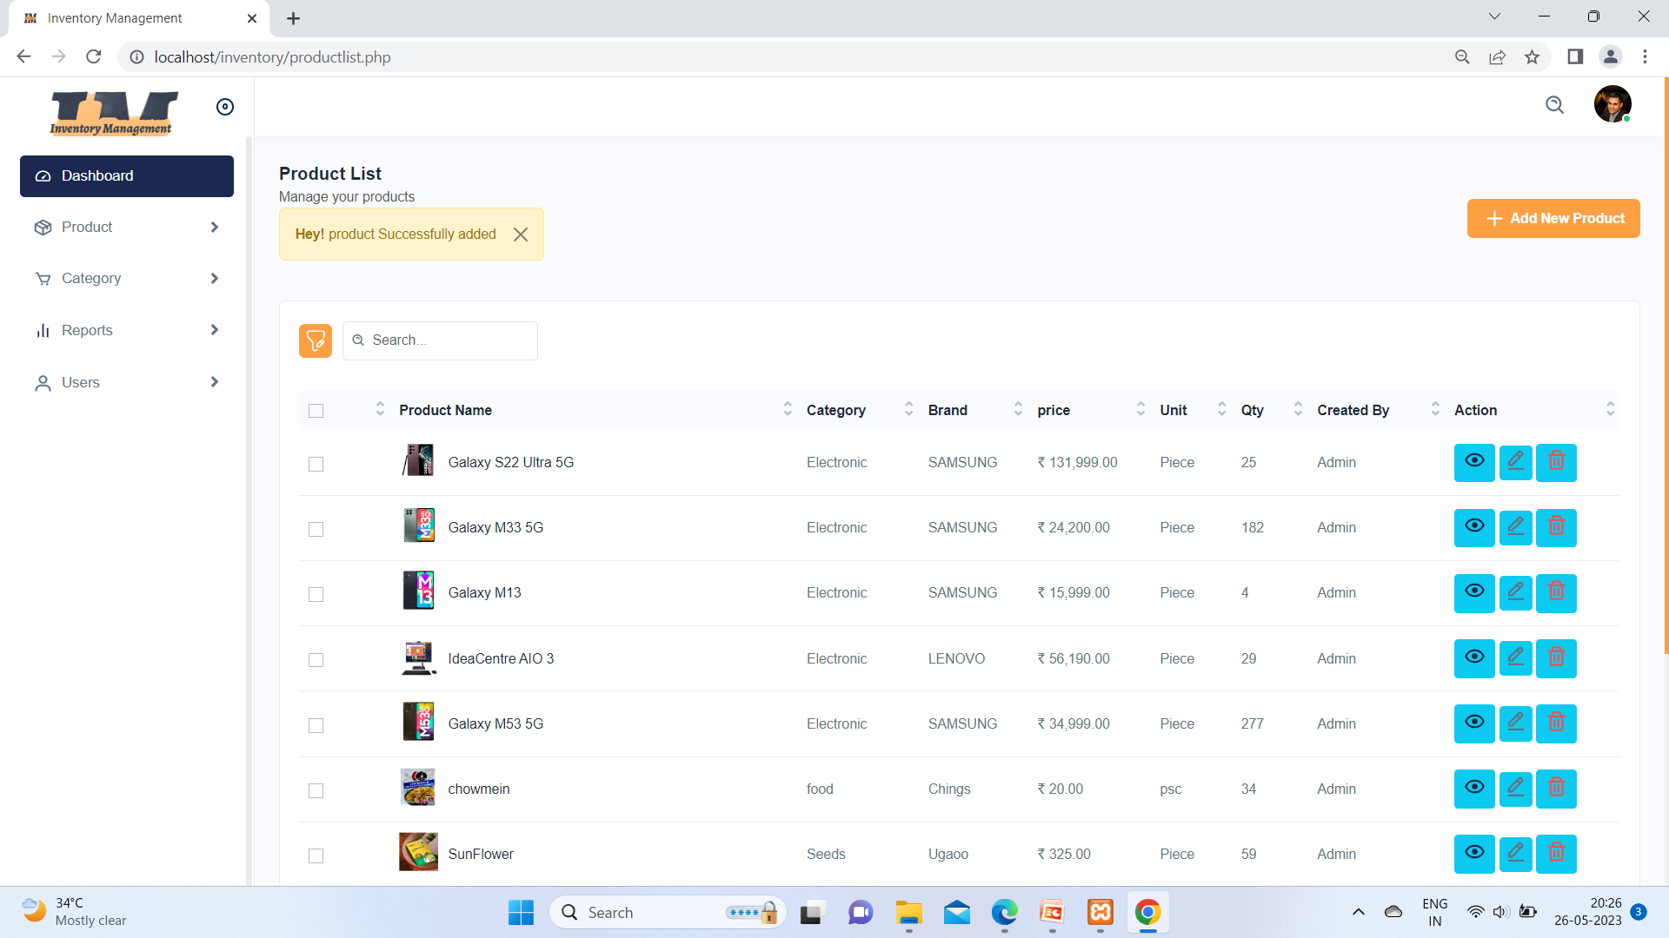

Here product added successful

15) Updating Product Page:-

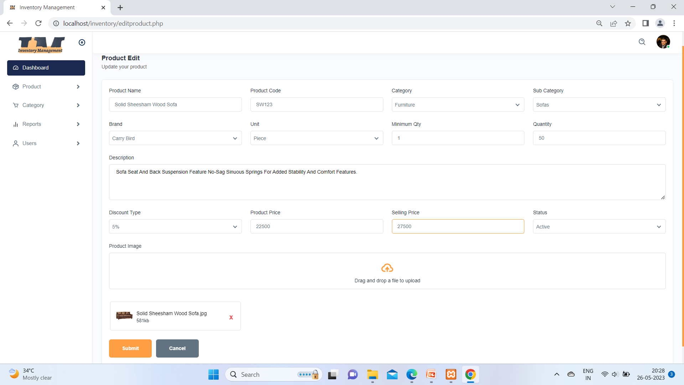

Above image admin updating selling price

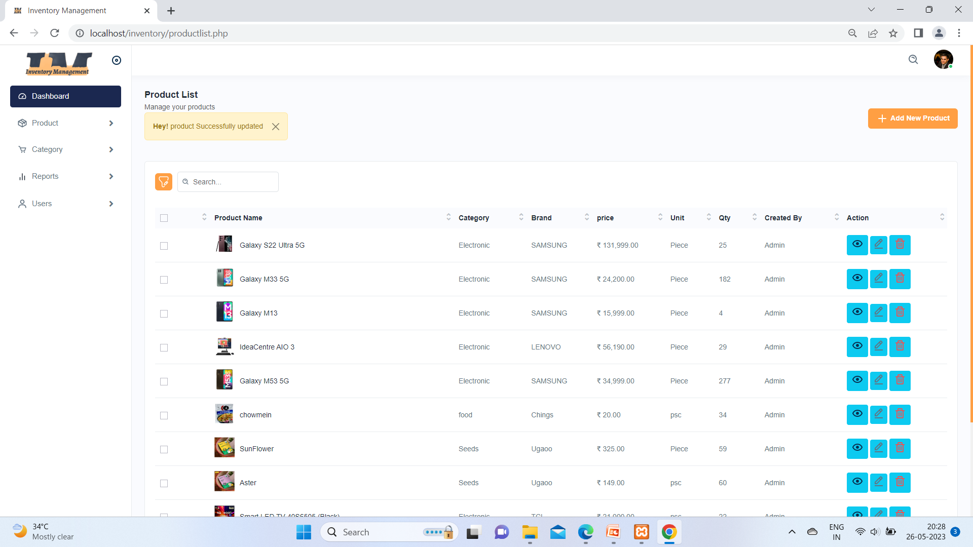

After clicking submit button your product will updated. Message display like product successful updated.

16) View Product page:-

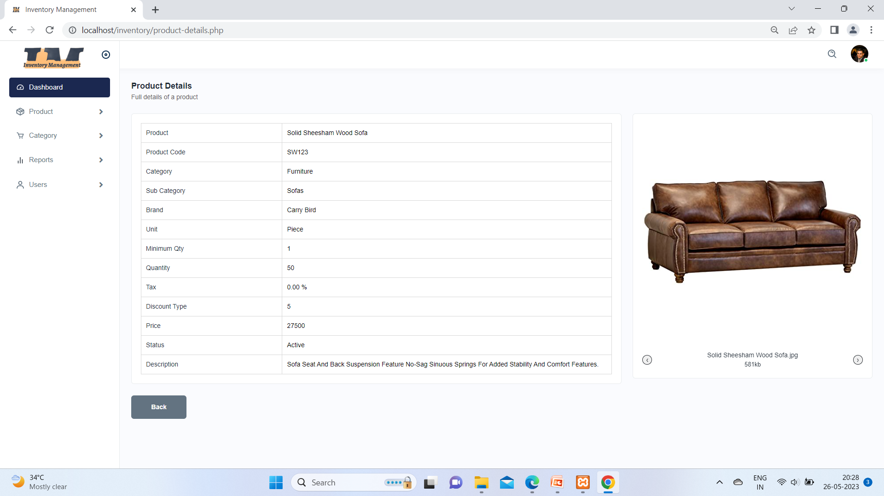

View action button at product list and you can see product from that action click button. Only you can read id . you can not change it .

17) Product Report:-

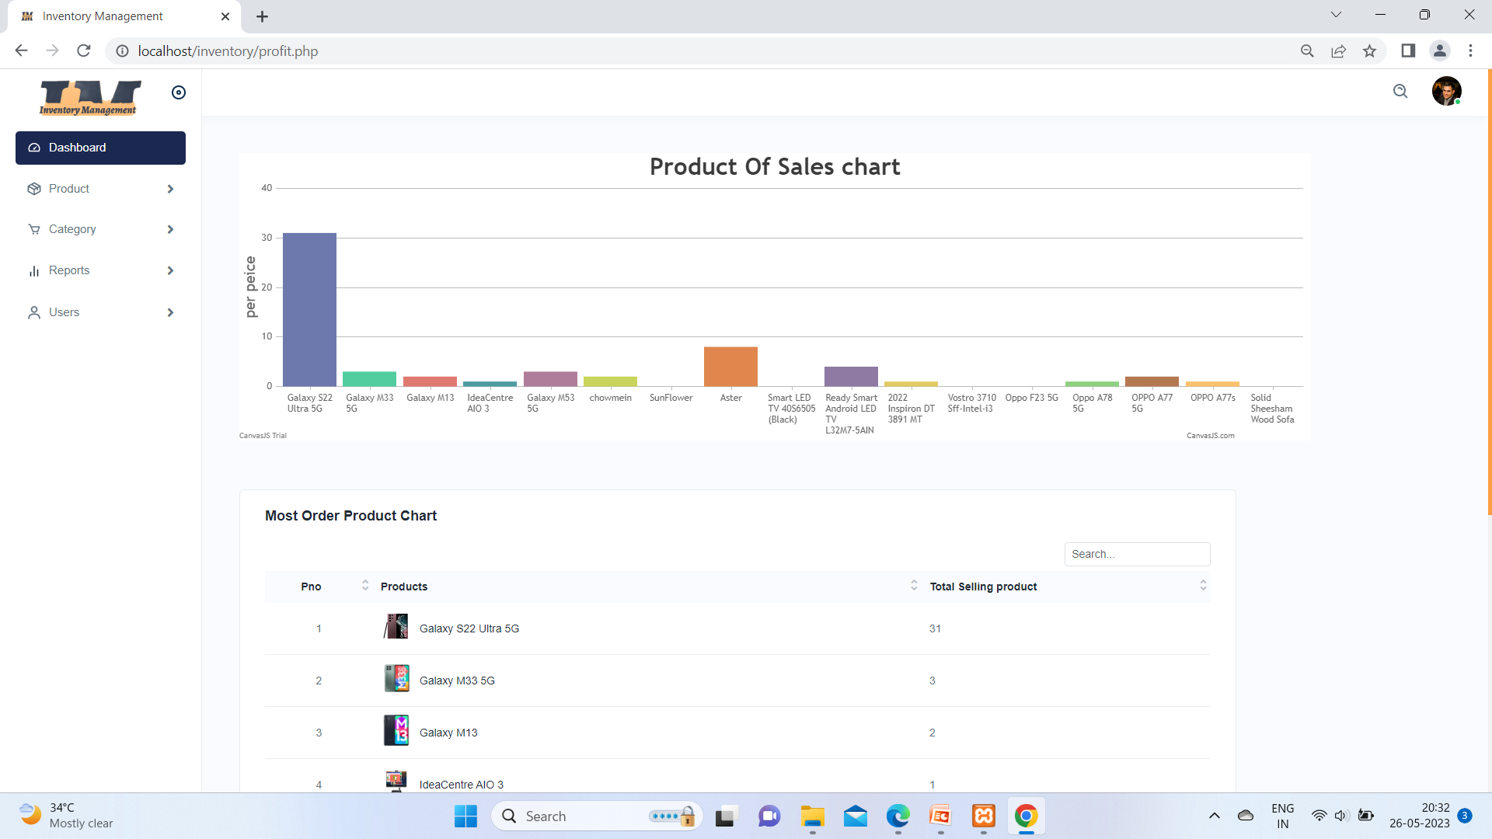

The give image represents Product sales chart .

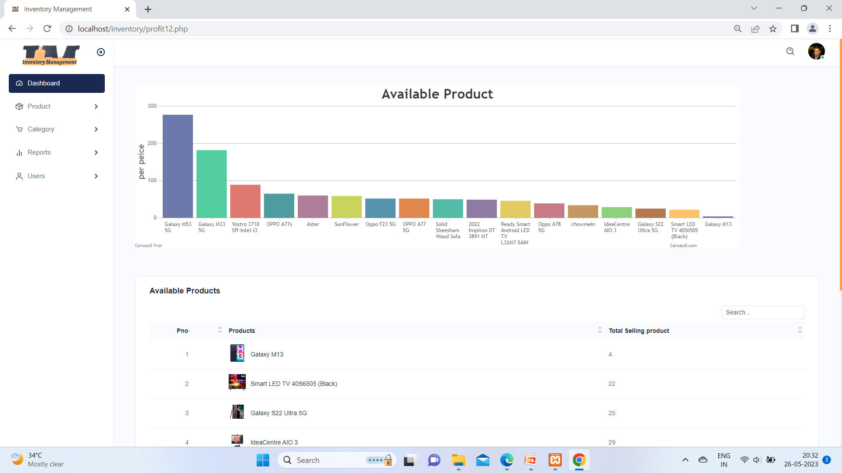

Here this chart is illustrates how many product we have and it is var chart essay understand. And shows table of product under chart.

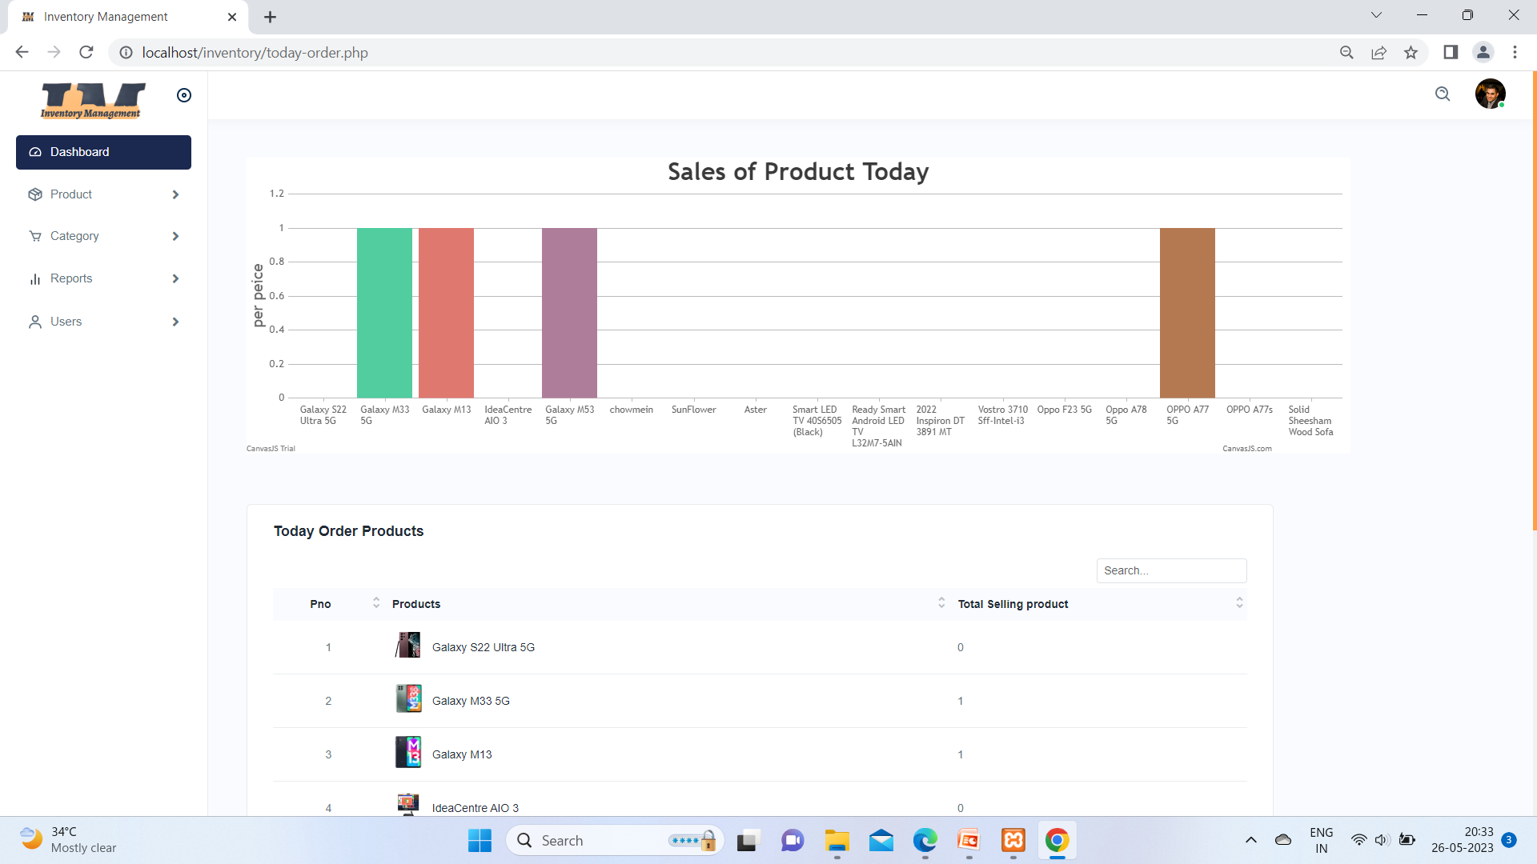

This chart shows on today sale of product. And also table

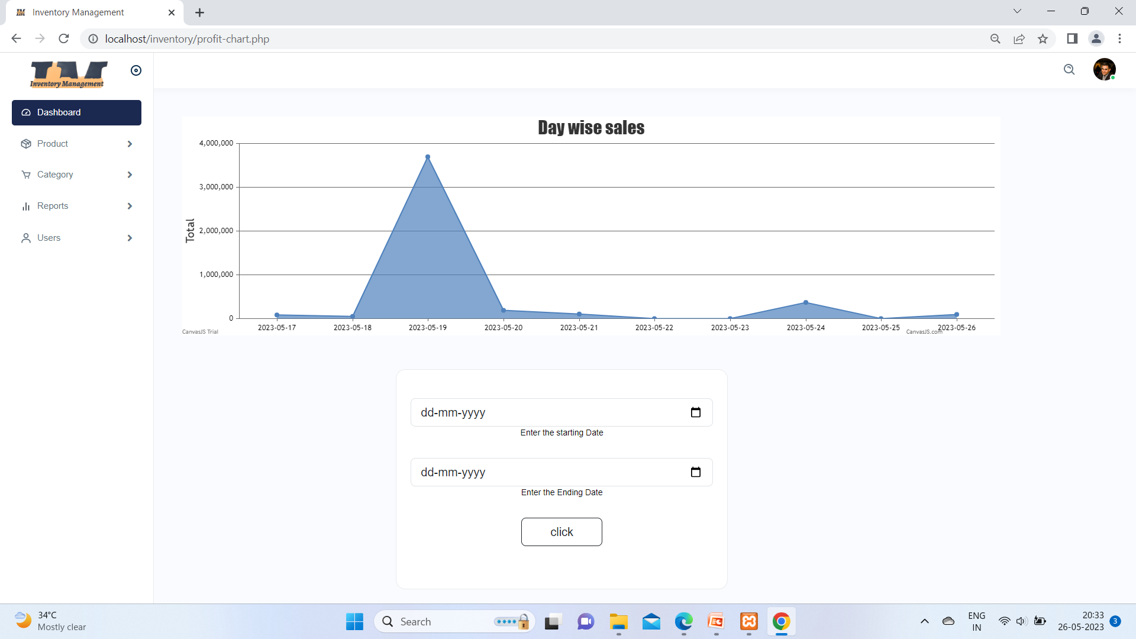

This line graph shows about day wise sales in inventory management and also you can select date from user that form.

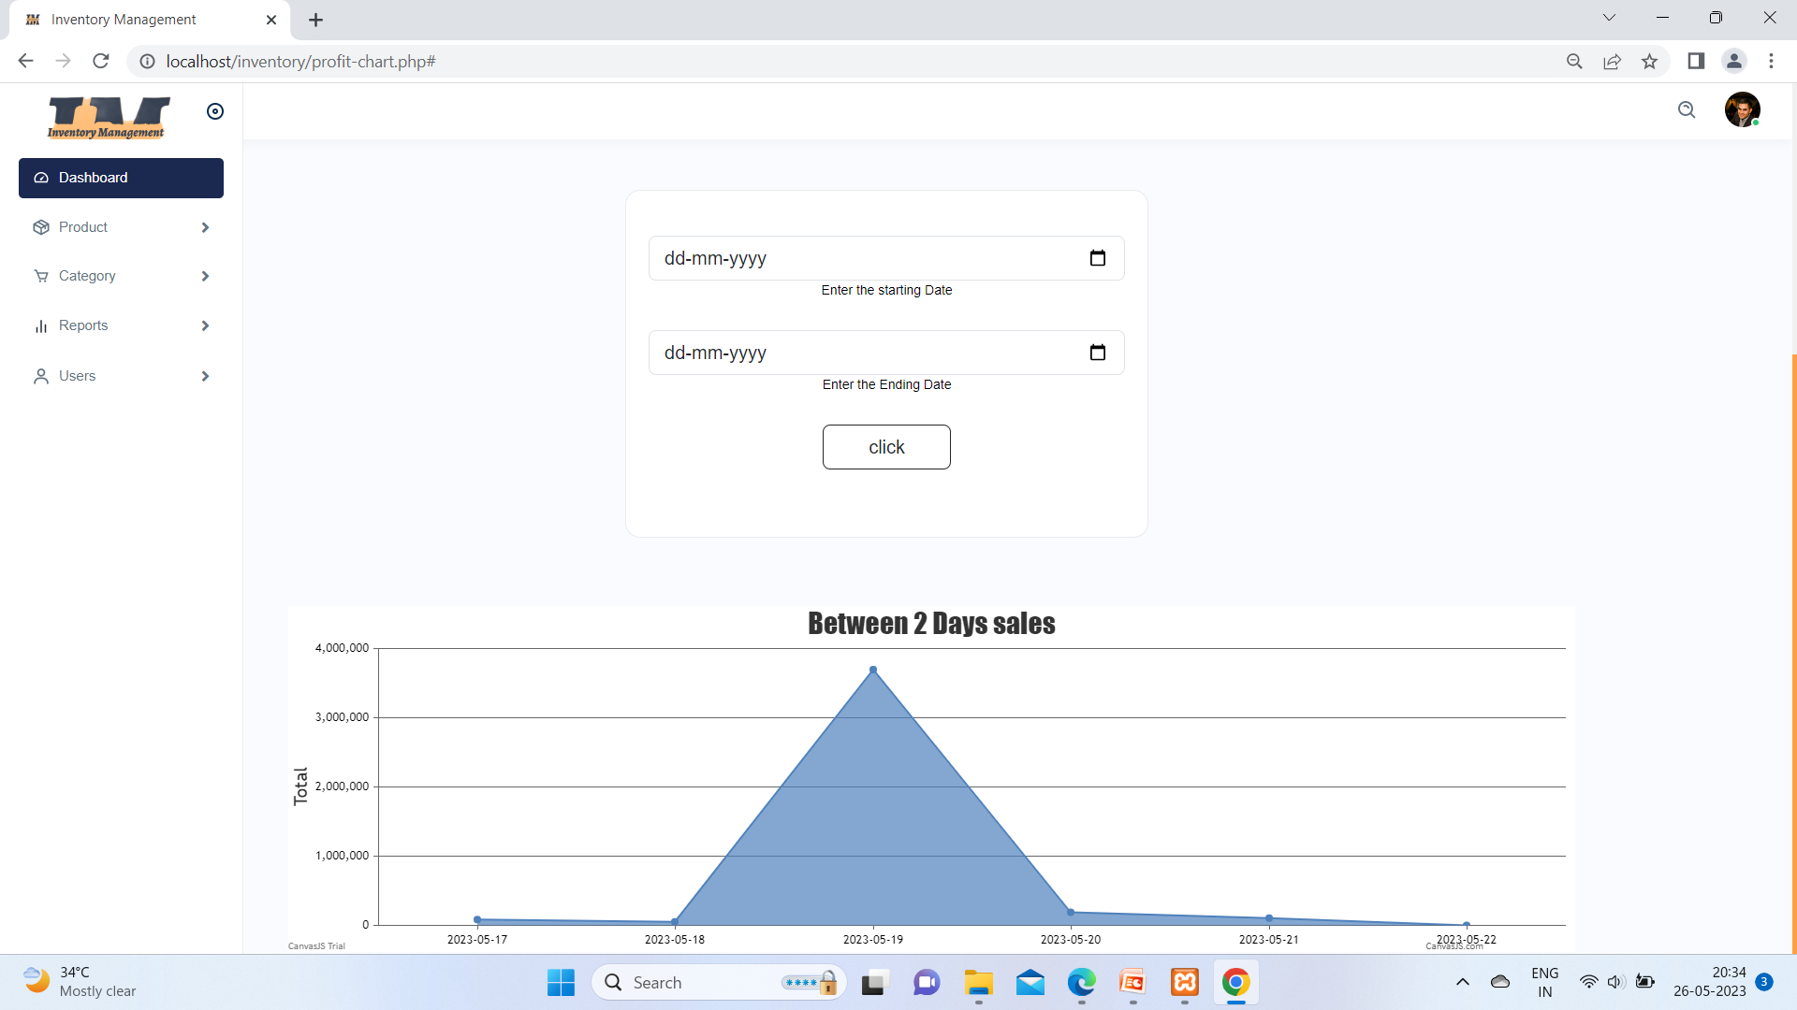

This chart shows between two days how many sold out product.

18)User List Page:-

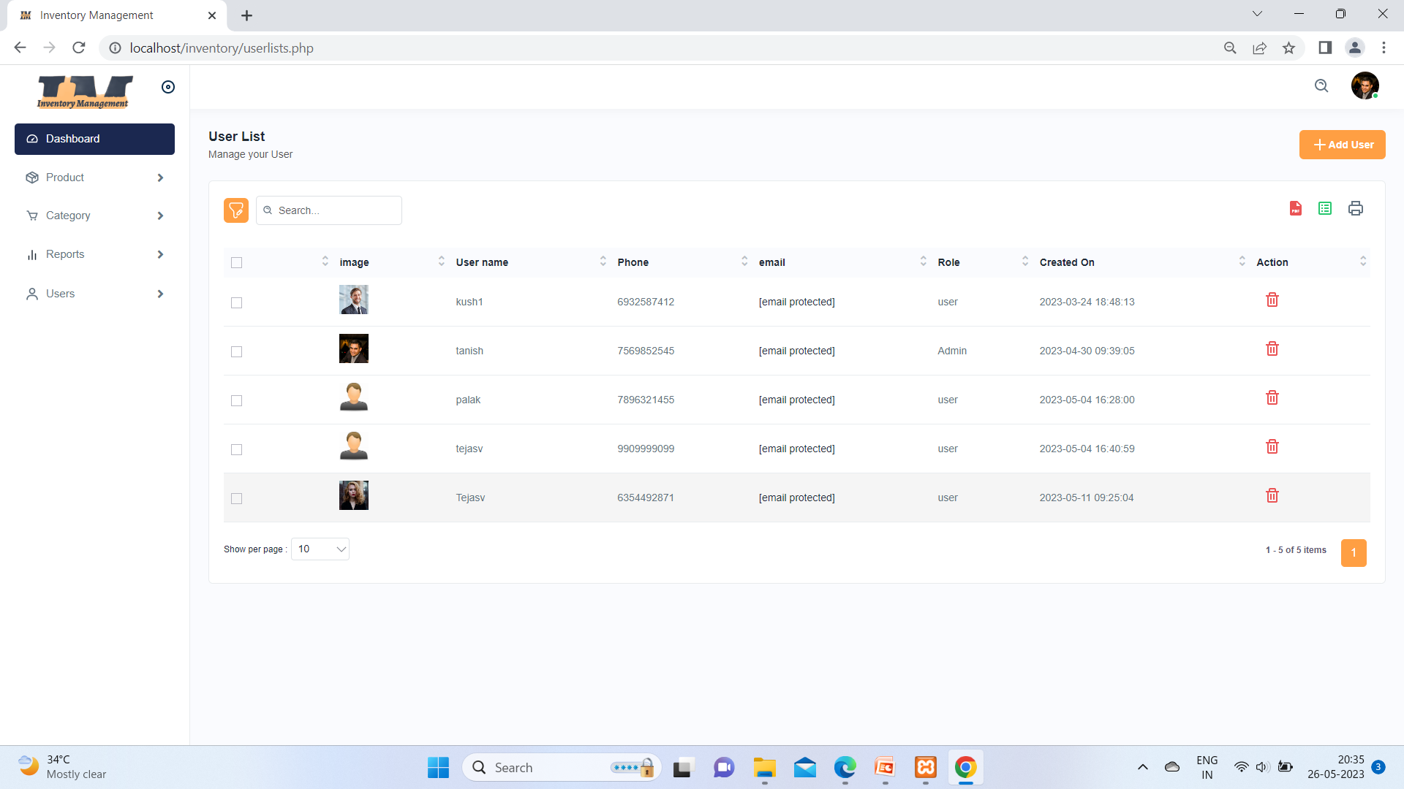

User has to managed by admin from this page and also admin can delete user

19) Add User/Admin page:-

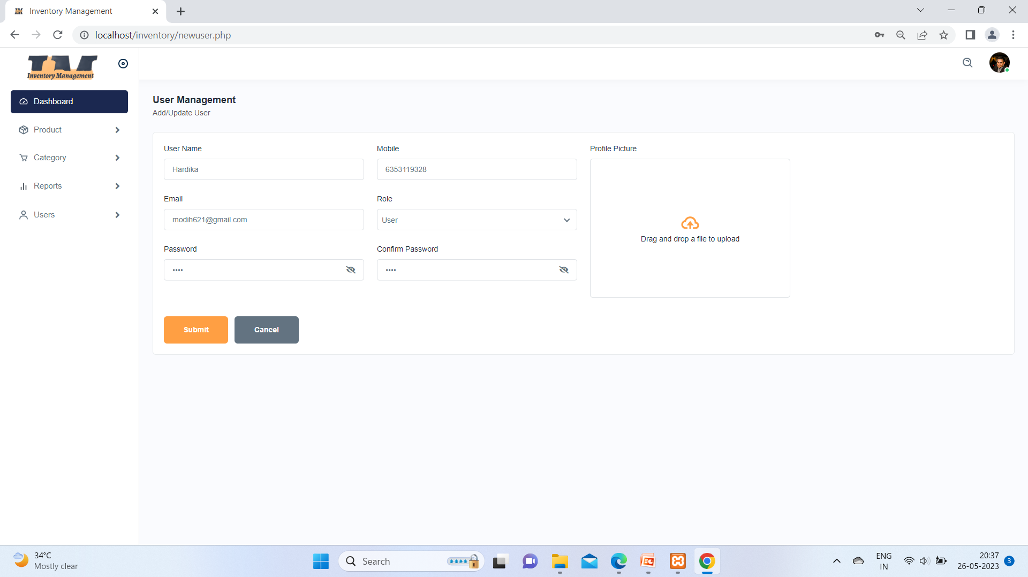

From here to admin can add a new user from this page.

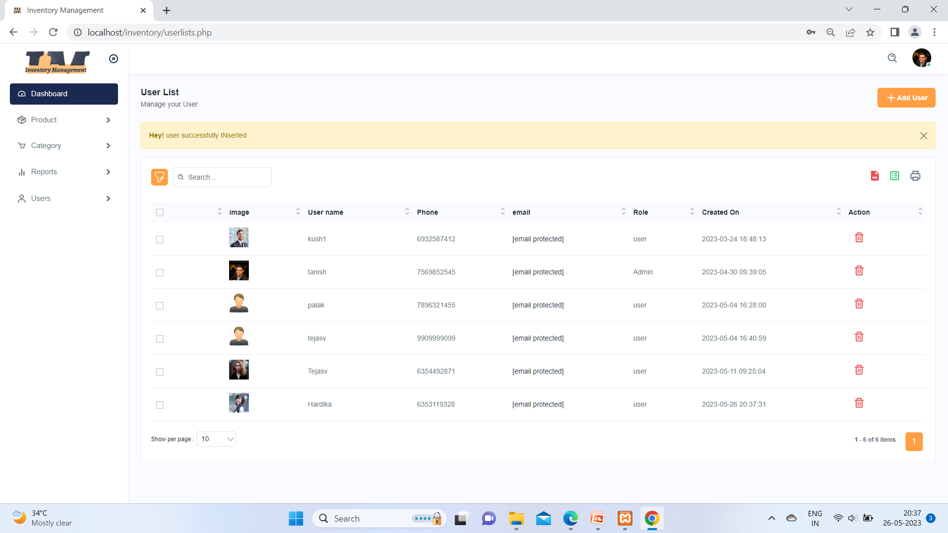

Here you can see number of users and admin added one user is seen from above message.

**4.1.2: User Module**

1. Index Page:-

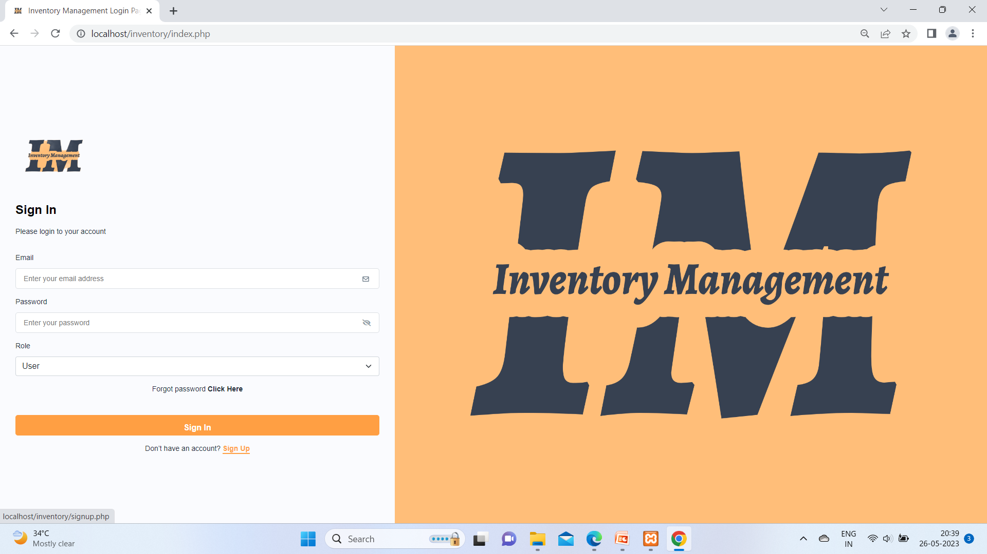

This page is index page when user came in our website its show this page first time . if the user has account then he can login other wise click on sign up.

1. Sign-Up Page:-

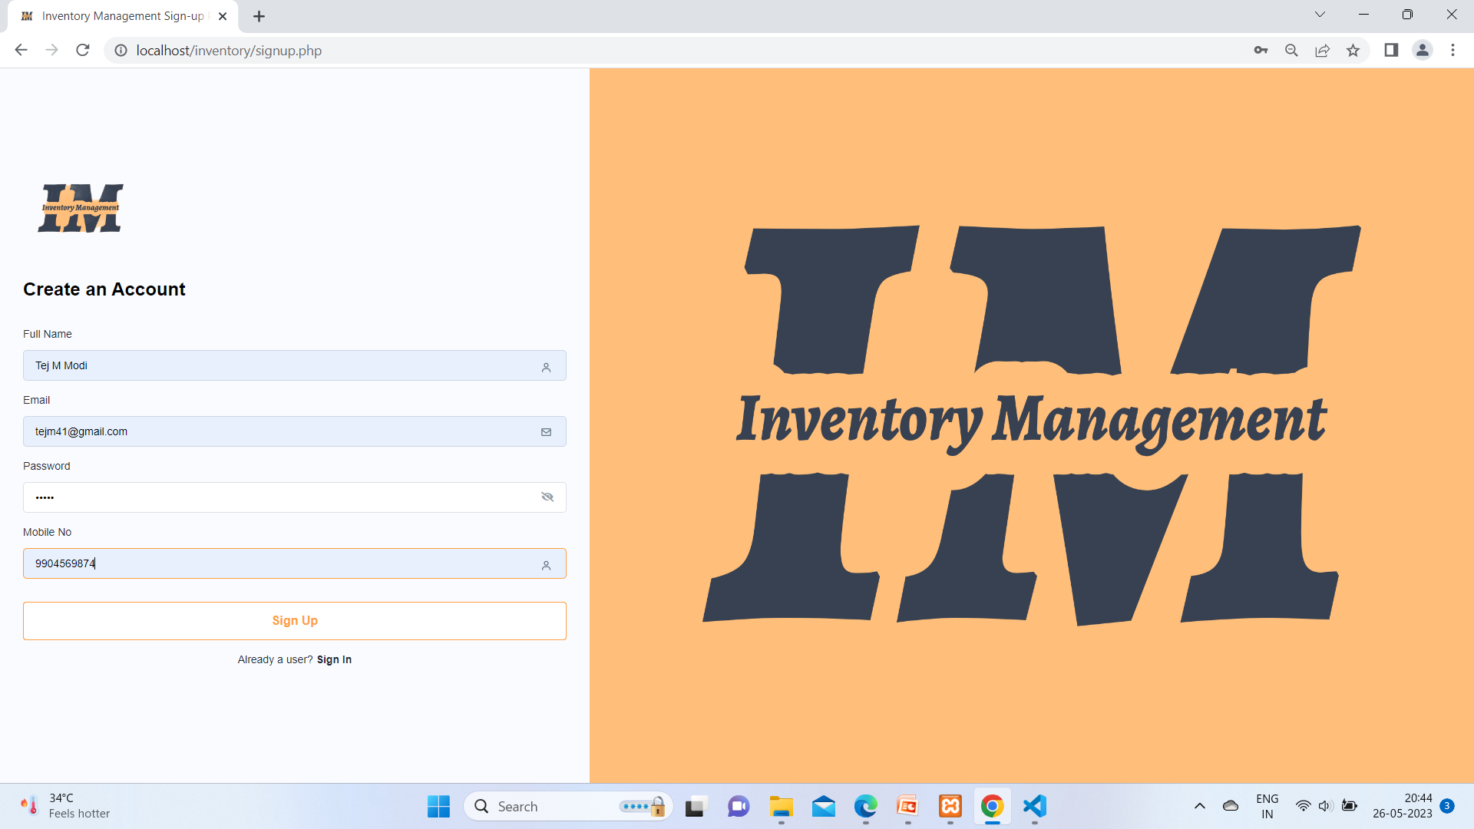

Above image represents user is signing up or we can say in other way creating new account.

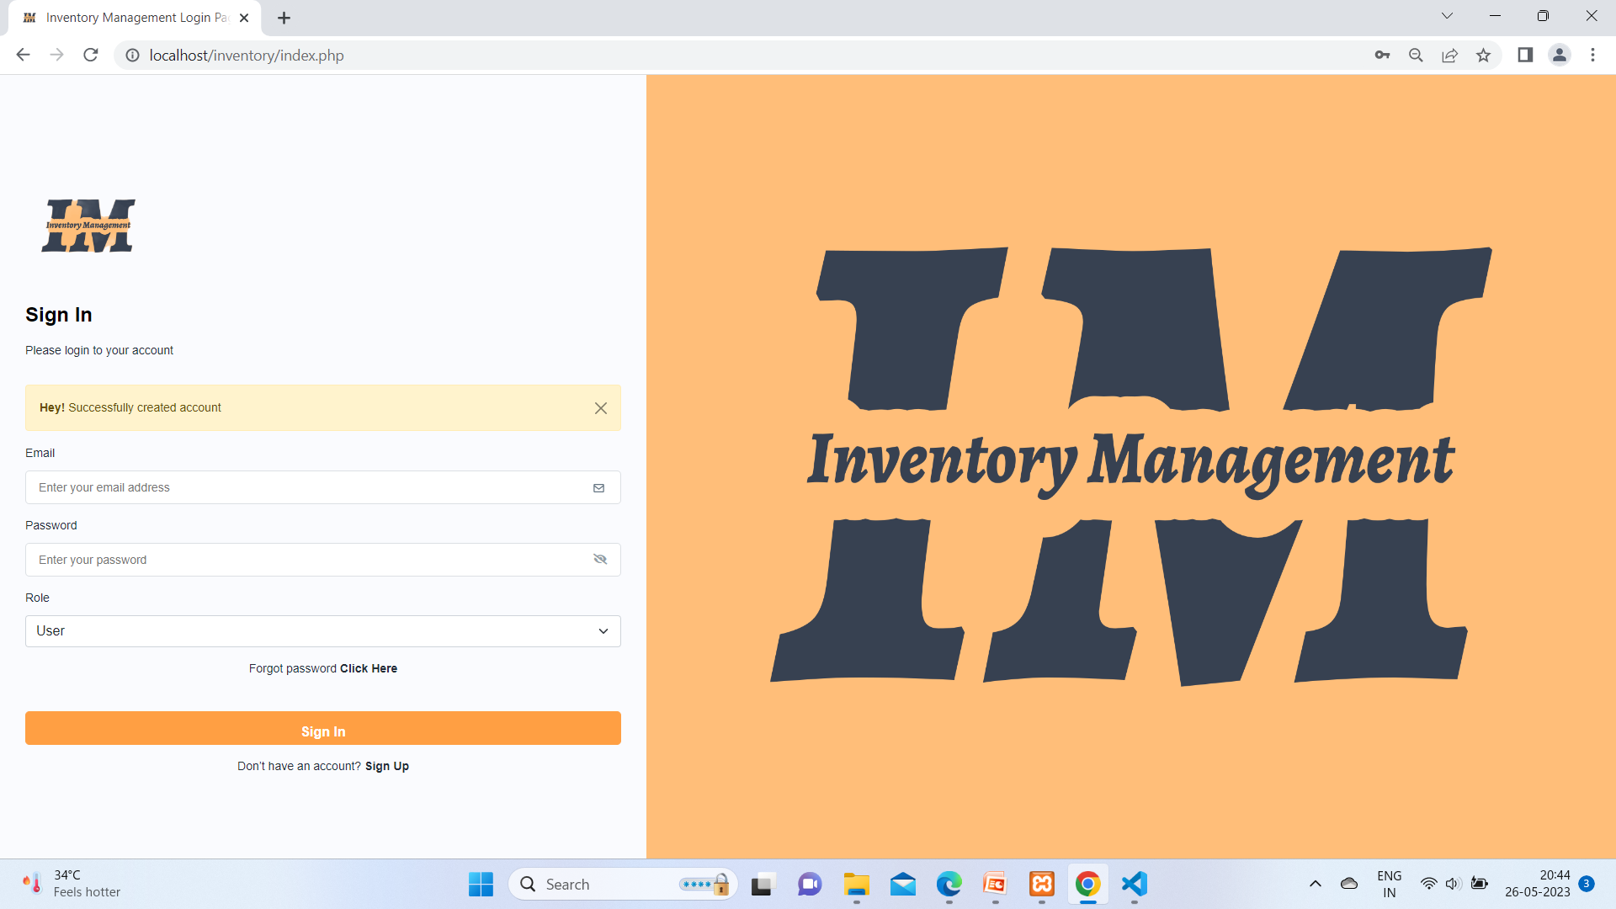

Successful created account message pop up and when you account create you go at index page and login form here

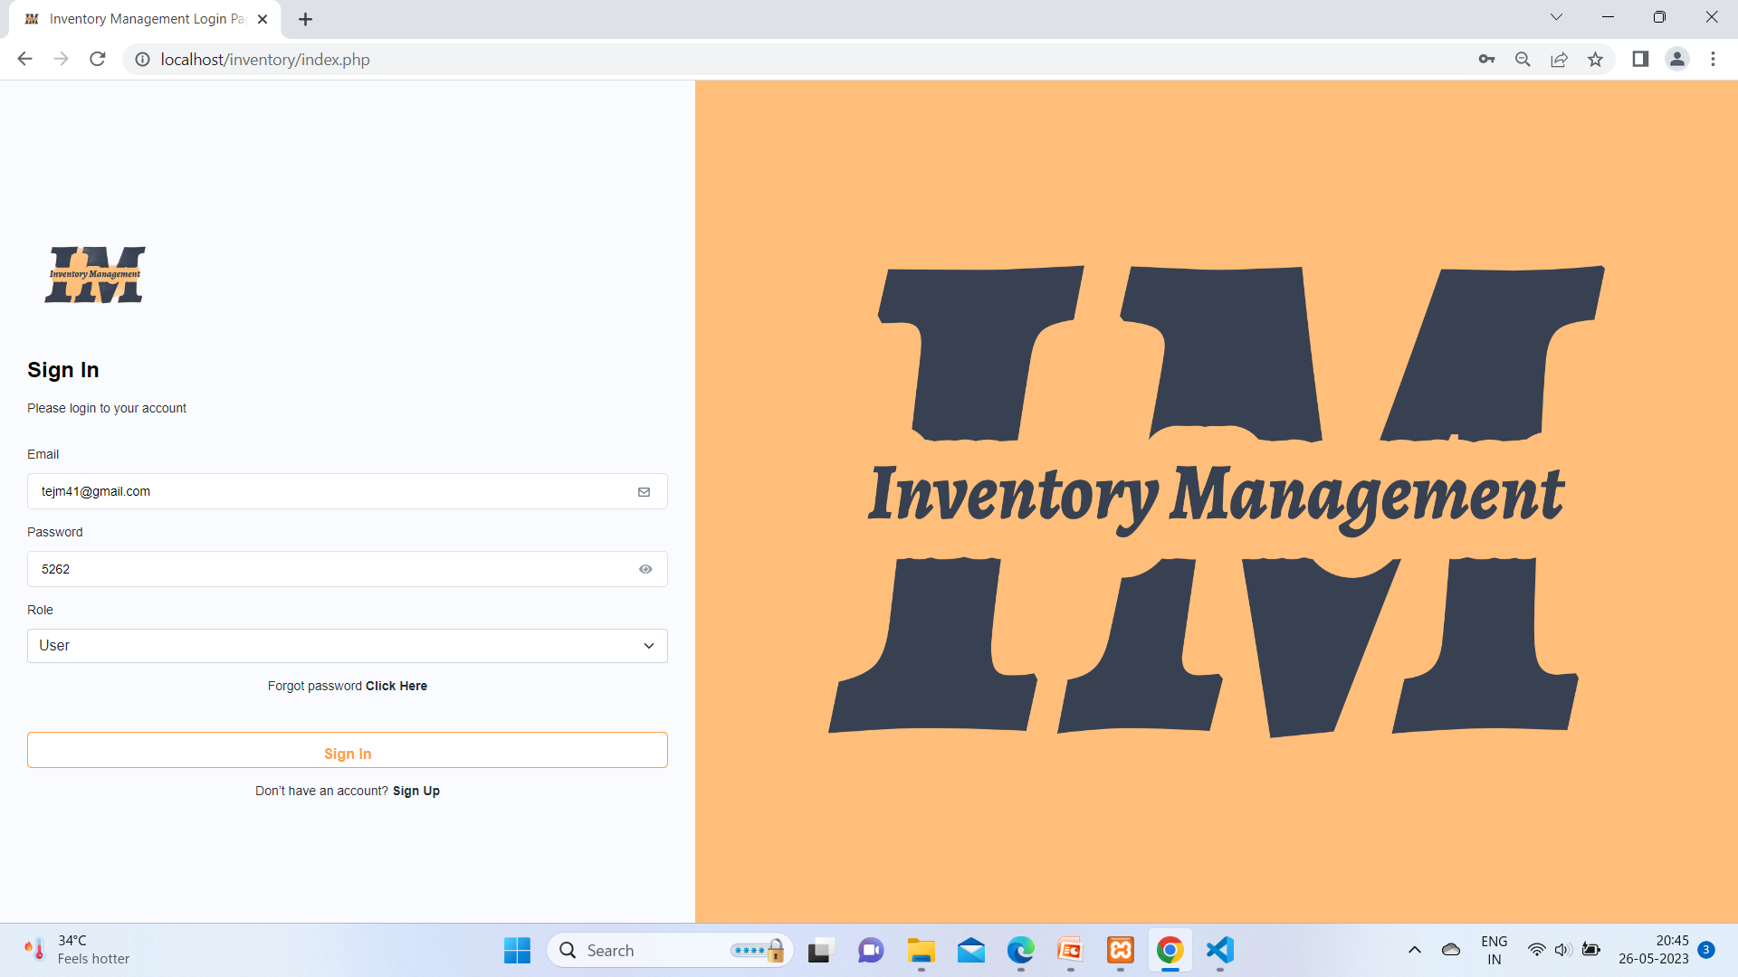

user fill the form and click on sign in button.

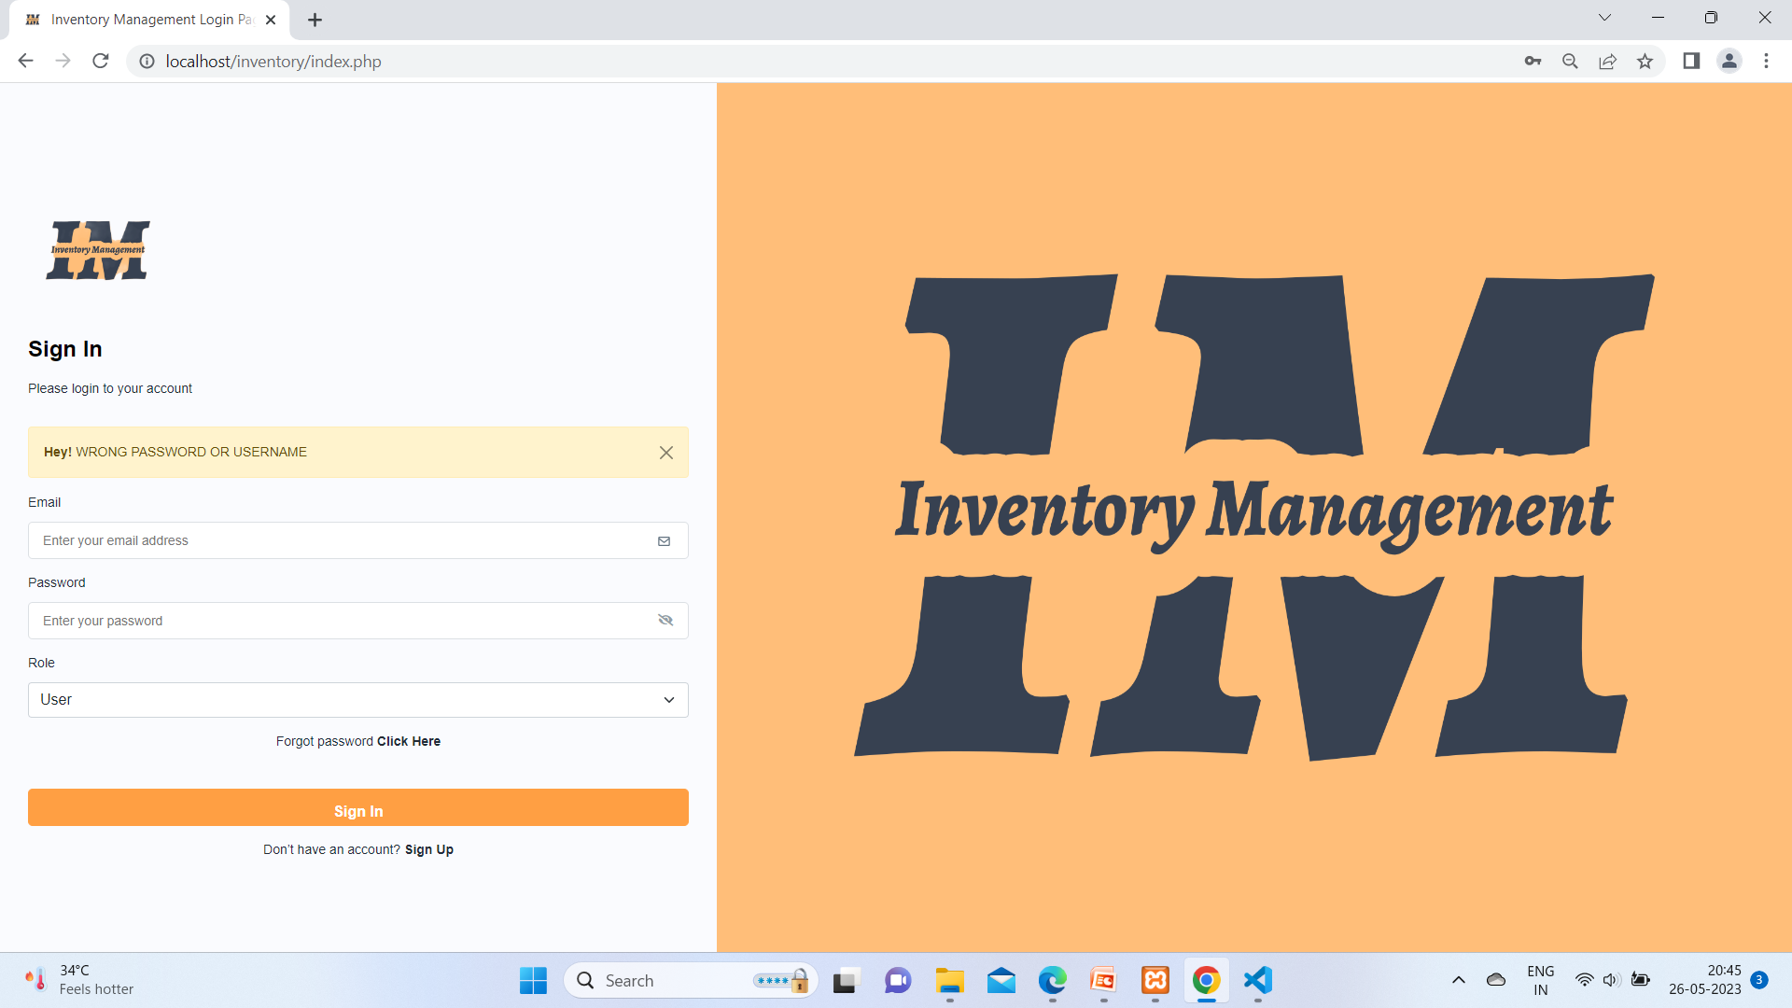

But here Password is wrong and your data will removed from text box you have to fill form again.

1. Forgot Password:-

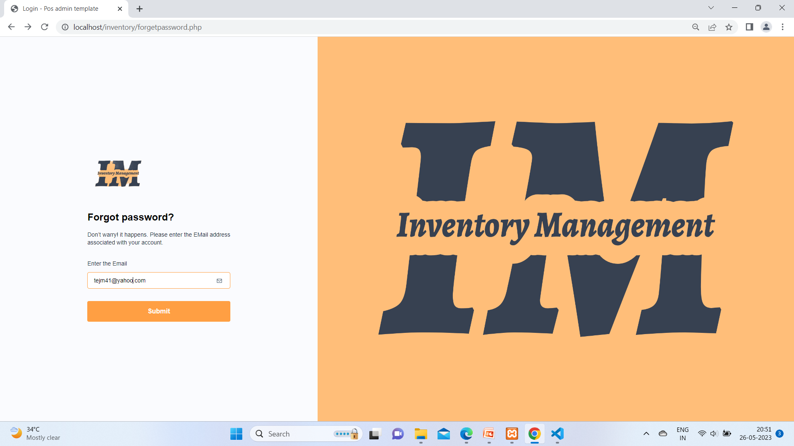

When user click forgot password. Here write email and submit it.

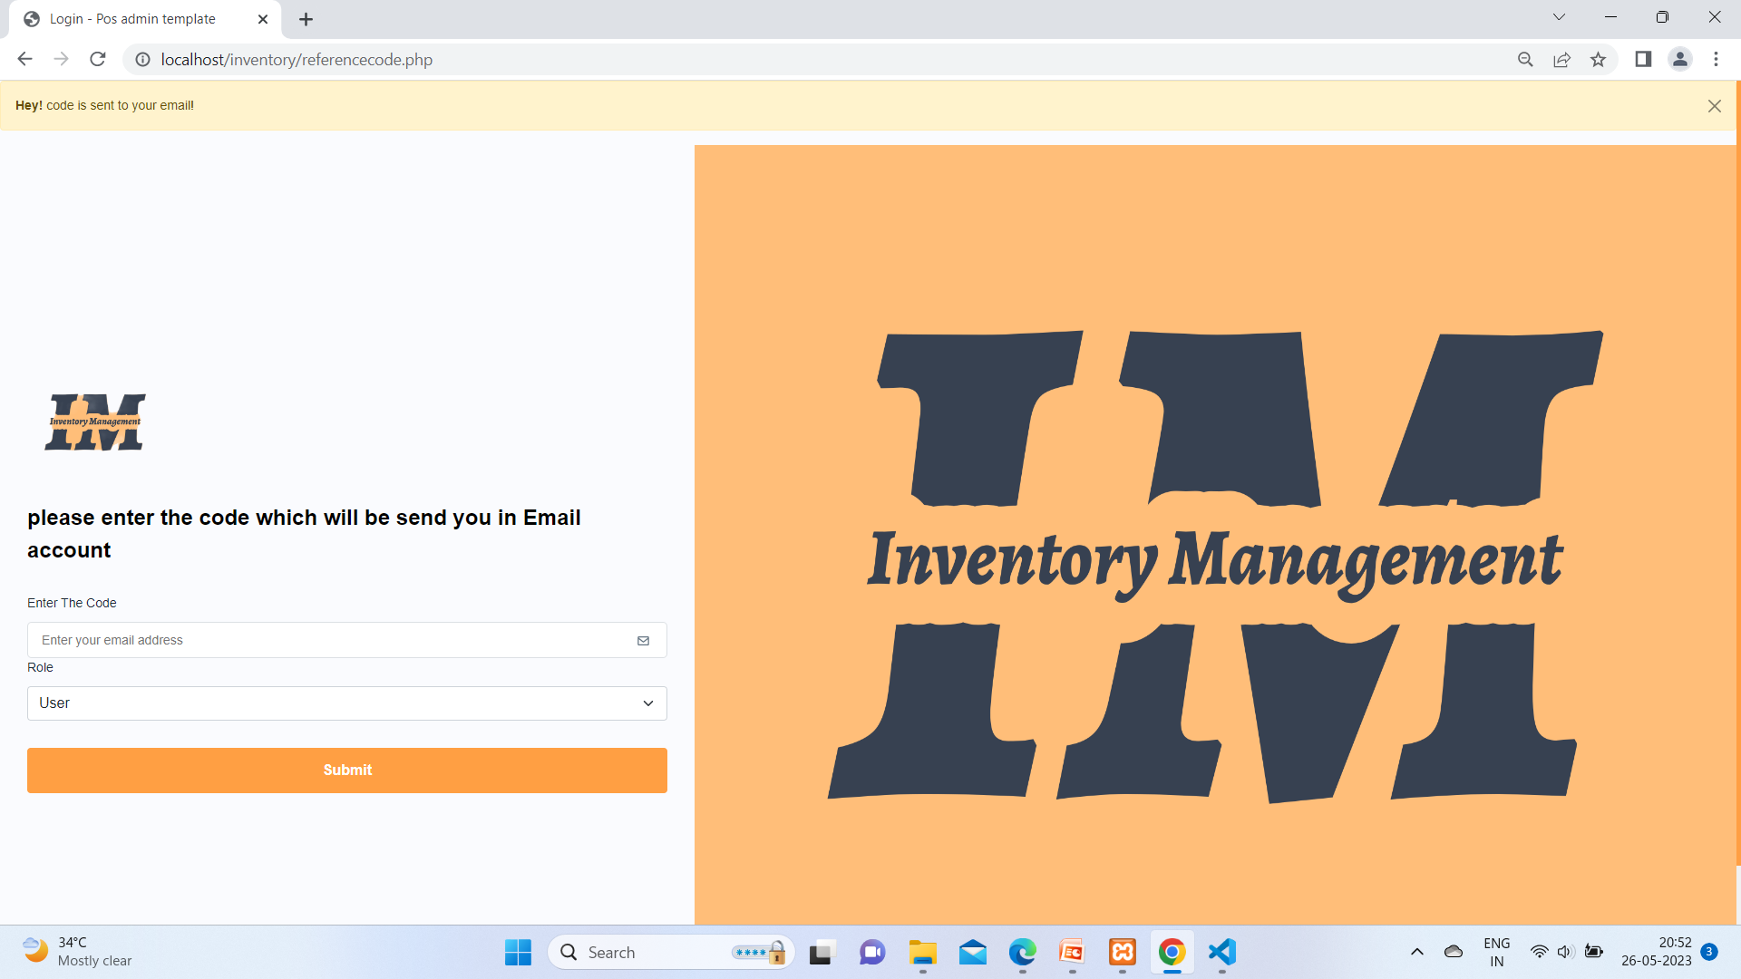

You will get notification at you mail box which you write and six digit code you gets then you must have to enter that code in enter code box and submit. You should have account other wise email not get.

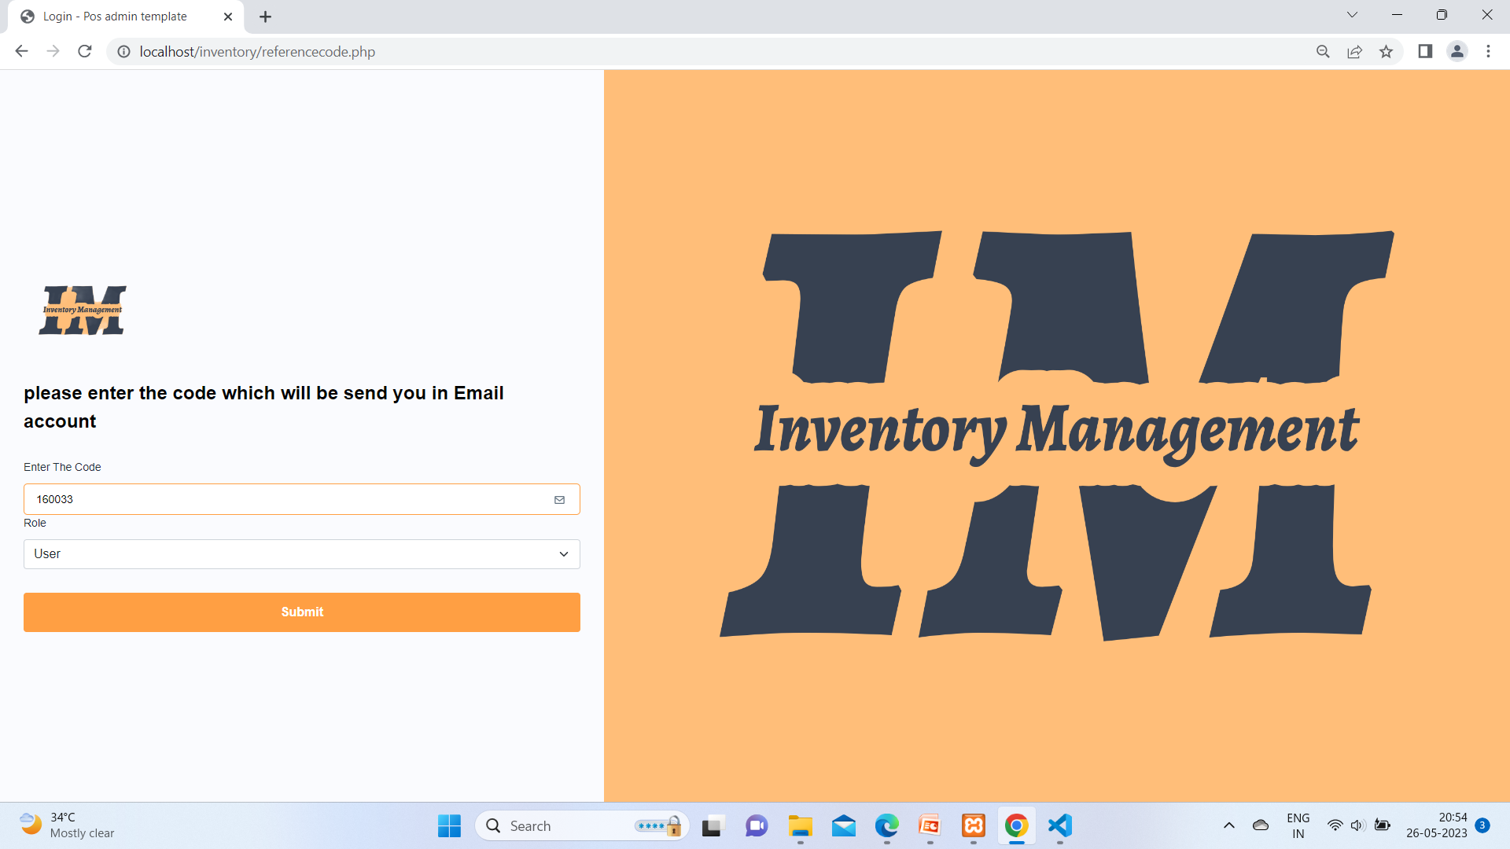

Entering code which you got from email and submit it.

1. User Home Page:-

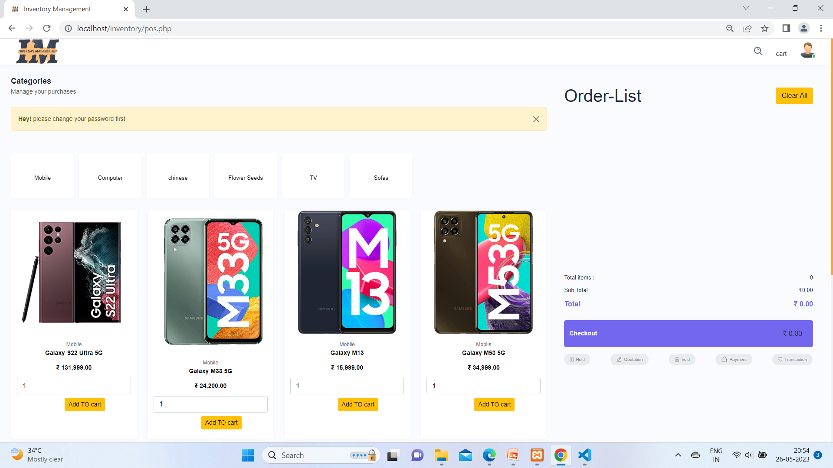

When user login its see like above picture and please change your password first message displayed.

1. Selecting Sub_Categories:-

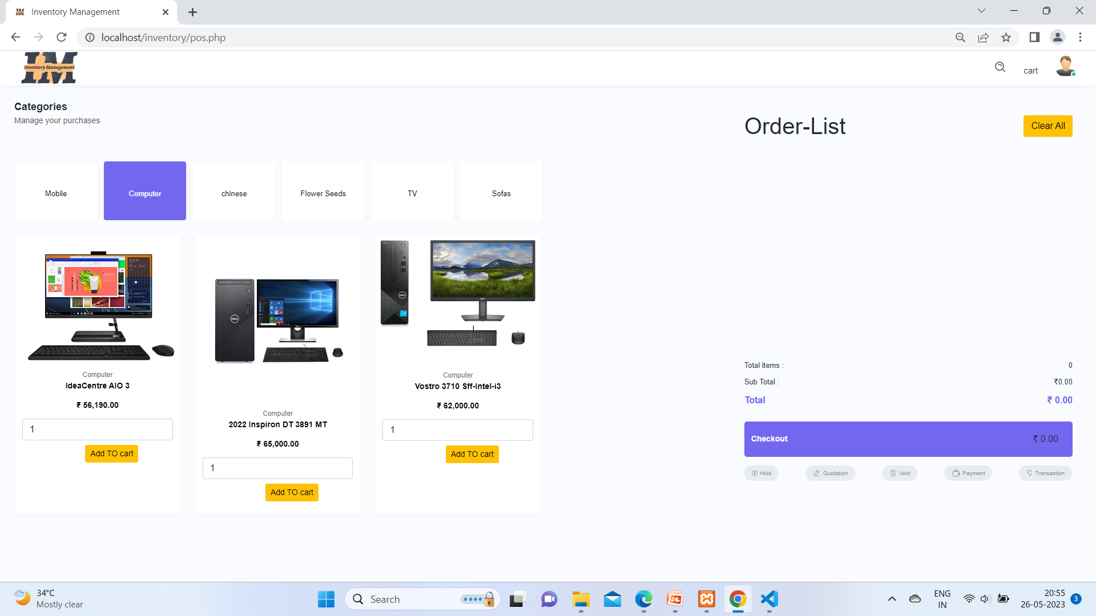

Here user is select sub categories

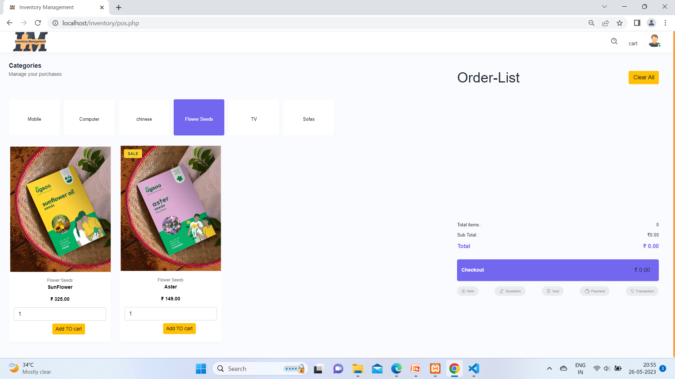

Same as above

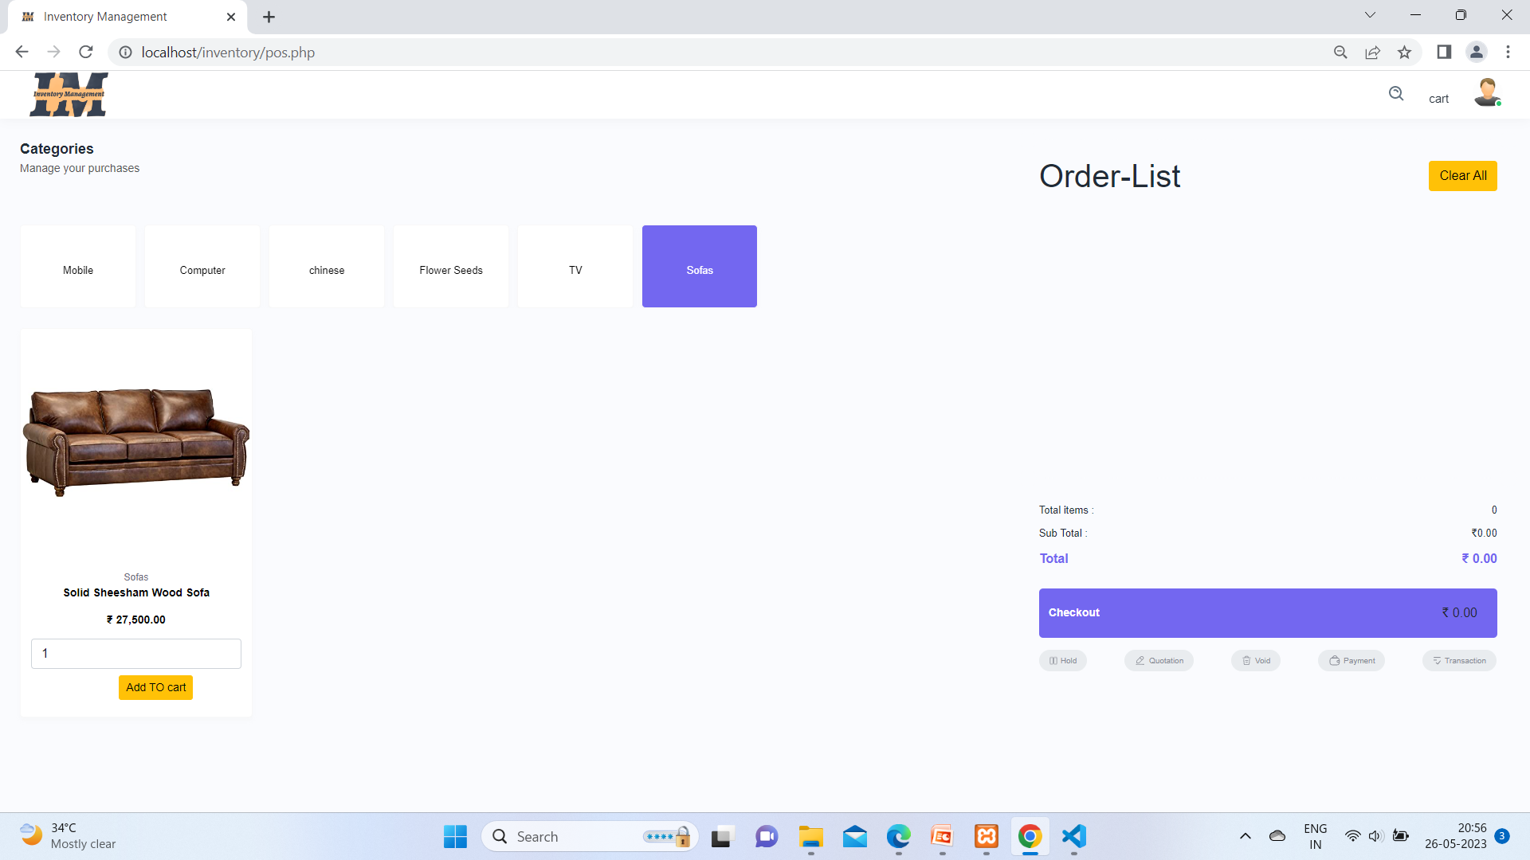

Select sofa sub category

1. Product Add In Cart:-

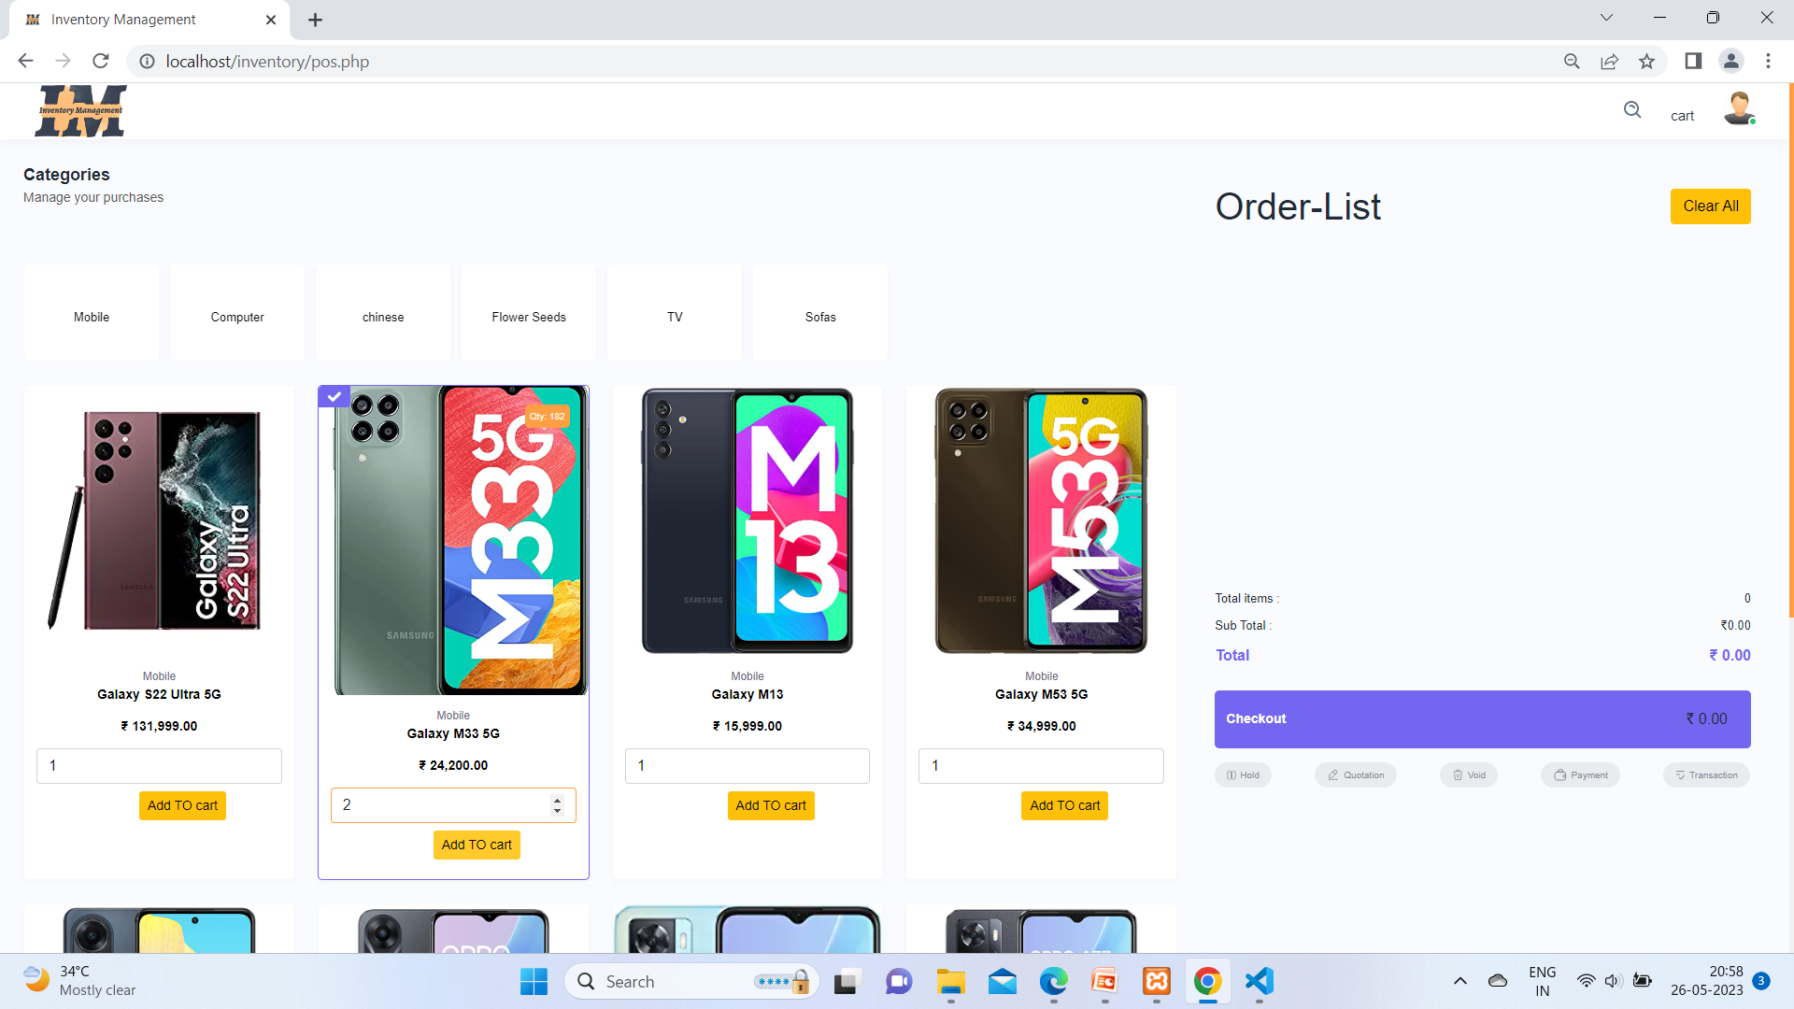

When out mouse cursor moves on any product on above right corner you can see qty of product and user is add 2 galaxy m33 5g phone product.

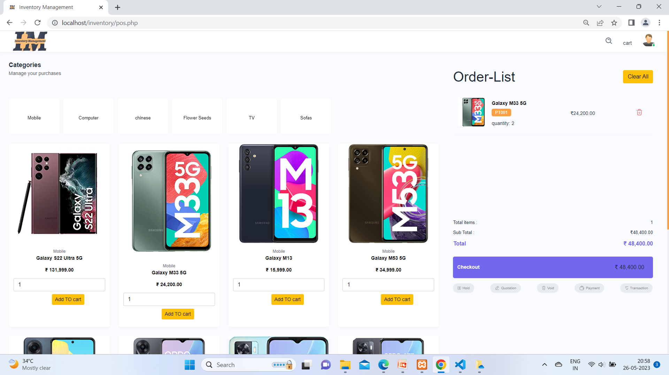

User clicked on Add to Cart button and product added in right hand side Order list.

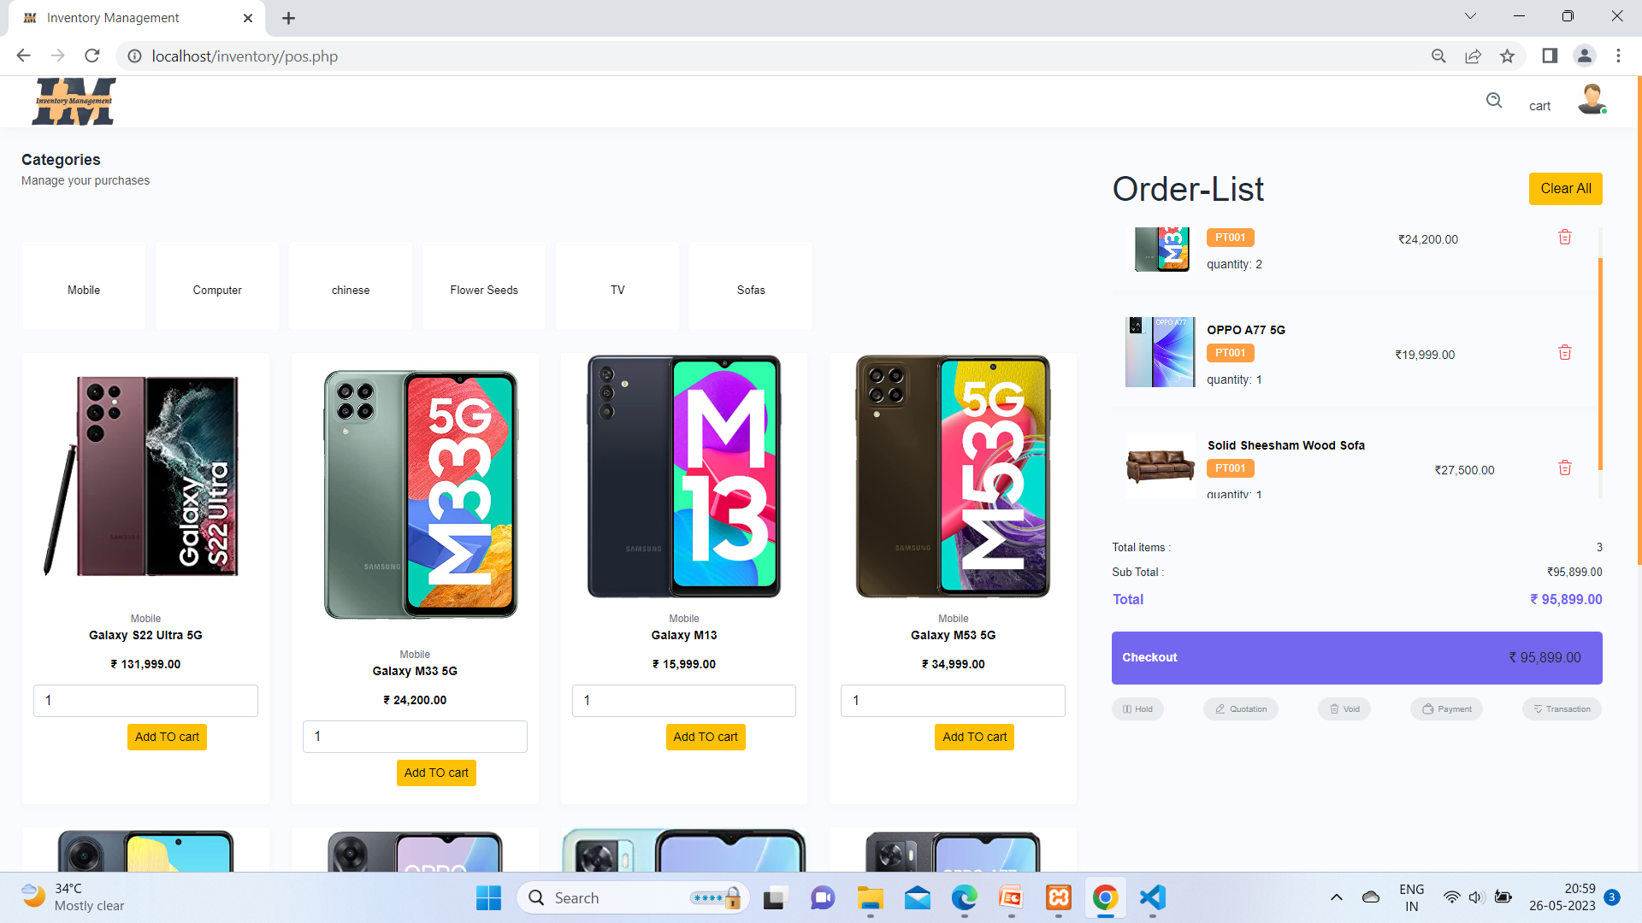

user has to add more product and click on cart which is beside of user profile.

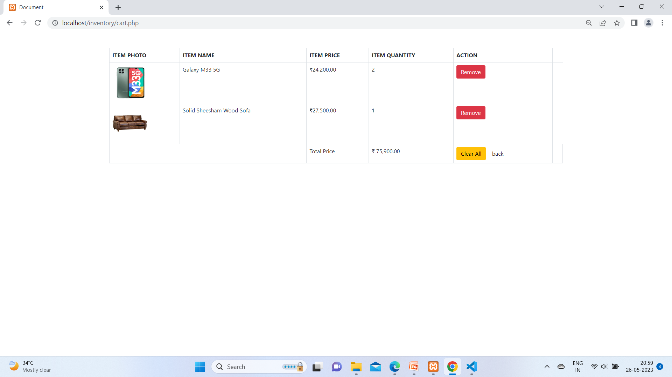

when user click at cart button this page opens.

1. Deleting Product From Cart :-

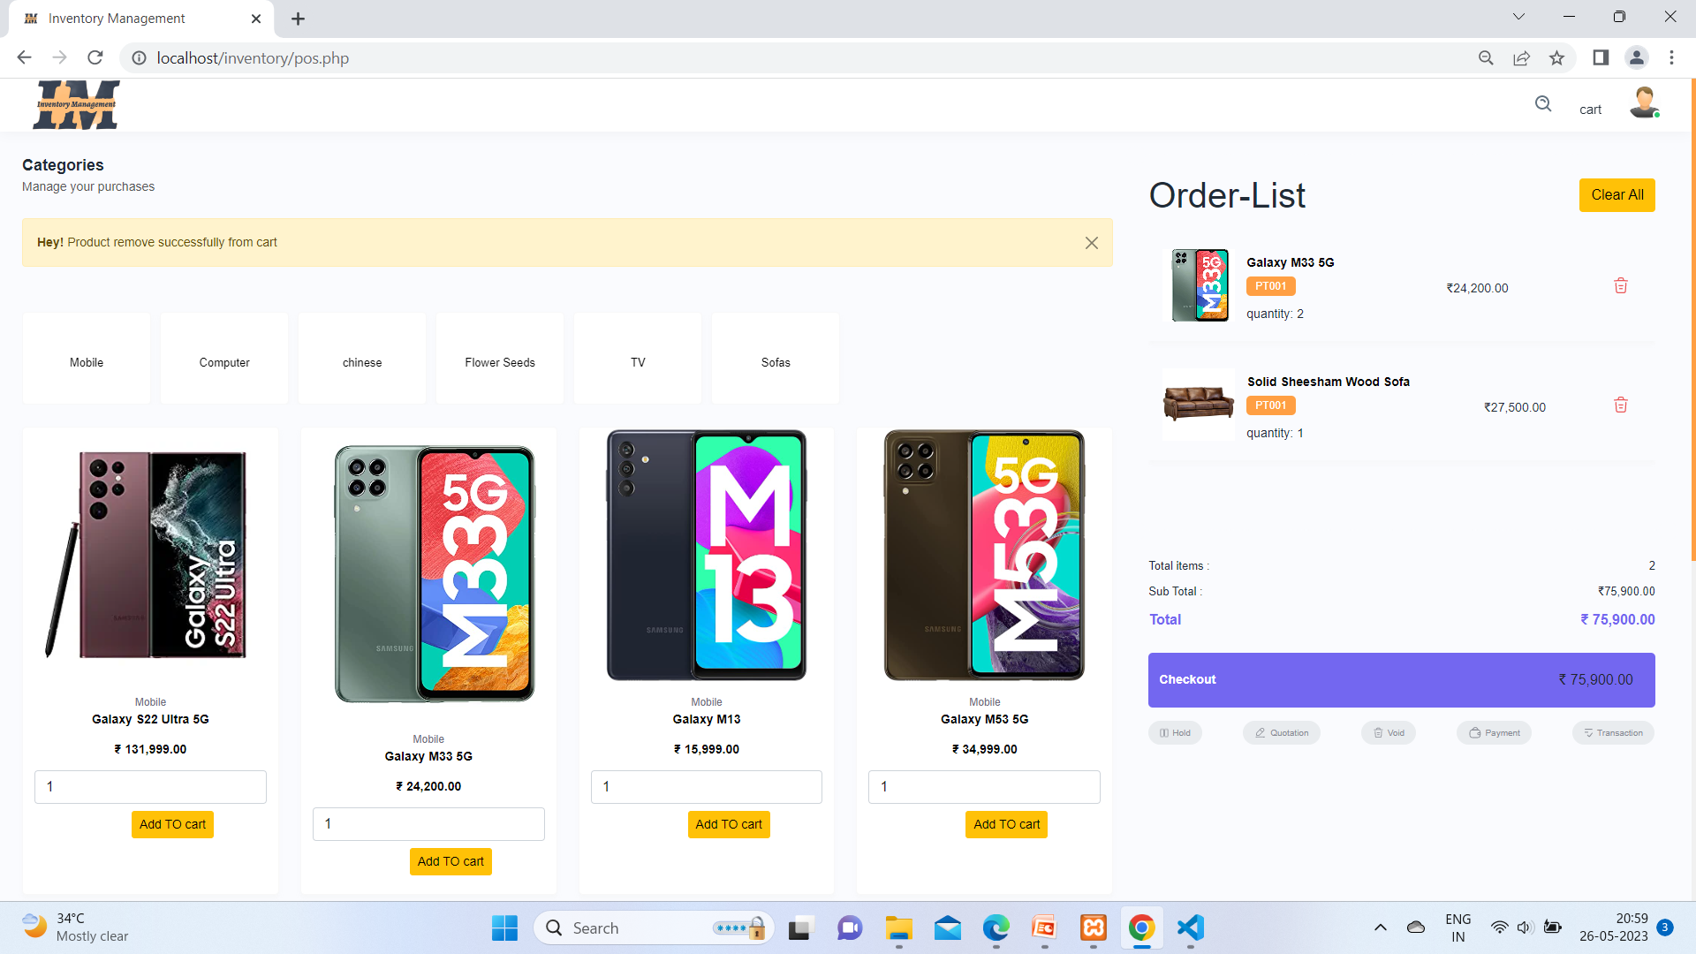

When user click on remove button his add to cart product removed form cart.

1. Order Product :-

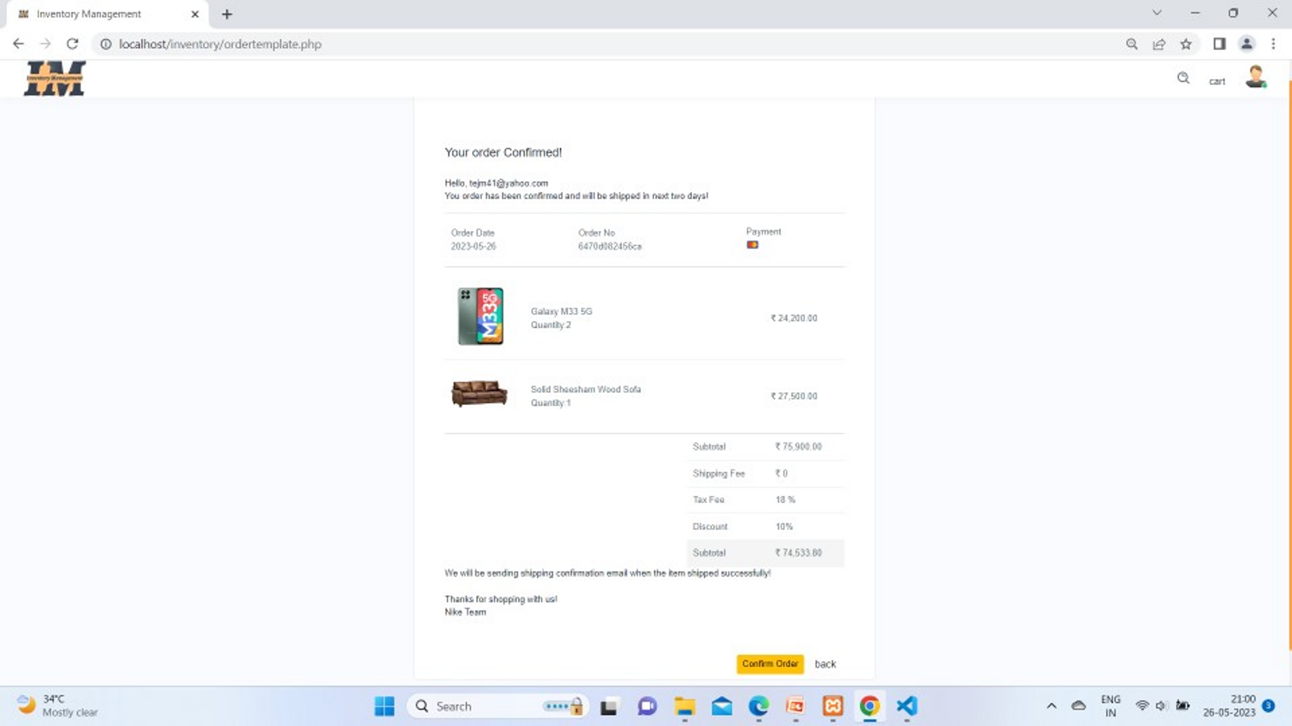

Here when you click checkout then you have to confirm order from this page.

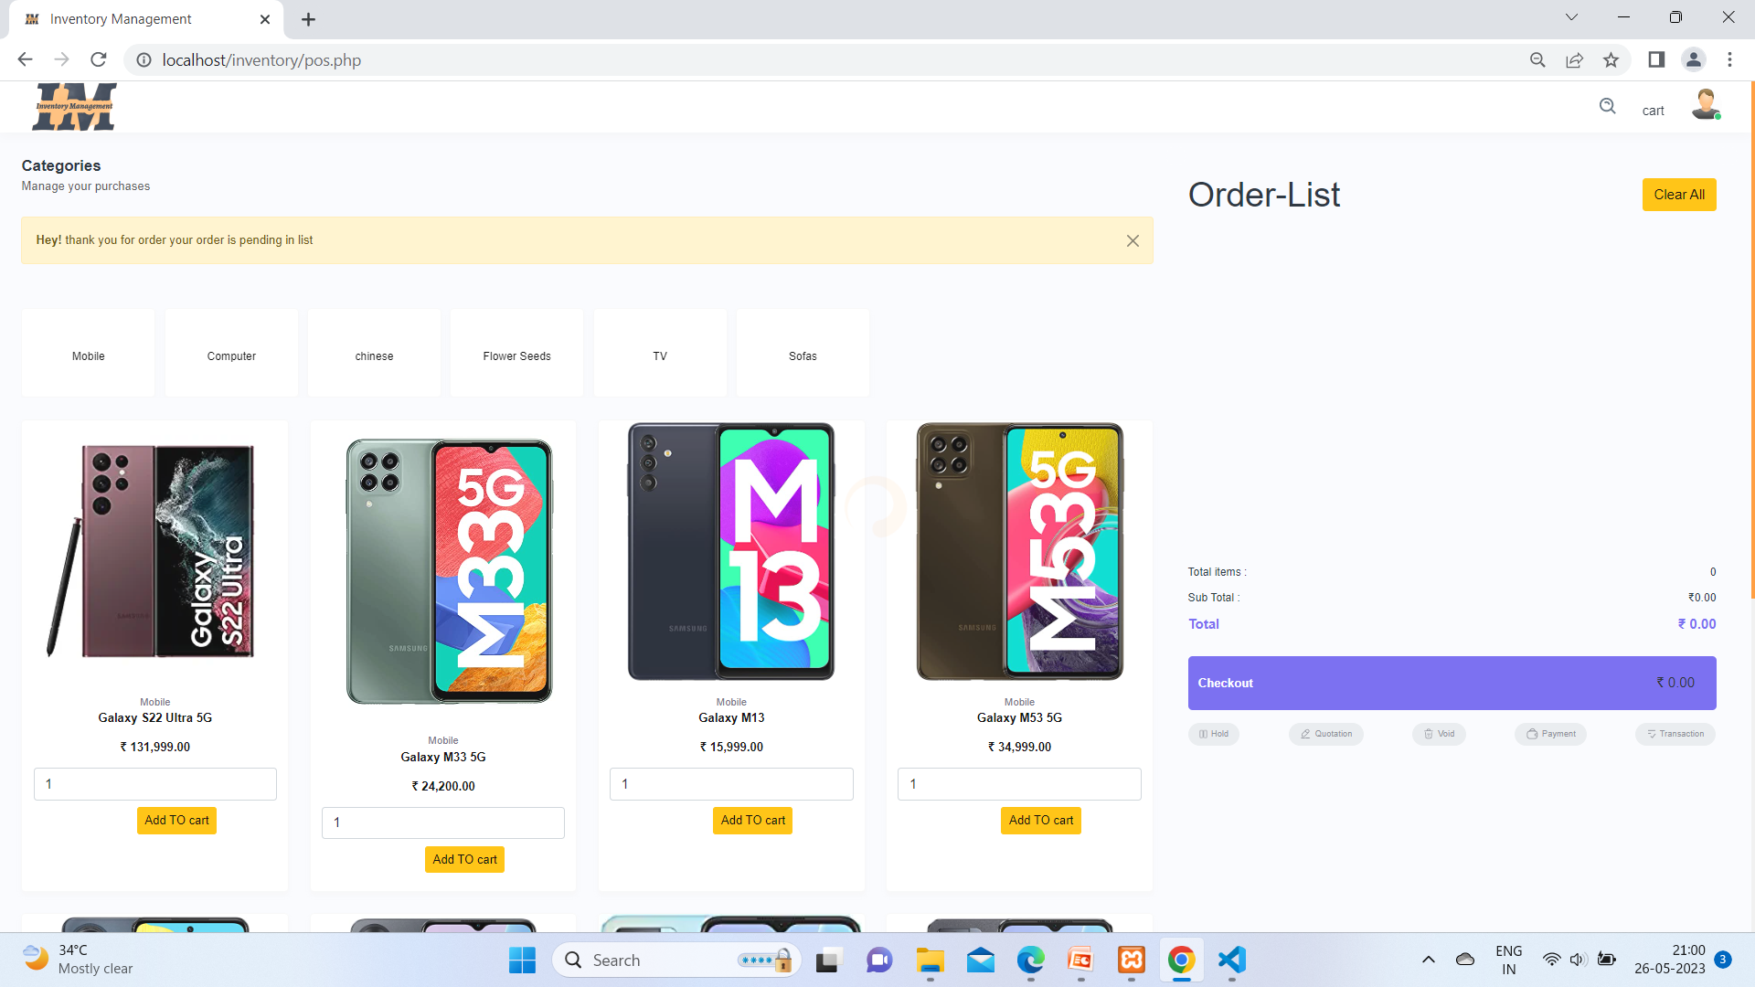

When click on confirm button your order will be in pending list.

1. User Profile :

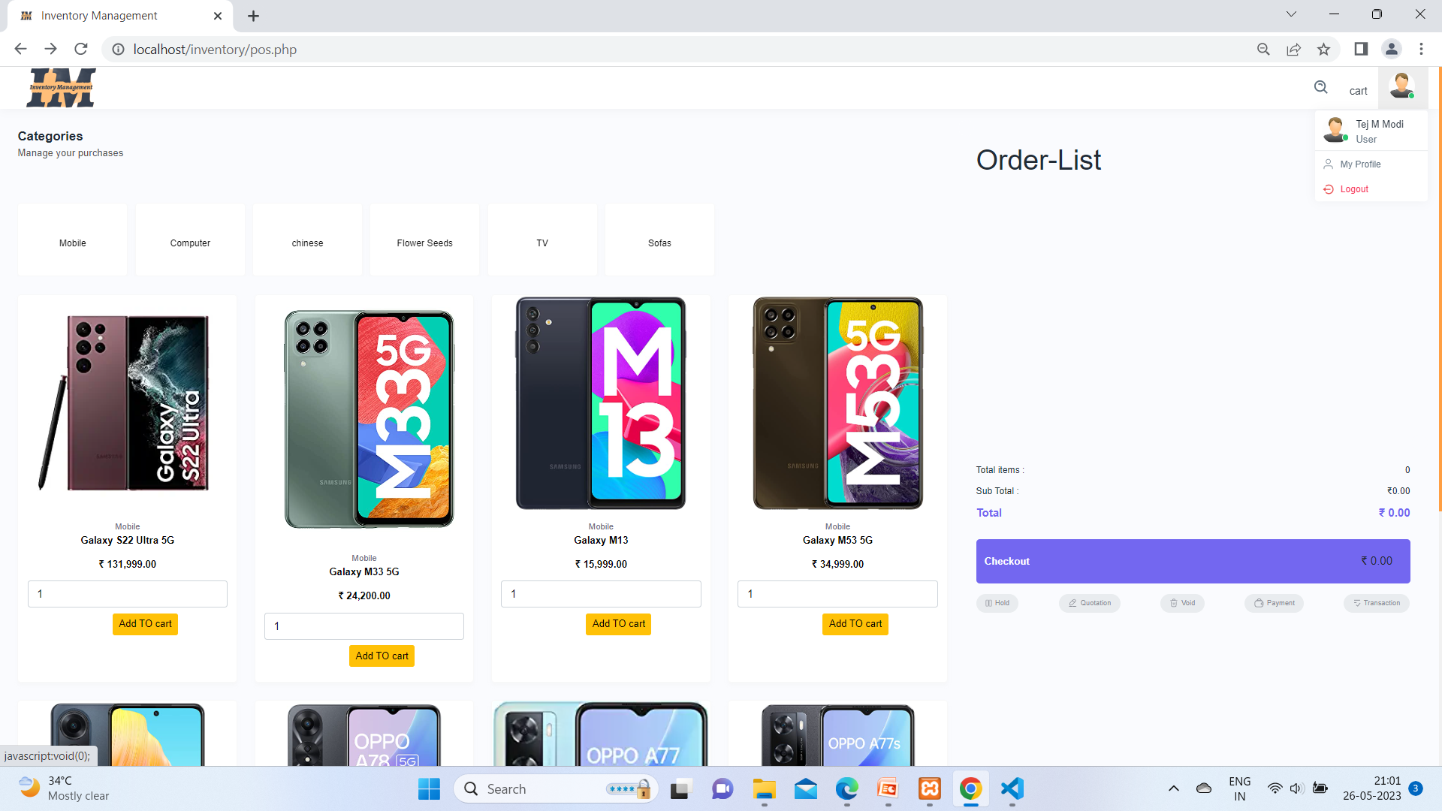

From here when your cursor at profile you can see two button such as my profile and logout.

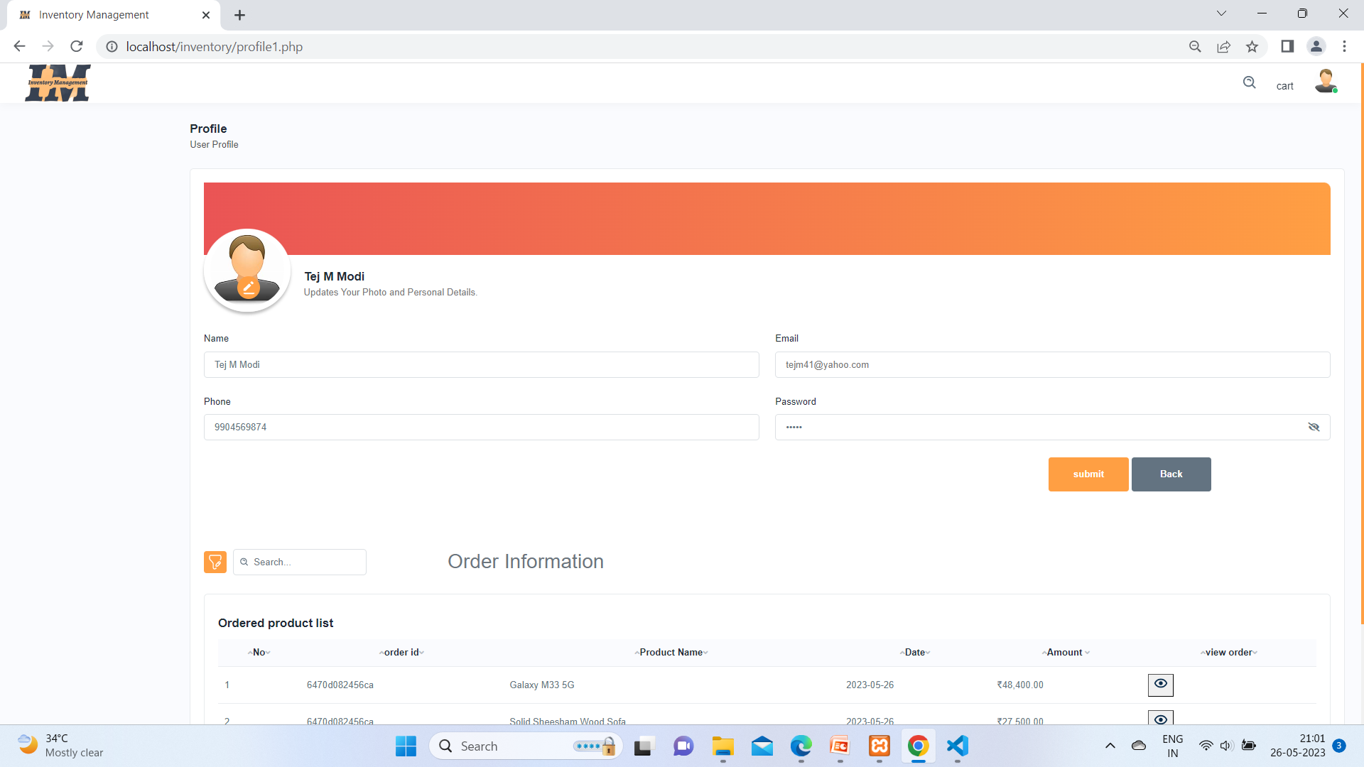

Clicked at my profile and you can update your profile from this page .

1. ) Updating User Profile:-

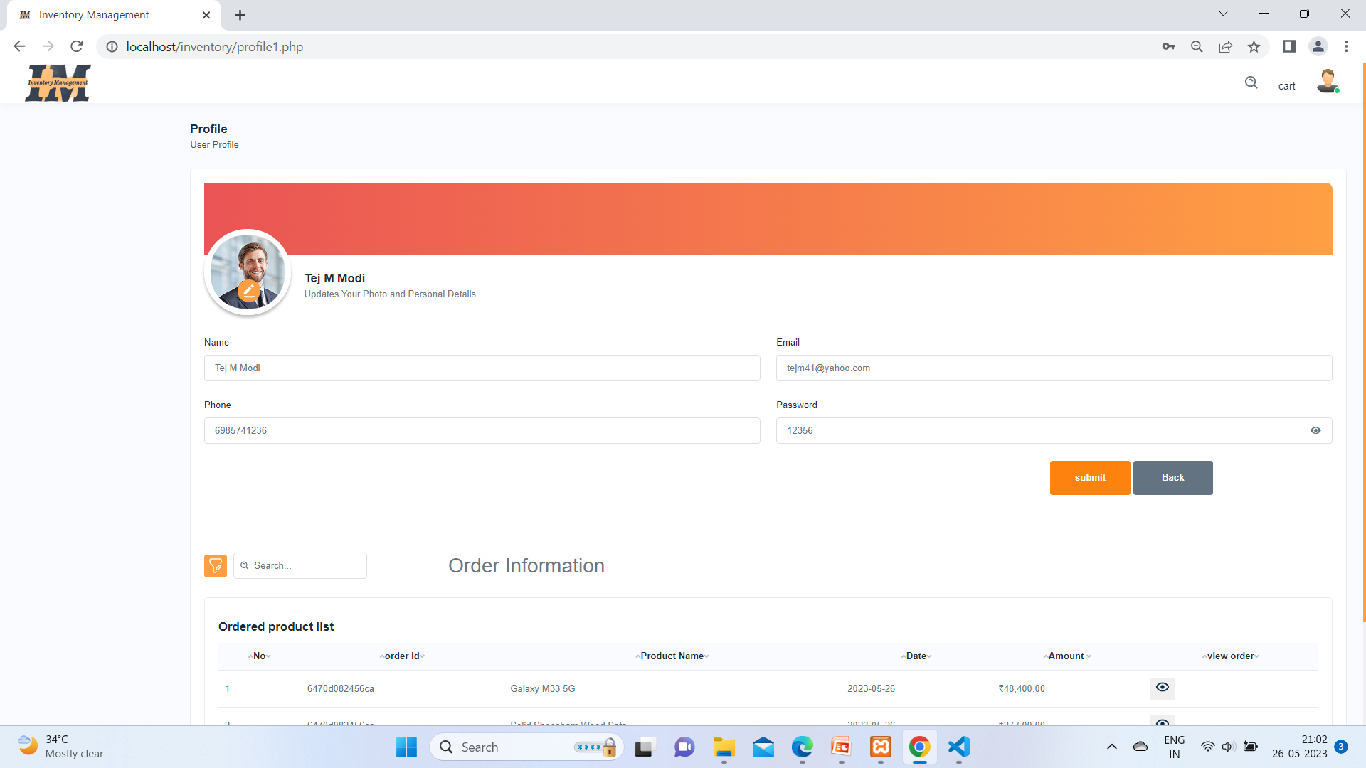

Updating profile

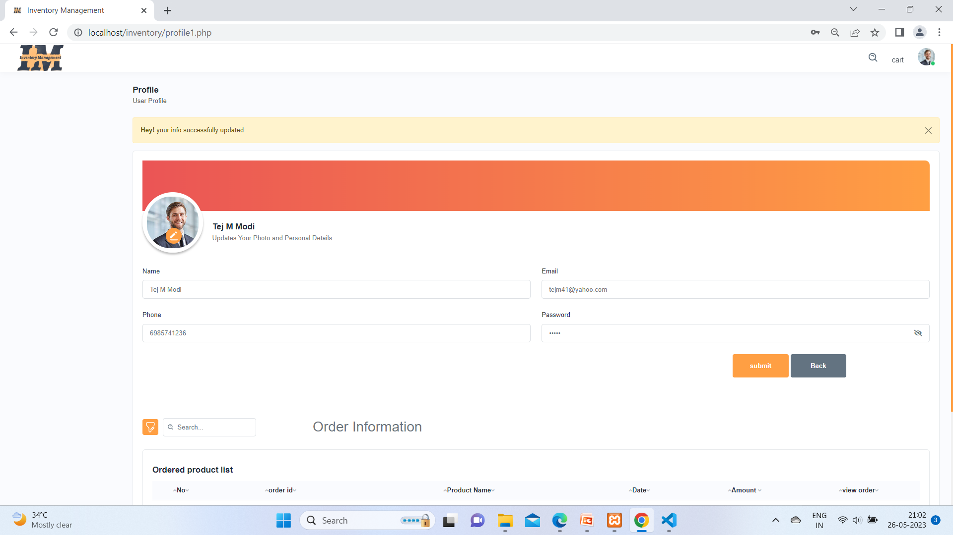

Profile has been successful updated.

11) Showing User Order :-

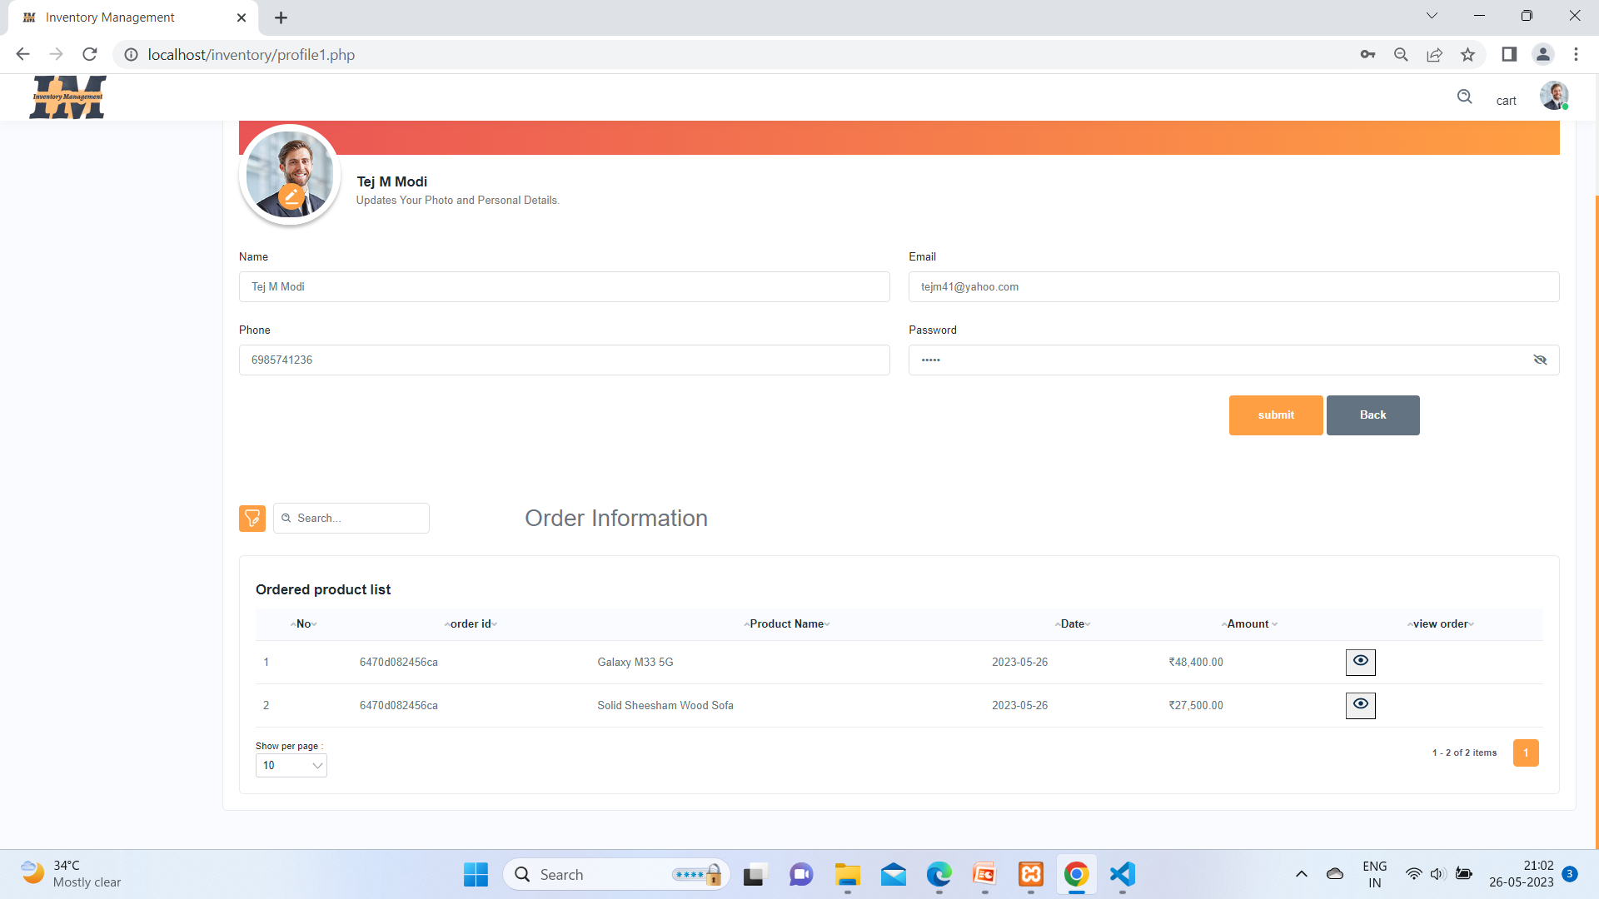

Under profile you can see order list which are ordered before some time.

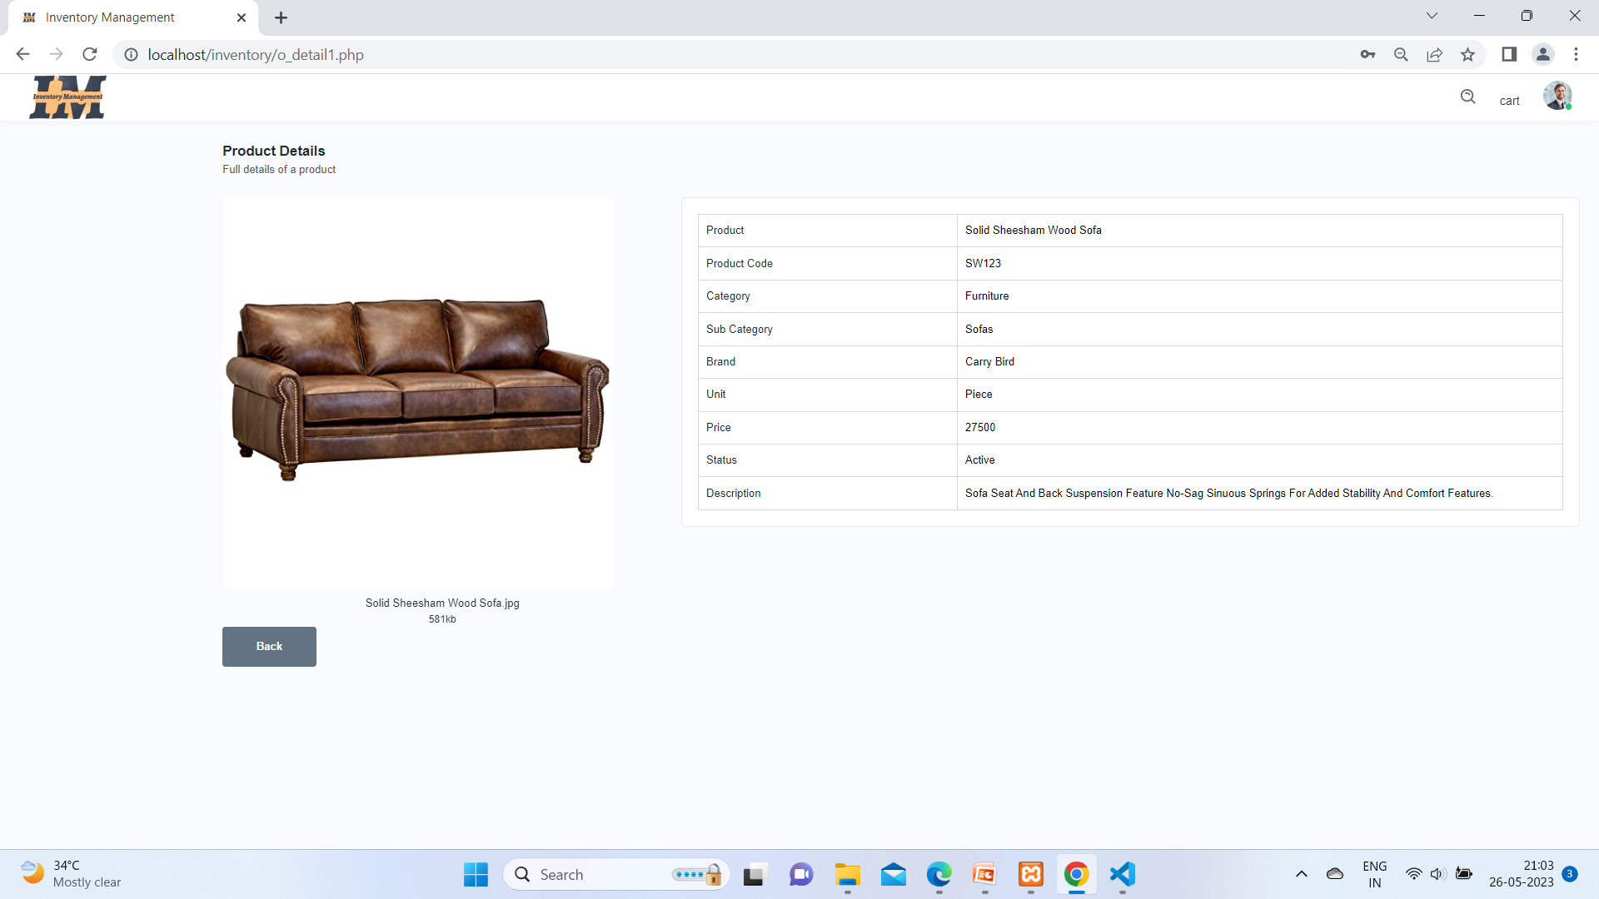

From order list table user can see their product.

**Chapter 5-> Conclusion & Future work**

After doing this project, I learned many things, I learned to prepare functional specification, design specification, system development life cycle in practical development and also learned real life software development with tools having an interactive feature.

I also understood the importance of naming conventions and coding conventions in the development process.

Through this project, I conclude that it is faster, more accurate, more reliable for the customer than the manual system.

About this Project it is seen that E commerce Web sites esaly manage their Stocks . Using Inventory Management.

During analysis I’ve visited hundreds of Ecommerce Websites, Database

Blogs, Specially for Variation Module, and Recursive tables to Manage Category Module

**Chapter 6-> References & Bibliography**

**Website Refer:-**

[www.Youtube.com](http://www.Youtube.com)

www.w3schools.com

[www.Google.com](http://www.Google.com)

[www.Canvasjs.com](http://www.Canvasjs.com)

[www.getbootstrap.com](http://www.getbootstrap.com)

**Books:-**

PHP 5.3 by Matt Doyle